We are always ready to make suggestions on great books to read and give as gifts--and are particularly handy when it comes to making suggestions to parents, grandparents, and many others for books for kids. Trust our staffers Betsy Balyeat, Linda Diekman, Kari Patch, and Amy Trogdon to find excellent recommendations for kids.

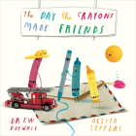

Here are Linda's suggestions for today:
The Day the Crayons Made Friends by Drew Daywalt ($19.99)
The crayons are back! Always ready for adventure, the crayons are out and about, making friends along the way. Enjoy their newest escapades! Ages 4 - 8

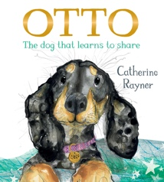

Otto: The Dog That Learns to Share by Catherine Rayner ($18.99)
Word gets out to Otto the puppy’s friends that he has a comfy, cozy basket. Now that they’ve taken over his spot, will they ever leave? Beautifully illustrated!
Ages 3 -6

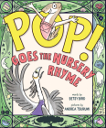

POP! Goes the Nursery Rhyme by Betsy Bird ($18.99)
These are not your everyday nursery rhymes! Fractured fun with guaranteed laughs!
Ages 3 - 5

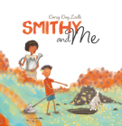

Smithy and Me by Darcy Day Zoells ($19.95)
Smithy, the dog, is the best playmate ever. Mom doesn’t even mind the bedtime messes. Or does she? Detailed drawings with a captivating canine!
Ages 4 - 9

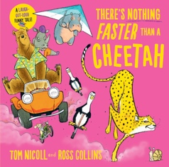

There’s Nothing Faster Than a Cheetah by Tom Nicoll and Ross Collins ($15.99)
What is faster than a cheetah? Could it be a penguin on a pogo stick? Maybe a bear in a beach buggy? Super fun speedy reading!
Ages 4-8

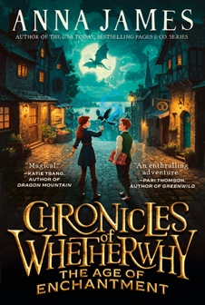

Chronicles of Whetherwhy: The Age of Enchantment by Anna James(paperback, $9.99)
Welcome to Whetherway where everyone has magic powers originating from the changing seasons and a select, special few have four seasons of magic. Riveting worldbuilding in a fast paced fantasy.
Ages 8-12

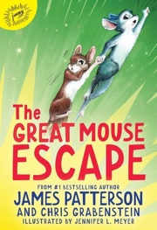

And these are Betsy's recommendations:
The Great Mouse Escape by James Patterson and Chris Grabenstein, illustrated by Jennifer L. Meyer ($17.99)
A tiny talking mouse sets off on a great adventure to rescue his friend Mikayla who has been mouse-napped. Ages 8 - 12

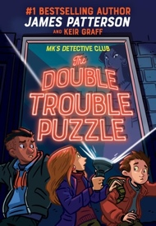

MK's Detective Club : The Double Trouble Puzzle by James Patterson and Keir Graff ($17.99)
Discover Nancy Drew for a new generation. Minerva Keen is the best kid detective in Chicago. She is looking for a new mystery to solve with her friends. But she may have found more than she bargained for! ﻿Ages 8 - 12

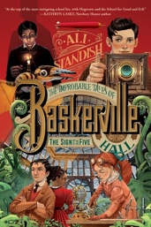

Improbable Tales of Baskerville Hall Book 2 : The Sign of the Five by Ali Standish ($15.99)
Arthur returns to the elusive Baskerville Hall and must solve the mystery behind a poisoned Sherlock Holmes. Another great adventure! Ages 8 - 12

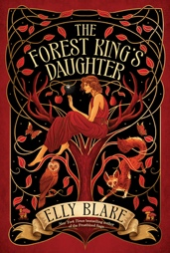

Forest King's Daughter by Elly Blake ($19.99)
A young forest princess became friends with a lonely boy from underground. He gifts her an amber ring, a worthless trinket---or so he thought! Age 13 and up

