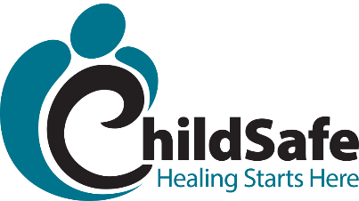
Beyond Consequences & Advanced
Parenting Skills Class
Beyond Consequences is a unique, relationship-based approach to parenting traumatized children and those with attachment challenges. This approach provides a trauma-informed explanation of “acting out” behaviors. Caregivers will learn how children escalate through behaviors, as well as how to respond to help their children during these times. When children and caregivers expand their ability to emotionally tolerate stressful situations, behavior naturally improves. The class is appropriate for biological parents, adoptive parents, foster parents, and kinship-care providers.

Some Program Topics
- Emotional regulation and dysregulation
- Window of stress tolerance
- Trauma and memory
- Acting out behaviors, i.e. lying, stealing, aggression, etc.
- Signs and stages of verbal and behavioral escalation
- Caregiver responses to decrease escalation
- Setting appropriate and enforceable limits

When:
June 1st – July 6, 2020
(6 weeks)
Mondays 1:00 PM – 2:30 PM
Where:
ONLINE - ZOOM
Cost:
The class is free through a grant from the Temple Hoyne Buell Foundation
Book is Included

Email info@childsafecolorado.org or call (970)472-4133 to enroll!
2001 S. Shields St. Bldg. K, Fort Collins, CO 80526 • O: (970) 472-4133 • F: (970) 493-6655
wwww.childsafecolorado.org • On Twitter: @ChildSafeCO • On Facebook: www.facebook.com/ChildSafeColorado

