Contact:  Ukallaysaaq T. Okleasik  VP, Corporate Affairs  Phone: (907) 387-1230  Fax: (907) 443-6437 | PO Box 905  Nome, Alaska 99762  ukallaysaaq@snc.org  www.snc.org | 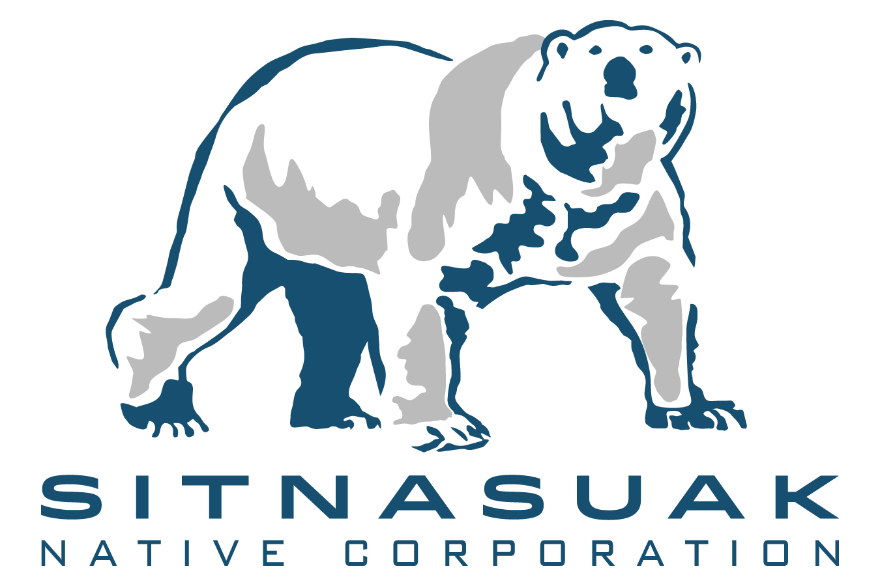

Press Release

D.J. Webb Steps Up to New Leadership with Sitnasuak Financial Services

February 21, 2019
Ms. D.J. Webb has stepped up to a new leadership role – the General Manager of Sitnasuak Financial Services, proudly a subsidiary of Sitnasuak Native Corporation which wholly owns Fidelity Title Agency of Alaska, LLC and Mat-Su Title Agency, LLC.

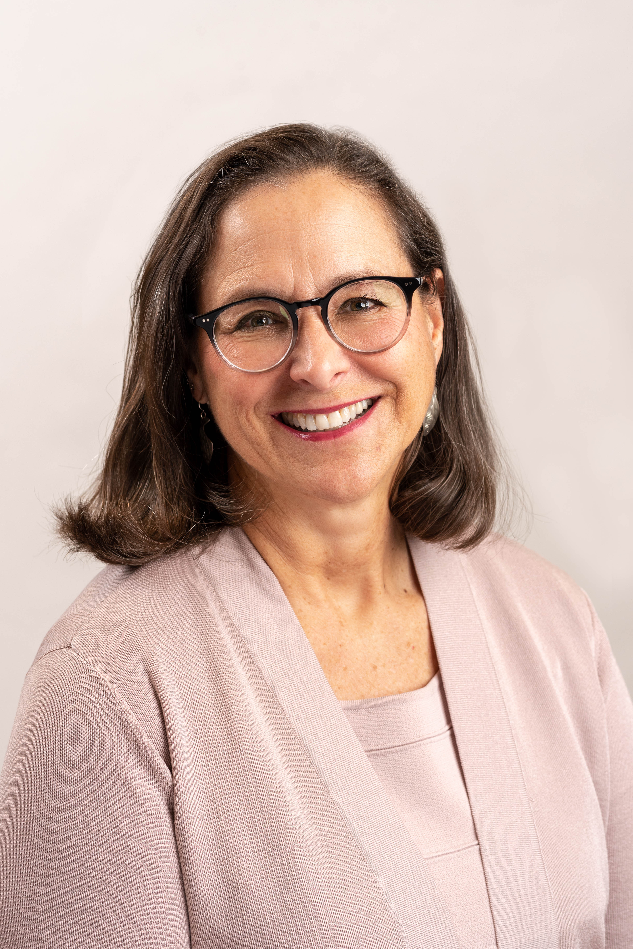
Ms. Webb is a long-time employee and title-industry expert. For over fifteen years, she has worked with Fidelity Title Agency to offer trusted title and escrow services with homeowners, financial institutions, attorneys and commercial property owners across the State of Alaska.

Ms. Webb will lead the title companies and financial services from the statewide branch headquartered in Anchorage. Fidelity Title Agency recently opened the new Fairbanks branch to better serve customers in the Interior and Northern Alaska. Mat-Su Title Agency, based in Wasilla, serves the Palmer, Talkeetna and Chitna recording districts.

“We know people have a choice in which title-insurance company to use,” D.J. shares, “so we like to make sure customers know they can trust the experts with our title companies. We’re a family of Alaskan-owned companies with a long history and strong experience throughout the state and we proudly serve our fellow Alaskans. We believe it’s important to make sure you’re getting a title agency that has your best interests at heart.”

Fidelity Title Agency and Mat-Su Title are independent agents, wholly owned by Sitnasuak Financial Services, that offers expertise and trust in the real estate buying and selling process. Products include insurance that is issued by national underwriters. For more information on the agencies, visit the company web sites at www.alaska.fntic.com and www.matsutitle.com.

About Sitnasuak Native Corporation
Sitnasuak is headquartered in Nome, Alaska, with operations in Nome, Anchorage, Wasilla, Fairbanks, California, Virginia and Puerto Rico. Sitnasuak’s family of companies and brands include Fidelity Title Agency of Alaska, Mat-Su Title Agency, Bonanza Fuel, Bonanza Express, Nanuaq, Mocean, SNC Technical Services, SNC Manufacturing, Aurora Industries and Sitnasuak Applied Technologies. SNC is one of the Alaska Native village corporations created in 1971 under the Alaska Native Claims Settlement Act (ANCSA). Today, SNC is the largest of 16 village corporations in the Bering Straits region, with over $134 million in annual revenues. SNC is owned by almost 2,900 Alaska Native Shareholders. For additional information on Sitnasuak as well as our business products and services, please visit our website at www.snc.org or like our Facebook page at www.facebook.com/Sitnasuak/.

###

