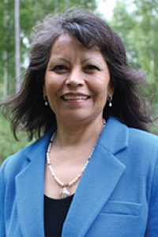
Dorothy Shockley, President/CEO, Bean Ridge Native Corporation
Statement of Interest: I am currently President of Bean Ridge Corporation of Manley Hot Springs and have been since 2013, and CEO since March 2017. I would like to serve on the ANVCA Board to represent the very small village corporations who have yet to establish their own businesses and/or 8(a) company like Bean Ridge. Bean Ridge started out with 42 original shareholders and a quarter of a million dollars, and after forty years and half a million dollars in assets, we are still looking for a business opportunity or mentor. We did partner with three other small village corporations - Minto, Nenana, and Stevens Village Corporations – and formed a new company, Tene Hut’aane, to give us more leverage and share costs and risks. I appreciate the direction ANVCA has taken the past year focusing on corporations that still can use some help and I would love to be on the team to offer my perspectives. My goal would be to see all of our village corporations succeed in finding the right opportunity whether it's developing a business, 8(a) contracts, JV, or partnering.
Professional experience:
Independent contractor, Shockley Consulting, January 2013-present
President/CEO, Bean Ridge Corporation of Manley Hot Springs, March 2013-present
Tribal Technical Assistance Specialist, Intertribal Agricultural Council, July 2013-November 2015
Legislative staff, Sen. Albert Kookesh, January 2005-May 2012
Project Manager/Supervisor/Education and Training Director, Council of Athabaskan Tribal Governments, 1998-2004
Crew/Supply Coordinator, Alyeska Pipeline Services, June-August 2001
Village Liaison, UAF Interior-Aleutians Campus, 1994-1997

