As the city of Anchorage begins to push its boundaries and overflow into its adjacent communities, Eklutna, Inc. as the “Largest Private Landowner” in the Municipality of Anchorage, must keep in step with the demand for growth while finding the balance of its culture, to respectfully manage its lands, solidify its business relationships, and secure revenues for future generations.
The housing shortage is one of the recent issues that has risen within the Municipality of Anchorage and with Eklutna’s land holdings, of course a lot of eyes turned its direction. With residential growth also comes the demand for commercial development in those newly developed areas. However a development can’t take place without utility infrastructure in place. One of the major issue all developers are facing within the Municipality is the lack of expanded infrastructure into areas that can be developed. Currently there is no place to just hook-up. Infrastructure currently available for development expansion is too far away or overloaded. Eklutna has been working with all the major utilities and, most notably in recent news, Anchorage Waste Water Utility (AWWU) to develop cost effective ways to develop improved infrastructure into these areas. A project of this magnitude does not happen overnight. Eklutna has spent years working on this issue and is prepared to continue this work until it is resolved. Only then can future residential and commercial developments begin to take shape.
New development construction and road projects also brings a demand for gravel resources and sites to receive overburden, fill and a snow dump. Eklutna has gravel resources they make available to offset these demands. Eklutna’s Pit next to the Village offers gravel extraction and dirt import. The North Eagle River location also offers these resources, but also offers this location as a snow disposal site in the winters. Again these resources are not depleted over night, but take years to create a flat developable piece of land. The extraction years provide the corporation with the opportunity to read the community and decide what would be the best suitable use for this site. Commercial plaza, parks, sports complex or something completely different? Areas near the Eklutna Village are envisioned with opportunities and resources that would enhance the Village culture such as man-made lakes, community gardens, and gathering centers.
Part of the revitalization project that the corporation hopes will positively affect the Village culture is the lower Eklutna Dam Removal. The Eklutna River was once a viable salmon resource. The construction of the lower dam not only changed the salmon’s natural habitat but hindered them from returning. The deconstruction of the dam is progressing slowly as years of built up sediment is removed as the face of the dam is methodically deconstructed. Currently, 18 feet of the dam and 23 feet of sediment has been removed from the site. Once the deconstruction is completed in the summer of 2018, then next steps to begin rehabilitation of the salmon run will begin. This will take several years and will require cooperation with the utilities and the Municipality of Anchorage to release enough water from the Upper Eklutna Dam. The steady release of water into the river will allow enough depth for the salmon to lay their eggs and ensure their survival through winter. Studies and meetings have already begun to keep this project on a positive path.
Just up Eklutna Lake Road is another project underway that Eklutna feels will be beneficial to the community, the Ernie Turner Recovery Center. Eklutna is working with Cook Inlet Tribal Council (CITC) on providing a new site and as the contractor, to build the new 16 Bed Treatment Facility. Substance abuse and addiction has reached a critical point within the Native Alaska community; and the new Ernie Turner Center will be a recovery center for Native Alaskans who have gone through detox and are recovering from drug and alcohol addiction. The Ernie Turner Recovery Center hopes to open its doors at the new location summer 2018.
As the only remaining Village in the Municipality of Anchorage, representatives from the Native Village of Eklutna and Eklutna, Inc. are often asked to be a part of committees, partnerships and to perform welcoming ceremonies, at events such as the Alaska Federation of Natives Convention when held in Anchorage. The corporation is humbled to have this honor and privilege, and sharing its story whenever possible. The corporation wants the public to see we are not just another development company, but that with every project there is a purpose for our Tribal Shareholders and our community.

“Building our future, developing our resources, connecting our communities; we are Eklutna”

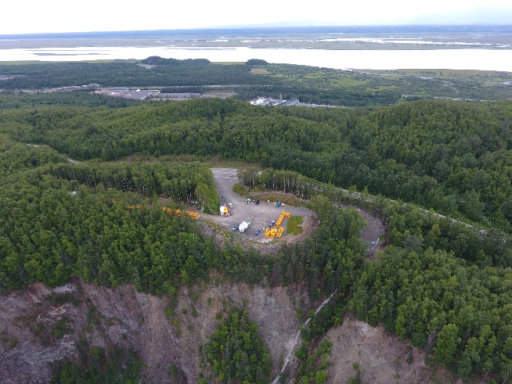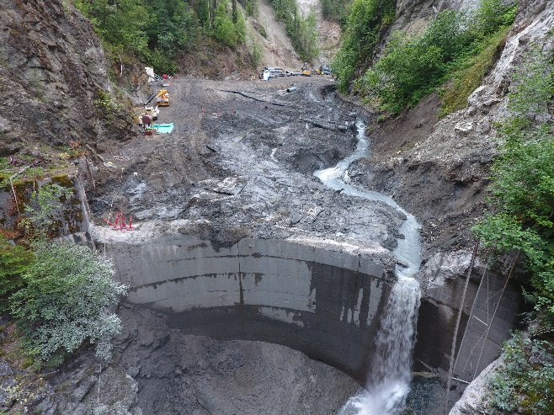
Eklutna Dam Removal Project

Aerial Photos by Noel Aspiras, Eklutna, Inc.

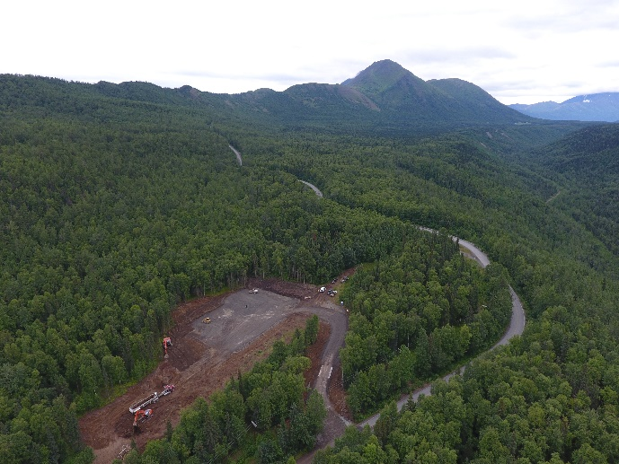Ernie Turner Project Site, Eklutna Lake Road

