Re-Building History and Maintaining Heritage
By Heather Kaiser
Corporate Communications Manager
Cape Fox Share Services
hkaiser@capefoxss.com

In Tlingit, Sanya Kwáan means Cape Fox?
CFC is the Alaska Native Corporation for the village of Saxman and is comprised of a family of businesses divided between two distinct groups: The Federal Contracting Group and The Commercial Group. Over the years, the company primarily generated revenue through harvesting timber and managing lands across 23,040 acres. As the timber industry slowly declined, the strategic business structure realigned towards new markets, which now include hospitality, tourism, real estate, and federal contracting. CFC’s mission is to maintain a strong financial foundation to provide immediate and long-term economic, education, and cultural benefits for our native shareholders. Whether federal or commercial, our customers recognize our quality of service and our employees provide exceptional skill and expertise. We are a value-adding company that works together with our customers to meet and exceed requirements.
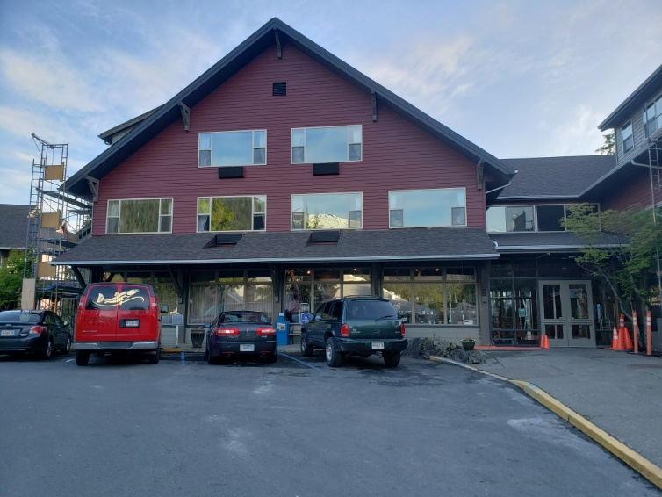
A New Look
Cape Fox Corporation’s largest Alaska enterprise is a mountain lodge, built 30 years ago, positioned on a ridge between the Tongass Narrows and Deer Mountain. Cape Fox Lodge is a rustic-modern hotel which overlooks the town of Ketchikan. The Lodge boasts 72-rooms (with either mountain or water views) with full guest amenities. Cape Fox Lodge is the premier lodging, dining, and conference location in Southeast Alaska. It combines beautiful views overlooking the Tongass Narrows, a historic collection of local native artwork, premium dining, and luxury accommodations. Each room is decorated with a collection of native artwork that brings the unique spirit of the native culture to each room.
In 2018, the Lodge began an 18 month, $3Million renovation. This is the first renovation the Lodge has undergone since it was first built. The extensive renovations include complete exterior and interior renovations, a new roof with copper impregnated shingles to prevent moss growth, 72 completely remodeled rooms with newly added air conditioning, new windows, furnishings, and fixtures in each room. Cape Fox Lodge will now be one of only two hotels in Ketchikan with air conditioning.
Among the amenities offered by the Lodge are a restaurant and conference facilities. The Heen Kahidi restaurant in the Lodge was remodeled to reflect the premium dining experience and to showcase the amazing views of downtown Ketchikan and the Tongass Narrows. The renovation also expanded the Lodge’s conference facilities by a third. The additional banquet facilities enable the Lodge to host larger, more diverse events.
In addition to Cape Fox Lodge and restaurant, renovations included the maintenance and upgrade to the funicular rail car. The original tram was constructed in Italy. The upgraded tram got a brand new roof, a rebuilt mechanical system, and upgraded tracks. The tram is used to transport guests of the Lodge from the top of the hillside lodging to the quiet, scenic town below. The tram transports visitors from Ketchikan’s historic Creek Street district to the Lodge.
Upholding the Mission
Each of these initiatives has allowed Cape Fox Corporation to support its mission of growing and maintaining a strong financial foundation to provide immediate and long term economic, education, and cultural benefits to its Shareholders. By doing so, we are preserving the rich Tlingit customs and heritage for generations to come. Between April and September, almost 1Million people visit Ketchikan from around the world. The upgraded Cape Fox Lodge offers a unique cultural experience, beautiful Alaskan views, and simple elegance.
For more information, visit CapeFoxCorp.com.

