

- READ A J&P RECOMMENDED BOOK EVERY TWO MONTHS
  - RECEIVE STUDY GUIDES TO INFORM YOUR READING
    - DISCUSS THE BOOKS WITH OTHERS VIA ZOOM

Books for the 2021-2022 Reading Season:

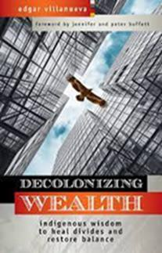
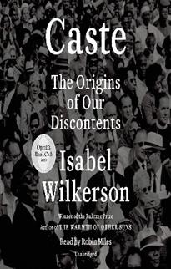
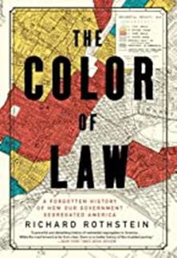
June 12, 2021
August 9, 2021
October 11, 2021
December 13, 2021

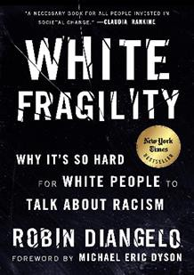
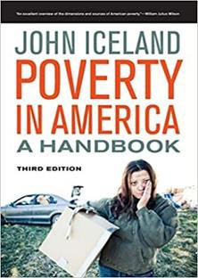
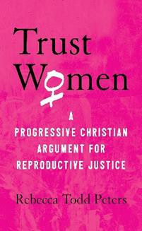
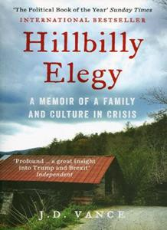
February 7, 2022
April 11, 2022
June 13, 2022
August 8, 2022

Most of these books are recommended by Presbyterian Women. There will be two times to join the Zoom sessions, 12:30 – 2:30 pm and 6:30 – 8:30 pm (Central Time). You must be registered to receive the study questions and to join the call due to Zoom protocol. Contact Kathleen Keefer at: kathleenkeefer20@gmail.com You do not need to commit to participate in future book discussions as you will register for each one separately. The “CLUB” is open to all regardless of gender.

