
How to get your IDI results as well as an Individual Development Plan (IDP)

- Go to https://calendly.com/debbie-at-culturecrux
- Choose this option:
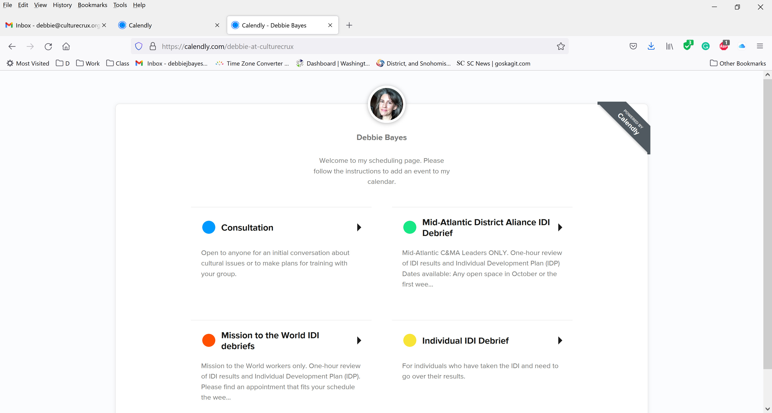
- Select any available time and date in October or first week of November.
- Make payment. The special discounted fee for a one-hour individual IDI debrief and Individual Development Plan is $100 per person. The normal fee is $150 per person. This discount is only good if you make an appointment between now and the end of the first week of November.
- You will receive a zoom link after you make your appointment.
- Please contact me with any questions or difficulties in making your appointment debbie@culturecrux.org or (425) 239-8685.

I look forward to meeting you and working together on this next step of developing your intercultural abilities!

