PRIORITIES

Student Achievement | Reading at grade level by the end of third grade, Math Proficiency by seventh grade, skillful use of technology, Social Studies and Civics Education are focal areas of our curriculum, instruction and assessment efforts.
Funding | Inflation for supplies and recruitment and retention issues put a tremendous strain on General Fund budgets. One time only (OTO) funding helped postpone the reality that schools are underfunded.
School Safety | There are many safety measures that must be taken in order to protect our most valuable resource, our students. (For example; Infrastructural improvements to school building entrances to limit access, training for staff, School Resource Officers, Threat assessment protocols by qualified individuals, costly alternatives for educating students who pose a high level of risk to others, communications and notification systems, etc.
Career /Technical  Education &  Transformational  Learning | Students who are CTE concentrators have a graduation rate of 94%. This program is vital to an economy that needs workers with basic skills. Great Falls Public Schools provides students, parents and staff with the full advantage of flexibilities provided through Transformational Learning, Advanced Opportunities and Personalized Learning plans.
Early Childhood  Education | Montana is one of only eight states that doesn’t fund Early Childhood Education. Reading at grade level by third grade is a universally accepted metric for student success. However, not all students have the same foundation coming into kindergarten and find themselves behind before they begin.
Student Wellness | 2021 Montana Youth Risk Behavior Survey indicates;  - 41.4% of grades 9-12 students reported feeling sad of hopeless for more than 2 weeks  - 10.2% of grades 9-12 students made a suicide attempt  - 17.6% American Indian students attempted suicide one or more times  - 21.7% of grades 9-12 students seriously considered suicide  - Great Falls Public Schools report 504 homeless students in 2021  Schools and communities desperately need high quality professional services to deal with the rising mental health and wellness needs of our youth.
Recruitment and  Retention | Staffing at all levels is in a near crisis level. Many teachers are retiring and there is high demand throughout the State and nation in attracting new employees.  Great Falls Public Schools Hired 86 new teachers in 2022

RESOURCE DOCUMENT LINKS

GFPS Budget Book

https://www.gfps.k12.mt.us/Page/220

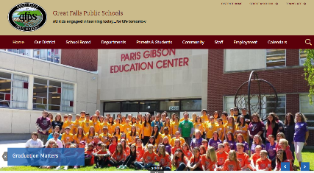

Safety District Website
https://www.gfps.k12.mt.us/Domain/194

District Website

https://www.gfps.k12.mt.us/

CONTACT INFORMATION

Topical Expertise
Name
E-mail
Phone

Superintendent | Tom Moore | tom_moore@gfps.k12.mt.us | (406) 268-6096 | Legislative input
Business Manager | Brian Patrick | brian_patrick@gfps.k12.mt.us | (406) 268-6050 | Financial implication
Executive Director  of Student Achievement | Heather Hoyer | heather_hoyer@gfps.k12.mt.us | (406) 268-7432 | Education issues
Executive Director  of Student Achievement | Lance Boyd | lance_boyd@gfps.k12.mt.us | (406) 268-6777 | Education issues
Executive Director  of Student Achievement | Jackie Mainwaring | jackie_mainwaring@gfps.k12.mt.us | (406) 268-7444 | Education issues
Director of Information Technology | Tom Hering | tom_hering@gfps.k12.mt.us | (406) 268-6068 | Technology

