Meet our STRIDE Tennis Program Leader, Dave Graham Jr.
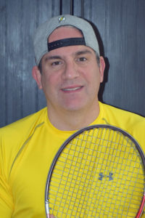
Dave has played tennis most of his life and competed at High School and College level. He got involved with the STRIDE Tennis Program in 2010, looking for sports activities for his son Luke, who has Autism. He then became the STRIDE Tennis Director. He is fortunate to have fantastic volunteer assistants, such as his father (David Sr.), wife (Michele), daughter (Rory), and a number of high school students, which help make the program run seamlessly. The goal is to teach the athletes tennis skills, have an opportunity for social interaction, and create a place to have FUN!
In his spare time Dave enjoys playing sports, performing music with his bands, LEGENDARY LOSERS (who have played at some STRIDE events) and WATCH REGGIE RUN (a band he started with his son Luke), and watching his daughter, Rory, compete in Cross Country and Track & Field. See you on the courts!

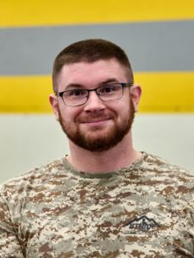
Meet Our STRIDE Camp Director: Stefon Stilwell
When I was younger, I went to Double H Ranch which had a profound impact on me. As a child growing up with Spina Bifida, I spent 9 summers at Double H Ranch, and it was one of the highlights of my childhood. I got involved with STRIDE back in 2010 when I found out about the Sled Hockey program. In 2014, I found out about the Camping Program when I attended the STRIDES 4 STRIDE 5K for my first time. I signed up shortly thereafter to volunteer for the camp and quickly felt the rewarding and fulfilling experience of volunteering at SCORE. I have been able to see my camp kiddos grow into great young adults. I have also been able to volunteer with a fantastic group of people and become more and more involved with STRIDE. It has allowed me to provide the experiences I had as a child to other children, which gives me great joy and contentment. I have been the camp director of the STRIDE camping program since 2015, and it is something I talk about passionately and often to anyone who will listen. My main goal every summer is to help my campers become more independent and try new experiences!

Meet our STRIDE Swim Leaders:
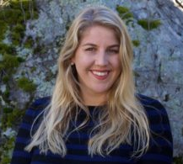
Aquatic Coordinator:Emelia Carlino
Emelia Carlino received her Masters of Public Health from the University at Albany and currently works as a Well-Being Account Manager at MVP Healthcare. She joins STRIDE with 15 years of competitive swimming experience that led to her Division 1 collegiate swimming career at Binghamton University. Emelia is Water Safety Instructor certified and has been teaching special needs children and adults for close to a decade. Originally from Dutchess County, she served as the head swim instructor for three years at Hudson Valley Swim. She values water safety skills above all and is passionate about sharing her comfort in the water with others while having fun doing so. STRIDE perfectly aligns with her belief that with proper guidance, swimming can be adaptable and enjoyable for all skill levels.
Assistant Program Leaders:
Marleah Lybolt
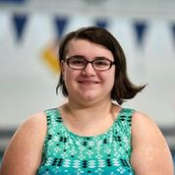
Marleah is an Occupational Therapy Assistant student at Maria College; her long term career plan is to become a special education teacher. She has been volunteering for different STRIDE programs since 2013, and is now an assistant coach of the swimming program. Her experience with STRIDE began when she was struggling to manage her own disability. For Marleah, swimming was a perfect fit because she loved the program and quickly developed strategies to manage her own disability and help others in the process. Her goal is not only to teach the kids swimming skills, but to make sure they know that they are capable of so many things. That knowledge is just as important to a person with special needs.
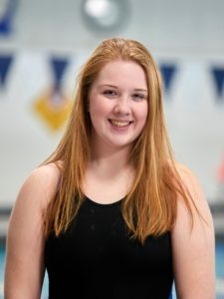
Tess Mulvey
Tess graduated from Columbia High School in 2017 and now attends The College of Saint Rose, majoring in Childhood and Special Education. She has lived in East Greenbush, NY her whole life with her mother, father, and brother. She has been volunteering with STRIDE for two years through the swim program. She spends most of her free time reading books or watching Netflix in the winter. In the summer, she is usually reading or swimming in her pool. She loves to spend her Sundays mornings in the pool with all the STRIDE swimmers.
Meet our East Greenbush Bowling Program Leader: Gina Howard
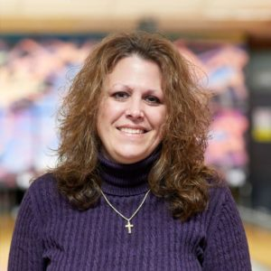
Although I am not an avid bowler, I have a passion for working with children. As an elementary teacher, I have worked with many children over the course of my career. My time spent volunteering for STRIDE has been most memorable and touching. I was first introduced to the STRIDE program when I met my husband Brian and my step-son Alex over 14 years ago. They were both involved with STRIDE through various programs and I immediately joined them. Over the years, Alex has participated in bowling and other sports such as golf, swimming, and even the bicycle camp.
When the number of bowlers became too large to accommodate in Latham; I offered to take a leadership role in volunteering to head the bowling program in East Greenbush. My commitment originally began for Alex but quickly became just as gratifying for myself and my husband as we have met such wonderful families facing the same daily challenges. It’s amazing to see the children grow and develop throughout the years and STRIDE is such a huge part of that for so many individuals. We look forward to seeing you on the lanes!

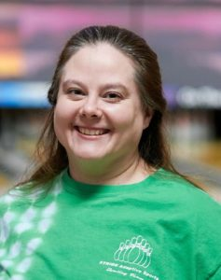
Meet our Latham Bowling Program Leader: Diane Grugan
Bowling was the sport for my family, as we used to joke that it was in our genes. I competed for my high school and was on the traveling team for Clifton Park Bowl. I have been involved with STRIDE as a parent for over 15 years, when Christian first joined STRIDE. I became the director of the Latham Bowling in 2012; in 2016 I became certified with Special Olympics as the head coach of our bowling team. It is very rewarding to work with athletes seeing them grow alongside each year and have so much fun. They particularly enjoy our Rock’N Bowl Pizza Party we have at the end of each session.
In my spare time I enjoy playing hockey, crafting, and pampering women as an Independent Beauty Consultant with Mary Kay. I’m also a LAX mom and enjoy watching my younger son Anthony play.

Meet our Yoga Instructor: Kristine Sigler
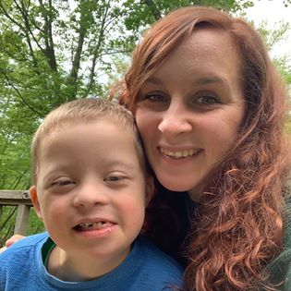
Kristine has been instructing yoga with STRIDE for the past 3 years. She is well versed in providing a variety of types of practices to suit the needs of all our athletes. She has taught children's yoga along with chair yoga and specialty classes for our Wounded Warriors. She has a unique perspective, when it comes to teaching because her son is an athlete in our programs.

