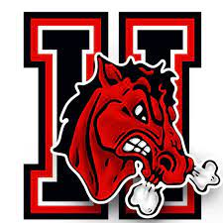
HARDING 25-26 WRESTLING SCHEDULE

Nov. 17 Battle of Belt @SHS
Dec. 6 @Buckeye Local
Dec. 13 @ Martins Ferry
Dec. 20 @ Carrolton Duals
Dec 29 @ Cambridge
Jan. 3 @ Indian Creek
Jan. 23/24 @ Union Local
Feb. 15 Districts @Buckeye Local
Mar. 21 OAC STATES @ Covelli Center Youngstown

