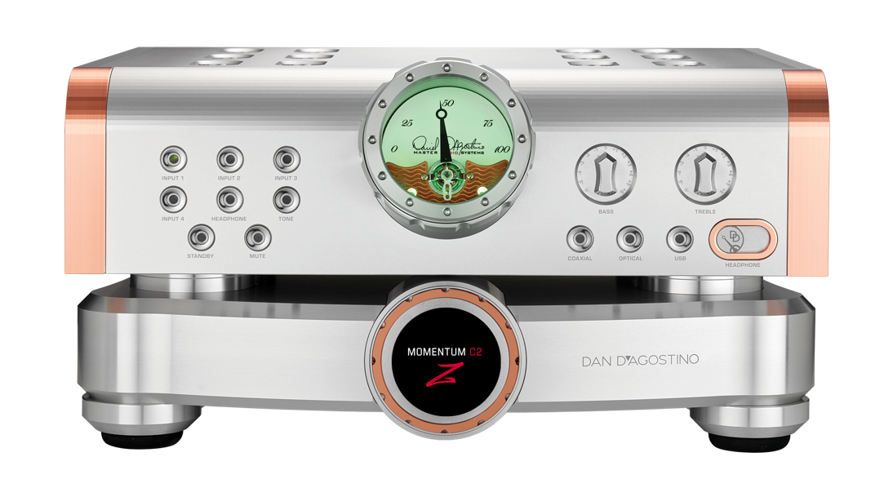

Dan D’Agostino Master Audio Systems announces the Momentum C2Z Preamplifier

Chicago, Illinois — April 10, 2026 — Dan D’Agostino Master Audio Systems, industry leader in high-performance audio electronics, is pleased to announce the addition of the new Momentum C2Z Preamplifier to the Momentum Series.

FOR IMMEDIATE RELEASE

The new Momentum C2Z Preamplifier expands the Momentum Series with a model specifically designed to enhance overall system performance when paired with the Momentum Z Monoblock Power Amplifier. Engineered to fully realize the capabilities of the latest Z circuitry introduced in the Momentum Z amplifier, the C2Z builds on an already exceptional preamplifier platform. Rather than replacing the Momentum C2, it serves as the optimal companion for the Momentum Z Monoblocks. Its upgraded circuitry refines the electrical interface between preamplifier and power amplifier, unlocking a higher level of system synergy, control, and musical realism.

“With the C2Z upgrade, we set out to do more than refine an already exceptional platform—we wanted to fully exploit the performance of the Momentum Z Monoblock circuitry. We have created a more direct and optimized connection between preamplifier and amplifier.” —Dan D’Agostino, Founder

At the core of the development is a reimagined output stage for the Momentum preamplifier. The introduction of a current-capable field-effect transistor (FET) architecture enables significantly greater current delivery and enhanced stability. This advancement allows the preamplifier to drive the Momentum Z amplifier’s optimized input stage with greater authority, ensuring that the full capabilities of the Z circuitry are realized across the system.

The heart of the Momentum C2Z circuitry is the FET integration into the preamplifier’s output stage, enabling it to deliver substantially higher current to the amplifier. This pairing creates a highly optimized interface: a preamplifier capable of delivering current with precision, and an amplifier designed to receive and utilize it effectively.

FETs are widely recognized for their suitability in high-performance audio applications. Their inherently high input impedance minimizes loading on source components, preserving signal integrity, tonal balance, and dynamic nuance. Additionally, their low noise characteristics and excellent linearity make them ideal for handling delicate signal levels at the front end of amplification stages. Unlike bipolar devices, FETs operate as voltage-controlled components, requiring minimal input current and delivering smooth, highly linear transfer characteristics—contributing to lower distortion and a more stable interface between components.

In the Momentum Z amplifier, the Z circuitry takes a novel approach by intentionally lowering the traditionally high input impedance associated with FET designs. This allows the amplifier to draw more current from the Momentum C2Z Preamplifier, strengthening the electrical coupling between components. The result is improved transient response, enhanced dynamic contrast, and a more precise rendering of musical detail.

One of the most notable sonic benefits of this architecture is a significant improvement in low-frequency performance. Bass reproduction gains greater texture, control, and dimensionality—particularly at lower listening levels, where subtle detail is often diminished. With the complete Z circuitry signal path, low-frequency articulation remains precise and controlled, revealing subtle tonal nuance even at low listening levels.

Together, the Momentum C2Z preamplifier and Momentum Z mono amplifier form a unified system that achieves new benchmarks in dynamic authority, low-level resolution, and overall musical ease.

About the Company
Since its introduction fifteen years ago, the Momentum series of components has been esteemed by industry professionals, reviewers and customers as among the finest audio electronics in the world. The first amplifier charted the course of a Momentum legacy that today has expanded to include the Relentless, Progression and Pendulum series, with new products continuously in development. Each of these, like the Momentum C2Z Preamplifier, is infused with unique DNA that sets every Dan D’Agostino Master Audio Systems design apart.

For more information on Dan D’Agostino Master Audio Systems and our innovative
luxury audio products, please explore more at: dandagostino.com

MEDIA CONTACT:
Bill McKiegan
(203) 623-4922
bill@dandagostino.com

PRESS IMAGES:
Momentum C2Z Preamplifier
Credit: ©2026 Dan D’Agostino Master Audio Systems
https://dandagostino.com/resources/images

