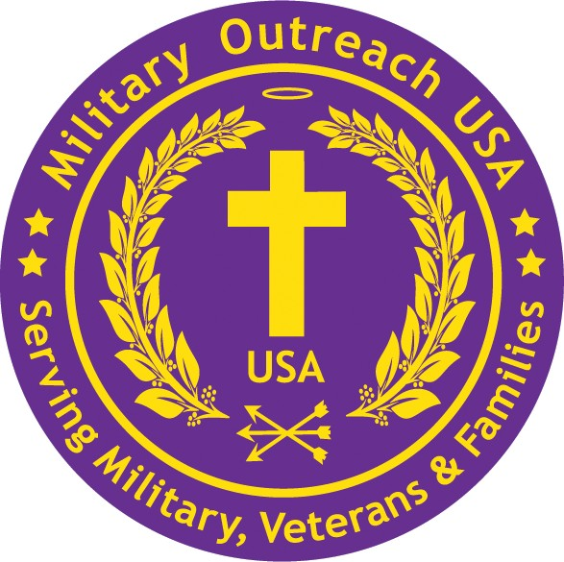
Suicide & Solutions Workshop 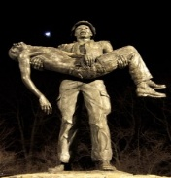

3020 Milwaukee Avenue • Northbrook, IL 60062 • 877-734-4244 www.MilitaryOutreachUSA.org

Lake Zurich American Legion Post 964
December 6th @ 8:30am to noon

Mission. Invite any and all that will benefit from HOPE (Healing, Opportunity, Planning, and Empowerment). Our 1:1 solutions is focused on reducing veteran suicides, 22+ per day, across our Veteran community and the growing number to our First Responders. Speakers include:

James H. Mukoyama Allen J. Lynch Philip Chappy Ferrer
Major General (retired) 12th Calvary Regiment SGT 82nd Abn Division
Chicago born, served in 1st Calvary Division 1/505 Infantry/signal
DMZ Korea, Vietnam Medal of Honor Iraqi Veteran
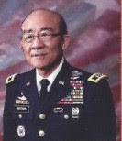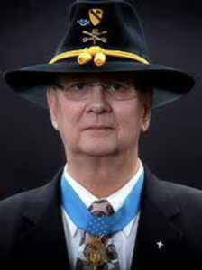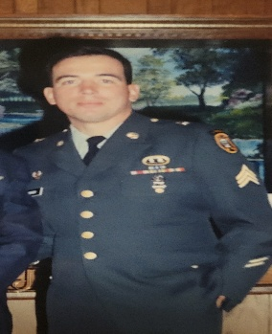
See videos: MilitaryOutreachUSA.org ajlynchfoundation.org/about-us/ militaryoutreachusa.org/
about-allen-j-lynch/ stand-by-me-heroes/

We invite civilians, First Responders, Veterans, professionals. Issues encompass Moral Injury, Post-Traumatic Stress, Traumatic Brain Injury, Military Sexual Trauma and invisible wounds. Our focus is Mind-Body & Soul. Please confirm attendance, include others who may join with an email to Sue.Brown@militaryoutreachusa.org

Healing. To move forward first we confront ourselves, forgive then prepare to move forward with a Foxhole Soul Counselor, a mentor.

Opportunity. Challenges from our past and present will come. We answer the call to ‘Stand-by-me’ turning lessons learned and best practices into awaiting opportunities.

Planning. Fail to plan and we have already failed. Foxhole Soul Counselors help with planning, accountability and next steps climbing mountains as a team.

Empowerment. As a small team we guard your six, provide mentors to gain strength. We may struggle but a small experienced team ensures success.

Donate. Go to Militaryoutreachusa.org/donate/stand-by-me-heroes.

