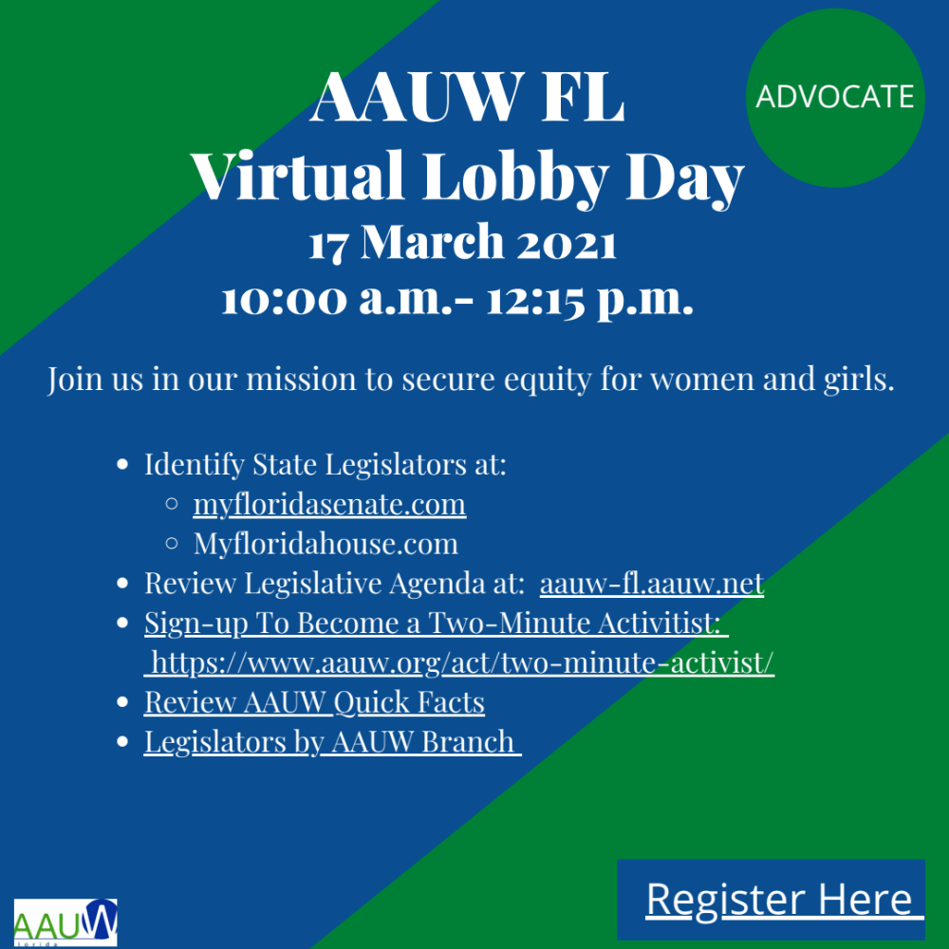

ARE YOU READY TO LOBBY!
The Public Policy Committee (PPC) has been hard at work creating an informative virtual Lobby Day 2021 event. We are excited and hope you have registered and scheduled appointments with your state legislators. Please note the event time change, 10:00 a.m-12:15 p.m., to accommodate our legislators’ schedules. We will have a full agenda and hope you will be able to accommodate the schedule change.

The PPC has created talking points for your use when emailing and/or speaking with legislators. They are attached here, along with AAUW-FL’s 2021 Priority Legislation and the virtual lobby day schedule. Please prepare:

- Review Talking Points
- Identify your Legislators and contact their office to arrange meetings, call and/or email.
- Identify your County Legislative Delegation by AAUW Branch
- Sign up to be a Two Minute Activist
- Review AAUW Quick Facts
- Respond to the AAUW-FL Action Alert when received from National

Please join the PPC and support Virtual Lobby Day 2021!

