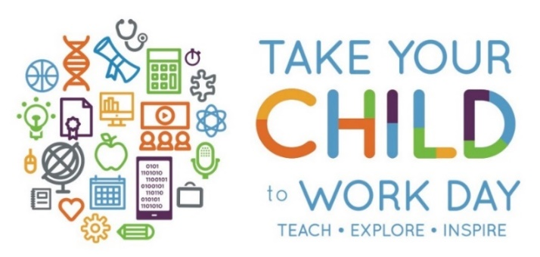

Thursday, April 26, 2018
Cerner is a health care technology company that connects people, information and systems at more than 27,000 health care provider facilities worldwide. Cerner proudly participates in the Annual Take Your Child to Work Day program, where the mission is to Teach, Explore, and Inspire youth about the ways technology can shape their world.
Cerner is looking for an organization to demonstrate a hands-on STEM related activity to showcase to associate’s children during Take Your Child to Work Day. Please see below for more information on the event and the STEM activity.

Event Details:

When: April 26, 2018 | 8:30 a.m. – 2:30 p.m.
Where: 51 Valley Stream Parkway, Malvern, PA 19355
Audience: 75 parents and 100 children in 1st-12th grade (most children are between 1st and 5th grade).
Activity Requirements: The STEM activity should meet the following requirements:
- Have a science, technology, engineering, or math lesson included in the activity.
- Be hands-on and engaging for children aged 1st-12th grade. Expect ~25 children in each session.
- Take approximately 45 – 60 minutes to complete and be replicated 3-4 times throughout the day.

What Cerner can offer: Cerner will gladly include your organization’s information in our activity book, which gets handed to all parent and children attendees. You may also hand out business cards to parents and promote your organization during your activity. Cerner also works closely with local schools and businesses to promote STEM education and we can keep your organization in mind for those partnerships.

Tentative Agenda: 9:00 a.m. | Executive Welcome
9:30 -10:30 a.m. | Morning Activities Session 1
10:30 -11:30 a.m. | Morning Activities Session 2
11:30-12:30 p.m. | Lunch
12:30 – 1:30 p.m. | Afternoon Activities Session 1
1:30 – 2:30 p.m. | Afternoon Activities Session 2

For more information: Please reach out to Dana Horne at dana.horne@cerner.com or at 610-310-4368.

