Irresistible Blooms Bundle
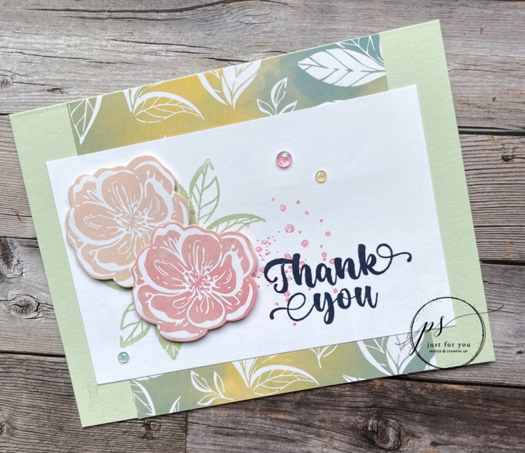
All images © 1990-2022 Stampin’ Up!®

Supplies:

Stamp Sets: Irresistible Blooms (161140)
Card Stock and Designer Series Paper (DSP) – Soft Sea Foam (149988); Basic White (159276); Hello, Irresistible 6” x 6” Designer Series Paper (161139)
Stamp Pads – Soft Sea Foam (147102); Night of Navy (147110); Flirty Flamingo (147052)
Tools – Stampin’ Cut & Emboss Machine (149653)
Other: Irresistible Blooms Dies (161149); Loose Frosted Dots (161153); Stampin’ Dimensionals (104430)

Measurements:

- Soft Sea Foam: 5 ½” x 8 ½” scored at 4 ¼”
- Basic White: 3” x 4 ¾”
- Designer Series Paper: 4” x 1” (2 pieces)
- Designer Series Paper: 2 flower images
Instructions:

- Fold the Soft Sea Foam cardstock on score line to create card base.
- Glue the two strips of DSP to the card front – top and bottom
- Stamp the leaves in Soft Sea Foam on the left side of the Basic White.
- Stamp some of the blotches in Flirty Flaming to the right of the leaves.
- Stamp the sentiment in Night of Navy on lower right corner.
- Cut out two flower images from the DSP using the coordinating dies.
- Pop up the flowers with Stampin’ Dimensionals on top of the leaves.
- Glue the stamp piece to the middle of the card based in between the DSP strips.
- Add some Loose Frosted Dots to finish the card.

