CHCS Weekly Menu for July 1st-5th

Monday | Tuesday | Wednesday
- Pork tenderloin  - Philly steak sandwich  - Roasted sweet potatoes  - Green beans  - Tomato salad  - Dessert bar | - Battered Cod  - Grilled ham and cheese  - Southwest potatoes  - Steamed capri veggies  - Apple salad  - Fresh fruit | - Fried chicken  - Roast beef & Swiss sand  - Mashed potatoes/gravy  - Corn  - Kansas dirt cake
736 × 717
Thursday | Friday
- BBQ ribs  - Buttermilk Shrimp  - Sweet potato fries  - Baked potato  - Peas  - Fresh fruit | - Spaghetti  - Hot turkey & Swiss sandwich  - Lettuce salad  - Garlic bread  - Dessert bar

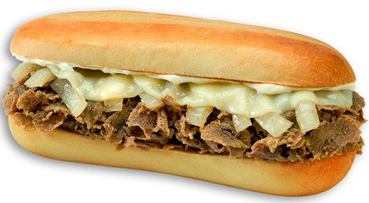

840 × 11821200 × 1172* There may be leftovers in addition to what the menu states *Grab & go fridge open 5am-5pm daily * Salad bar Monday-Friday

