***CHCS Breakfast Menu for May 13th-17th***

|  |  |  |
| --- | --- | --- |
| **Monday** | **Tuesday** | **Wednesday** |
| * Oatmeal * Cold cereal * Scrambled eggs * Sausage * Hash browns * Toast * Bagel * Greek or light yogurt | * Malt O Meal * Cold cereal * Scrambled eggs * Egg casserole * Toast * Bagel * Greek or light yogurt | * Oatmeal * Cold cereal * Scrambled eggs * Turkey sausage * Breakfast burrito * Toast * Bagel * Greek or light yogurt |

[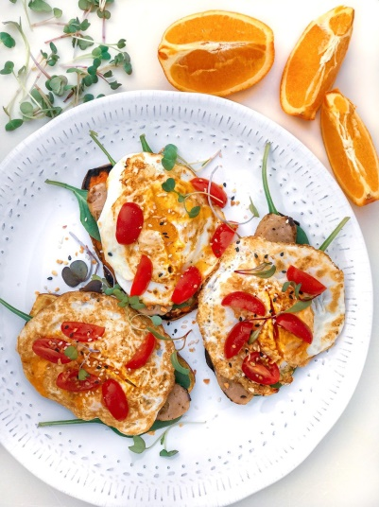](https://www.google.com/url?sa=i&rct=j&q=&esrc=s&source=images&cd=&cad=rja&uact=8&ved=2ahUKEwifz-6wwL_lAhUDnZ4KHek5C6QQjRx6BAgBEAQ&url=https://www.pinterest.com/pin/151926187416176338/&psig=AOvVaw3lzEKy9lCK3yKNI6-ZnAyV&ust=1572370432234887)

|  |  |
| --- | --- |
| **Thursday** | **Friday** |
| * Cream of wheat * Cold cereal * Scrambled eggs * Ham/egg/cheese slider * Toast * Greek or light yogurt | * Oatmeal * Cold cereal * Scrambled egg * Biscuits and gravy * Toast * Bagel * Greek or light yogurt |

* We always have milk. We usually have hard boiled eggs or fruit.