CHCS Breakfast Menu for July 1st-5th

Monday | Tuesday | Wednesday
- Raisin oatmeal  - Cold cereal  - Scrambled eggs  - Turkey sausage  - Raisin toast  - Bagel  - Greek or light yogurt | - Cream of wheat  - Cold cereal  - Scrambled eggs  - Egg & potato casserole  - Toast  - Bagel  - Greek or light yogurt | - Malt O Meal  - Cold cereal  - Scrambled eggs  - Egg, ham, cheese slider  - Toast  - Bagel  - Greek or light yogurt

Thursday | 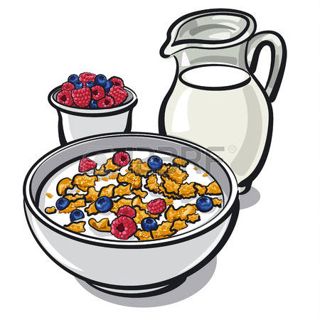  Friday
- Oatmeal  - Cold cereal  - Scrambled eggs  - Breakfast pizza  - Toast  - Bagels  - Greek or light yogurt | - Cream of Wheat  - Cold cereal  - Scrambled egg  - Biscuits and gravy  - Toast  - Bagel  - Greek or light yogurt

* We always have milk. We usually have hard boiled eggs or fruit. * There may be items available that aren’t always listed.

