The first one is below.


USING KEY NUMBERS TO FIND RELEVANT CASES
What is a Key Number? West attorney editors have read, summarized and classified case law by topic and subtopics that represent specific points of law. Each specific point of law is assigned a unique number, called a Key Number. Access the Key Number link from the Westlaw homepage.

From here, you can find a Key Number by browsing through over 400 main Topics or you can use the search option to retrieve links to the most relevant points of law represented by your search terms.

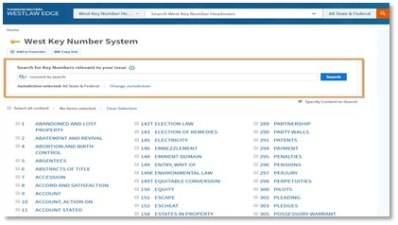

You will get a list of Key Numbers that may be relevant to your issue. Select your desired Key Number(s).

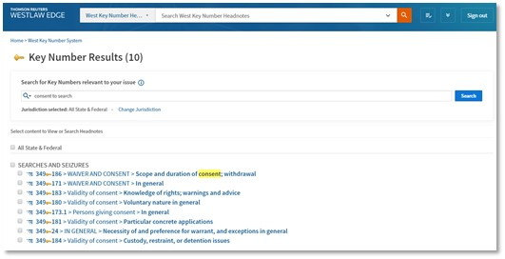

When you click a Key Number link, you will retrieve the case headnotes classified to that particular Key Number.

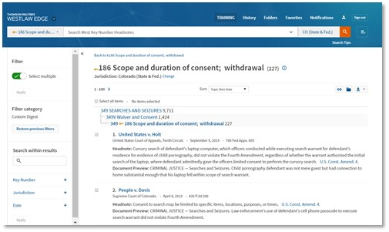
Using the Key Number system can be an efficient method to find relevant cases without having to craft a query. You can rely on the indexing expertise of the Westlaw attorney editors to quickly find cases with a specific issue.

