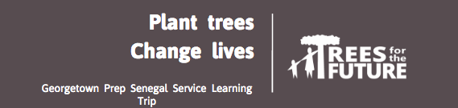

Senegal Immersion 2018
- August 1-12, 2018
- 8-10 students
- No language requirement, however priority will be given to French students.
- Approximate cost: $2,800.00
- The trip is during the planting season so students will help plant thousands of trees
- Direct flight from Dulles Airport to Dakar
- The trip starts with a crash course in Wolof language
- We will avoid city centers and tourism centers
- Spend time in villages with your homestay family
- Meet Trees for the Future personnel and Peace Corps Volunteers assigned in the area.

Observe through shadowing
Students will be assigned to a family and get hands-on experience helping their families with work in the field and at home.

Uncover truth through inquiry
Students will learn to use participatory exercises such as community mapping, daily and seasonal calendars, and needs assessments to better support the local community.

Jesuit Values
This Senegal learning experience will be rooted in values shared with the Jesuit Volunteer Corps.
Students will:
- Reflect on Ignatian Spirituality
- Understand a new sense of Community
- Embody Simple Living and learn a new understanding of needs vs wants.
- Make a plan to achieve Social Justice

Define a vision for the future
Students reflect and determine how they can use their strengths and skills to contribute to a common purpose as they develop a global consciousness.

Implement a plan for change
Students practice and learn professional skills, such as effective communication strategies and project management skills, to make their intended change.
CONTACT: Bradley Boyle bboyle @gprep.org Christel Petermann cpetermann@gprep.org, Marcos Poole mpoole@gprep.org

I have never felt more connected to the mission of Georgetown Prep than during my service trip to Senegal. The philosophy underpinning the work of Trees for the Future in Senegal is very much compatible with the fundamental goals of our Jesuit mission and Pope Francis’ Encyclicals: care and compassion for the poor, care for the environment, and care for refugees. These issues are directly addressed by helping local farmers develop sustainable “living gardens,” which in turn increases income dramatically, revitalizes the land, and reduces the need for immigration.

The great paradox of service is that those providing the service receive more than they give. The men and women in the small Senegalese village of Ngodiba showed me how did live closer to God and family, and helped me to develop an even greater passion for my role as a Jesuit educator.

Peace,

Marcos Poole

And the boys learned a few new dance moves…

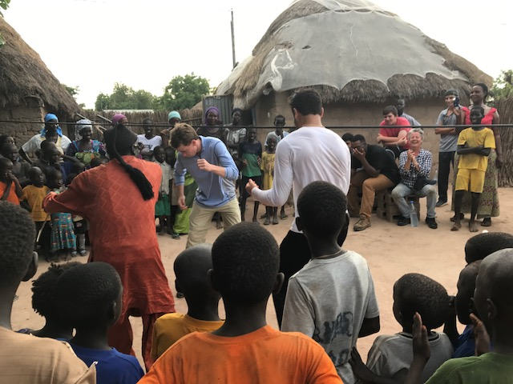

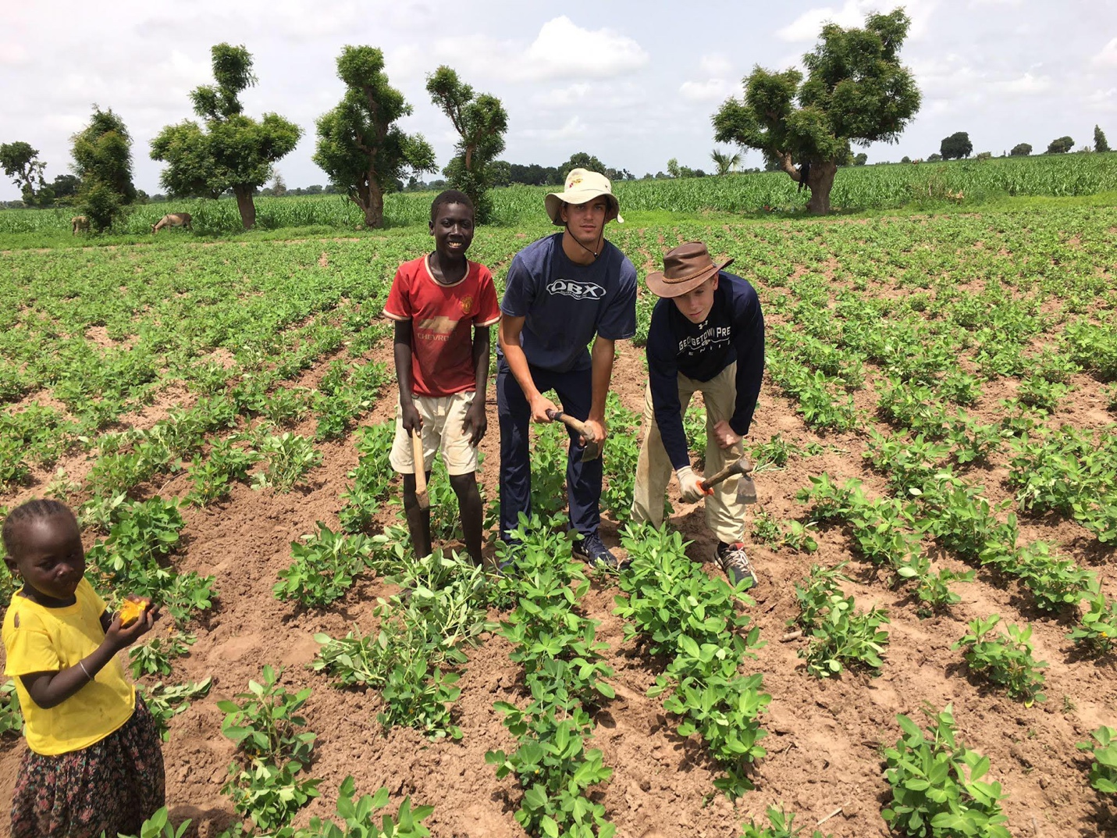

What impressed me most about the Senegal Immersion Trip was not the work we were doing or the conditions we were living in, but the people with whom we we were living and interacting. The people of Senegal are some of the happiest and welcoming I have ever met. The way they opened their homes up for us to stay with them, and the sense of community that exists in Senegal is astounding, I think, to any Westerner. Never have I seen such solidarity. Of course, the work we were doing with Trees for the Future was excellent. It will inspire decisions I will make going forward.
Austin W.
My Senegal Immersion Trip was an unforgettable, incredible and truly humbling experience. At first, being introduced to a new and unfamiliar culture was uncomfortable. But as time went on, I learned to appreciate my time there to the fullest. The people I met, the things I experienced and did along with my classmates and teachers will be things I never forget. I hope to soon travel back to Senegal and revisit the people and places that made this trip so memorable, made it a trip of a lifetime.

Gabe A.

Link to Videos

https://drive.google.com/file/d/1oa1N7qRQauYDOcILXYw4MmOdCCtNfNa0/view?ts=5a553c00
https://youtu.be/pxAq8HlP8mE

