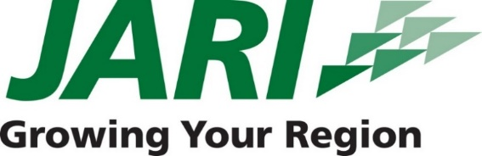
CONTACT
Christina Schrengost
(814) 410-3640

Michele Clapper
VP, Economic Development
mclapper@jari.com
(814) 262-8368

FOR IMMEDIATE RELEASE
February 15, 2019

FLOOD CITY FLOORING LLC RIBBON CUTTING CEREMONY
Justin and Christina Schrengost will host the Ribbon Cutting Ceremony of Flood City Flooring LLC.

JOHNSTOWN, PA – Friday, March 8, at 2:00 PM, Flood City Flooring LLC will host a Ribbon Cutting Ceremony for their grand opening at 225 Washington Street, Johnstown, PA. Please plan to join us in celebrating this new business!

Justin and Christina Schrengost are the owners and operators of Flood City Flooring LLC. Justin has worked for almost 20 years in the flooring industry. “Christina and I are very excited to have our own new business! It would not have been possible without the help of JARI, the City of Johnstown and the support of friends and family”, says Justin. Linda Thomson, President, JARI, states “JARI is pleased to welcome another home-grown small business into our local economy. Flood City Flooring will be a great addition to the downtown business community.”

Flood City Flooring LLC now has their showroom open to the public downtown. Justin has the skills and knowledge needed to be a top installer and flooring business expert in the industry. He and Christina are proud to create local jobs to help the community prosper and provide customers with excellent service at an affordable price.

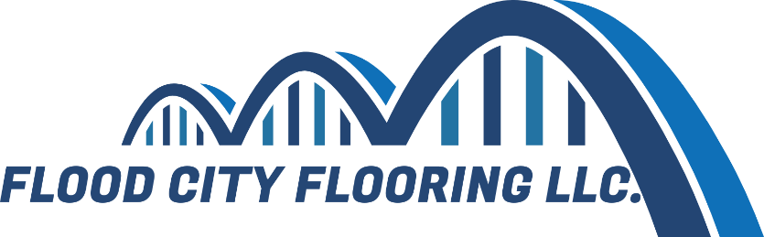

ABOUT JARI
JARI is a non-profit economic development organization that has been a devoted partner of the business community in Cambria and Somerset Counties since 1974. JARI’s team of business professionals has a combined 155 years of experience in economic and entrepreneurial development. Our agency provides value-added services and connections to the right people in government, commercial lending, equity investing, real estate and other regional, state and federal economic development groups.

###

