18th Annual

“Focus” on Vision Impairment &

Blindness Conference

Meeting the Needs of Individuals with Intellectual Disability & Vision Loss

October 6, 2026

8:00 am – 4:00 pm

Four Points by Sheraton, Norwood, MA

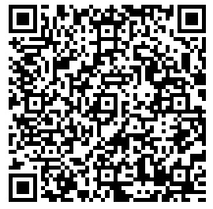
Keynote: Greg R. Waldorf, OD, MPH, FAAO
Associate Dean for Clinical Programs
MCPHS School of Optometry

“Becoming Vision Detectives: Spotting Eye Problems in Individuals with Developmental and Intellectual Disabilities”

Remarks at Lunch: John Oliveira, Commissioner,
Massachusetts Commission for the Blind

Awards at Lunch:

Mark Holt “Gift of Lunch”

Paul McDade “Focus” Award for Distinguished Service

Paul McDade “Focus” Award for Distinguished Leadership

“Focus” on Talent:

Closing Performance: Matteo Faso and Sai Pitman

Registration: Details on pages 14-15 and/or scan

QR code to register online. Thank you!

A Very Special Thank You

To Our Sponsors Including:

Lead Sponsors:
Department of Developmental Services
Massachusetts Commission for the Blind

Sponsors:
Perkins School for the Blind
DDS Southeast Region Training Council

Friends:
New England College of Optometry
Shriver Clinical Services

To Our Exhibitors Including:

American Printing House for the Blind (APH)
Audio Journal
Berkshire Talking Chronicles WRRS 104.3
Blue Chip Medical Products, Inc.
Brain Injury Association of Massachusetts (BIA-MA)
Campus School at Boston College
Careforth
The Carroll Center for the Blind
Community Autism Resources
DCR Universal Access Program
Easterseals Massachusetts

Lifestream Inc.
Mass EDP/State 911 Department
Massachusetts Commission for the Blind
MCB/DDS Partnership Project
Perkins Library
Perkins School for the Blind
SpecMed Technologies
Tovala
UCP of Western MA
Visiting Rehab and Nursing Services
Work without Limits

Poster Displays

Beyond the Eye: A Holistic Approach to Eyecare
Vickie Kuo and Jem Martin
New England College of Optometry

When Vision is Limited, Support Shouldn’t Be
Leah Arteaga and Ashleigh Miller
Massachusetts Behavioral Health Help Line (BHHL)

CVI Strategies At Work
Jessica Pugliesi and Paula Honzik
Campus School at Boston College

Relax in the Music: using music for relaxation
Lisa El-Lakis
DDS/Hogan Regional Center

Mapping It Out for Everyone
Elizabeth Filkins
Berkshire Talking Chronicle WRRS 104.3 LPFM,
UCP of Western Massachusetts

Become the Specialist the Field Needs:
Vision Studies Graduate Programs
Rachael Sessler Trinkowsky
University of Massachusetts Boston, Vision Studies Program

Developing Sensory Strategies for Students with Visual Impairments
and Multiple Disabilities
Sarah Maust, OT, MOT, OTR
Perkins School for the Blind, DeafBlind School

Simulating Common Visual Impairments to Promote Functional Safety Skills
Britney Bagley, PTA and Amanda Petry, OTR/L
NeuroRestorative Maine

Tactile Communication Board: Keeping the Communication Going
Sukhpreet K Rakieten, M.S.CCC-SLP/L
DDS, Wrentham Developmental Center

Introducing our Keynote:

Greg R. Waldorf
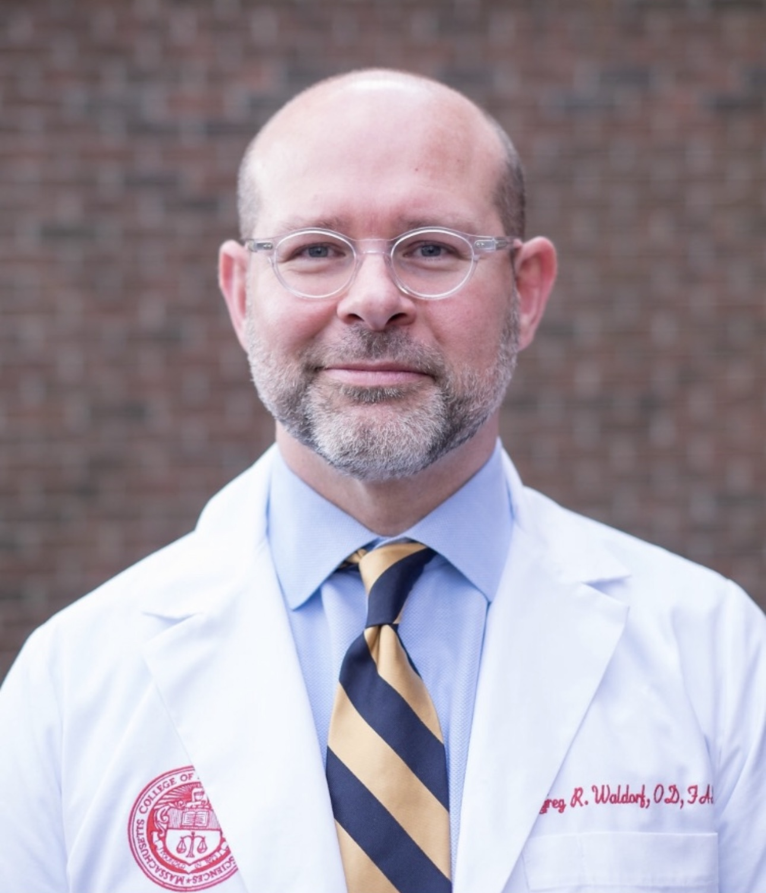
Dr. Greg Waldorf graduated from Northeastern State University, Oklahoma College of Optometry, in 1996, earning both his undergraduate and optometry degrees. He completed a residency in Pediatrics and Binocular Vision at the Illinois College of Optometry in 1997.

Dr. Waldorf practiced privately for 18 years before becoming a Fellow of the American Academy of Optometry. He joined the faculty at MCPHS School of Optometry in 2015. In 2019, he earned his Master of Public Health degree from MCPHS University and is currently pursuing a Master of Education in Health Programs at the Johns Hopkins University School of Education. His clinical specialties include pediatrics,
pediatric low vision, and the examination of special populations.

Dr. Waldorf’s keynote address: “Becoming Vision Detectives: Spotting Eye Problems in Individuals with Developmental and Intellectual Disabilities” will equip attendees with practical knowledge to identify signs of common vision conditions including myopia, hyperopia, astigmatism, presbyopia, cataracts, glaucoma, and macular degeneration. Learn to recognize behavioral, physical, and functional clues that may indicate vision changes or loss in the individuals you serve and discover strategies for connecting them with appropriate care.

He will also offer a concurrent session “‘Implicit Bias’ Toward Persons with Disabilities and Its Impact on Vision Care”. Using interactive activities like a paper-based Implicit Association Test, attendees will see how subconscious shortcuts can impact decisions. Participants will gain strategies to identify and reduce their own implicit biases and understand how these biases can affect the care of patients with disabilities.

Conference Agenda “At-a-Glance”

8:00 – 8:25 Registration / Vendors Open / Refreshments

8:30 – 8:45 Welcome Remarks

8:45 – 9:45 Keynote

9:45 – 10:00 Break / Exhibits Open

10:00 – 11:00 1st Concurrent Session

11:00 – 11:15 Break / Exhibits Open

11:15 – 12:15 2nd Concurrent Session

12:15 – 12:30 Exhibits Open

12:30 – 1:00 Remarks & Award Presentations:
          - Mark Holt Gift of Lunch
          - Paul McDade “Focus” Awards for Distinguished Service and Leadership
1:00 – 2:00 Lunch

2:00 - 2:30 Dedicated Time for Exhibits Session

2:30 – 3:30 3rd Concurrent Session

3:30 – 3:40 Break / Refreshments / Exhibits Open

3:40 – 4:00 “Focus” On Talent: Matteo Faso and Sai Pitman Raffle

Four Points by Sheraton Norwood

1125 Boston-Providence Turnpike

Route 1 (18 miles south of Boston)

Norwood, MA 02062

Phone: 781-769-7900
www.fourpointsnorwood.com

Please see page 16 for directions.

We look forward to seeing you on October 6, 2026!

“Focus” on Vision Impairment & Blindness

8:00 – 8:25 Registration / Exhibits Open / Refreshments

8:30 – 8:45 Welcome Remarks

8:45 – 9:45 Keynote:
“Becoming Vision Detectives: Spotting Eye Problems
in Individuals with Developmental and Intellectual Disabilities”
Vision problems occur at significantly higher rates among individuals with developmental and intellectual disabilities yet often remain undiagnosed for years. When patients cannot articulate what they see, or recognize their vision has changed, professionals and caregivers must become skilled observers. This keynote equips attendees with practical knowledge to identify signs of common vision conditions including myopia, hyperopia, astigmatism, presbyopia, cataracts, glaucoma, and macular degeneration. Learn to recognize behavioral, physical, and functional clues that may indicate vision changes or loss in the individuals you serve and discover strategies for connecting them with appropriate care.


9:45 – 10:00 Break / Exhibits Open

10:00 – 11:00 Concurrent Sessions

1A. “Implicit Bias” Toward Persons with Disabilities and Its Impact
on Vision Care
Presenter: Greg R. Waldorf, OD, MPH, FAAO

Description: This insightful lecture investigates the science of implicit bias and its influence on healthcare providers caring for patients with disabilities. It guides participants through how the brain forms unconscious associations, from simple illusions and mind tricks to stereotypes and implicit biases. Using interactive activities like a paper-based Implicit Association Test, attendees will see how subconscious shortcuts can impact decisions. The session reviews research on healthcare disparities, with studies showing treatment differences based on patients’ abilities, race, gender, and ethnicity. Participants will gain strategies to identify and reduce their own implicit biases and understand how these biases can affect the care of patients with disabilities.

10:00 – 11:00 Concurrent Sessions (continued)

1B. Best Practices for Planning Activities for Individuals With Intellectual And Visual Impairments
Presenters: Donna Mitchell, M.Ed., COMS
Nancy Sharon, TVI/COMS, Three Point Touch LLC

Description: Let’s talk about best practices for planning activities for individuals with intellectual and visual impairments!! We will discuss understanding the complex needs and rights of our learners, evidence-based strategies for teaching to the strengths of the individual and designing and implementing modifications and accommodations.

1C. Communication Without Limits: AAC in Deafblind Education
Presenter: Neha Sharma, MS CCC-SLP
Speech-Language Pathologist, Deafblind Specialist
Perkins School for the Blind

Description: This presentation explores the role of Augmentative and Alternative Communication (AAC) in supporting individuals who are deafblind across educational environments. Participants will examine a range of communication approaches, including tactile symbols, object communication, sign systems, partner-assisted strategies, and high- and low-tech AAC tools. Emphasis will be placed on individualized assessment, collaborative team practices, and creating meaningful, motivating communication opportunities throughout daily routines. Practical strategies and real-world examples will help participants better support communication access, engagement, and self-expression for learners who are deafblind.

10:00 – 11:00 Concurrent Sessions (continued)

1D. Find Your Own Beat
Presenters: Lisa El-Lakis, MT-BC/Music Therapist I
Amanda Goolsby, OTA/L, DDS/Hogan Regional Center
Description: Through the use of the Drums Alive program and drumming activities, individuals are encouraged to engage in self-expression, movement/exercise, group participation, peer/self-awareness and build a sense of community with the shared experience of drumming.

1E. New Products and Services (CEU’s are not offered for this session).
Different companies/agencies will discuss the services and products they provide that are helpful to individuals with visual impairment or blindness and those who support them, including:
- Perkins School for the Blind
- Berkshire Talking Chronicle WRRS 104.3 LPFM
- TBD
- TBD
PLEASE NOTE: CEU’s are not offered for this session.

11:00 – 11:15 Break / Exhibits Open

11:15 – 12:15 Concurrent Sessions

2A. Beyond Acuity: The Role of Vision Therapy in Functional Vision
Presenter: Katherine Green, OD, FAAO, FOVDR, FNAP
Associate Professor of Optometry
New England College of Optometry

Description: Vision is more than a measurement on the eye chart; it is a complex, learned process of efficiency and interpretation. This session provides a comprehensive look at common binocular vision disorders and their impact on daily activities. The role of vision therapy in managing visual symptoms will be explored, providing an understanding of the integration between functional vision and visual rehabilitation to transform activities of daily living.

2B. Body, Brain, and Vision: Cerebral/Cortical Visual Impairment, Sensory Processing, and Practical Tools to Support Self-Regulation
Presenters: Haley Oliver, OTD, OTR/L, Perkins School for the Blind
Kayla Matthews, M.S.,BCBA,CCVI, Perkins School for the Blind

Description: Cerebral/Cortical Visual Impairment (CVI) does not exist in isolation. As a brain-based visual impairment, it frequently intersects with complex sensory integration challenges that can impact a student's emotional regulation and access to learning. This session aims to bridge the gap between neurological understanding and practical classroom application. We will examine how visual processing loads influence nervous system responses and provide attendees with person-centered, practical tools. By focusing on interoceptive awareness and self-determination, we can empower students to not only better understand their CVI but to effectively communicate their internal states and sensory needs.

2C. Guiding with Confidence: Human Guide Skills and Vision Loss Awareness

Presenter: Allyson Bull Tordo, M.Ed., COMS, TVI
Director of Orientation and Mobility (O&M)
Massachusetts Commission for the Blind (MCB)

Description: This session is designed for anyone working with individuals with vision loss. It will cover appropriate human guide techniques, general blindness etiquette, reviewing different types of vision loss, and how to best utilize skills like voice guide.

11:15 – 12:15 Concurrent Sessions (continued)

2D. Beyond Treats: Fueling Independence in the Kitchen - Accessible Cooking Strategies for Adults with Vision Loss

Presenter: Tina Laffer MA., M.Ed, CVRT
Director of Community Engagement and Outreach
The Carroll Center for the Blind

Description: Cooking is more than a recreational activity; it is a pathway to sensory engagement, healthy living, and dignity. This session will explore practical ways to support adults with vision loss and intellectual/developmental disabilities in the kitchen through environmental setup, hygiene routines, tray-based organization, high-contrast materials, adaptive tools, switch-access options, and simple meal-building strategies. Participants will learn how thoughtful planning, descriptive communication, patience, and structured roles can make cooking accessible as either an individual or small-group activity.

2E. New Products and Services
Different companies/agencies will discuss the services and products they provide that are helpful to individuals with visual impairment or blindness and those who support them.
- Tovala.com
- Campus School of Boston College
- UCP of Western Massachusetts
- CareForth
PLEASE NOTE: CEU’s are not offered for this session.

11:15 – 12:15 Concurrent Sessions (continued)

2F. AI, Accessibility, and Real-World Outcomes: Emerging Technology in Vision Rehabilitation
Presenter: Alexander T. Pooler
Director of Assistive Technology & Consumer Database Systems
Massachusetts Commission for the Blind (MCB)

Description: This session explores how artificial intelligence and emerging mainstream technologies are beginning to shape vision rehabilitation and accessibility services. Through practical examples and live demonstrations, attendees will examine tools such as generative AI platforms, smart speakers, AI-powered visual interpretation tools, Meta smart glasses, OCR evolution, and mobile accessibility features. The presentation will focus on real-world applications, opportunities for increased independence, and the limitations and barriers that still exist for many consumers. Designed primarily for service providers, educators, and support professionals, this session encourages thoughtful and realistic discussion about how these technologies may support individuals with vision loss today and in the near future.

12:15 – 12:30 Exhibits Open

12:30 – 1:00 Remarks & Award Presentations:

● Remarks: John Oliveira, Commissioner
Massachusetts Commission for the Blind
● Mark Holt “Gift of Lunch”
● Paul McDade “Focus” Award for Distinguished Service
● Paul McDade “Focus” Award for Distinguished Leadership

1:00 - 2:00 Lunch

2:00 – 2:30 Dedicated Vendor & Poster Session!

Enjoy time after lunch for meeting our Exhibitors, viewing the Posters,
and networking with new friends and colleagues!

2:30 – 3:30 Concurrent Sessions

3A. How Can We Expand Access to Eye Care for People with
Neurodevelopmental Disorders?
Presenter: Danielle Ledoux, MD
Specialized Pediatric Eye Care

Description: Many people with neurodevelopmental disabilities struggle to find adequate access for their eye care needs. To improve access, our training and educational programs must teach the skills to eye care providers to competently examine and provide treatment for those with neurodevelopmental delay. This presentation will focus on some of the identified barriers and request help from the participants to determine unrecognized barriers and find solutions to overcome them.

3B. The Strength in Collaboration

Presenters: Mayanne MacDonald Briggs M.ED.
Transition Counselor
Massachusetts Commission for the Blind (MCB)

Rachel Dubuque
Assistant Director, Perkins Transition Services
Perkins School for the Blind

Michelle Algeri
Coordinator Supervisor, Children, ASD & Transition
Department of Developmental Services

Description: In this session presenters from MCB, Perkins School for the Blind and DDS will share collaboration strategies to improve transition outcomes for students with Blindness, Deaf-Blindness and additional disabilities. Each panel member will share best practices and strategies that we use to ensure student and family engagement in the transition process. From PCPs to leveraging the relationships we have built, from intake to eligibility will be covered

2:30 – 3:30 Concurrent Sessions (continued)

3C. The Benefits of Adaptive Yoga
Presenter: Michelle Charest
Orientation and Mobility Assistant
Wrentham Developmental Center/Shriver Clinical Services
Certified 200 HR and Certified Outreach Yoga Instructor
UMass Boston Student- Orientation and Mobility Program

Description: This presentation is meant to educate individuals on the benefits of adaptive yoga for individuals with developmental disabilities. This presentation will begin with an informational overview of yoga and an explanation of the philosophy of Shri’s outreach yoga specifically. Since Shri’s outreach program consists of multiple groups, we will focus on its adaptive yoga program and discuss its elements. After the information component, there will be a demonstration of a short class that will be interactive. The class can be completed in a chair
PLEASE NOTE: CECs are not offered for this session.

3D. Accessible Recreation Opportunities with DCR
Presenters: Teri Koopman, Outreach Specialist
Mariah Fontaine, Recreation Specialist
DCR Universal Access Program
Description: This presentation provides an overview of accessible recreation opportunities at the MA Department of Conservation and Recreation (DCR). Highlights include both supported programs (for all abilities) and independent opportunities. Additionally, you will learn about DCR’s Universal Access Program and see some of their adaptive equipment.

3E. New Products and Services
Different companies/agencies will discuss the services and products they provide that are helpful to individuals with visual impairment or blindness and those who support them.
- Community Autism Resources
- TBD
- TBD
- TBD

PLEASE NOTE: CEU’s are not offered for this session.
3:30 – 3:40 Break / Refreshments / Exhibits Open

3:40 – 4:00 "Focus" On Talent!!!

A special musical performance by Matteo Faso and Sai Pitman will put the finishing touch on the day!
RAFFLE Wonderful PRIZES!!! Must be present to WIN!
Registration Information

- Due Date: Please register BY September 22, 2026.

- Paying by Credit Card? Please Register Online: tinyurl.com/2tvws2zd

- Paying by Check or Purchase Order? Please complete the Registration Form on page 15 of this Brochure and return with payment to:
Sandra Faulkner / Vision and Vision Loss Services
Wrentham Developmental Center
PO Box 144
Wrentham, MA 02093
- Please make check payable to: Shriver Clinical Services Corporation

- Questions re Registration: Sandra.M.Faulkner@mass.gov or 508-384-5679.

- Refunds: We regret that refunds cannot be given after September 17, 2026 unless by notification from us to you that your check (# and amount) will be returned to you. This refund protocol will also be used if conference capacity is reached at the time we receive your registration and payment.

- Continuing Education Information:
Application for 4 hours of Continuing Education will be submitted to:
- ACVREP CE: Academy for Certification of Vision Rehabilitation & Education Professionals: 4 hours for COMS
- Questions: Samantha.Linden@mass.gov
- CEC: 4 CECs for Social Workers.
- Questions: Lisa.DiBonaventura@mass.gov
- MA Board of Registration in Nursing: 4 contact hours
- Questions: Dianne.Rodrigues@mass.gov
- MA CE / NECO: 4 hours of MA CE credits
- Questions: pontonec@neco.edu
- PDP / Perkins Training Center: 5 Professional Development Points
- Questions: Mary.Zatta@perkins.org
Please indicate your choice of CEUs on the registration form.

- Scholarships are available for individuals with intellectual disability and their families (priority given for the Southeast Region).
Information: Dianne.Rodrigues@mass.gov
- Reduced Room Rates of $175 per night, exclusive of taxes, will be available at the Four Points by Sheraton, Norwood, phone: 781-769-7900.
- Please mention Shriver Clinical.
- Rooms at this rate are held until September 4, 2026, and subject to availability.
- This Registration Brochure and Form can be downloaded from the "Training” section of: focusonvisionandvisionloss.org

- General Questions: Please contact Lisa.DiBonaventura@mass.gov
Paying by Credit Card? Please register online: tinyurl.com/2tvws2zd

Paying by Check or Purchase Order? Please use this form. Thank you!

Please Register Early! Registrations Due by September 22, 2026

“Focus” On Vision Impairment & Blindness Conference
October 6, 2026 - Four Points by Sheraton, Norwood, Massachusetts

Name: ____________________________________________________________

Agency Name: ______________________________________________________

Address: __________________________________________________________

_________________________________________________________________

Email: Phone:
________________________________________________________________
Can we share your contact information with sponsors? Yes No

Lunch Choice: If no choice is indicated, the Vegetarian lunch will be ordered.

    - Grilled Chicken Piccata* – Rice Pilaf, Asparagus, & Baby Carrots *Gluten Free & Dairy Free
    - Vegetable Napolean** – Mix Vegetable Stack with Mozzarella Cheese & Marinara Sauce
**Gluten Free & Vegetarian (please indicate if you prefer Vegan)

Special Accommodations Needed**:
** For Interpreting Services, please let us know by September 1, 2026.

Concurrent Session Selection: Select the letter of the 3 sessions you plan to attend.
10:00 - 11:00 | 11:15 - 12:15 | 2:00 - 3:00
A B C D E | A B C D E F | A B C D E

Please select the type(s) of Continuing Education (CE) you will be requesting:
ACVREP CEC Nursing CEU MA CE PDP

Conference Rate with Lunch:
General Admittance postmarked by 7/31/26: | General Admittance postmarked after 7/31/26:
$55.00 | $65.00

Total Payment Due:

Please indicate method of payment:
Check #: Purchase Order #: Cash:

- Please make check payable to: Shriver Clinical Services Corporation
Mail along with this form to: Sandra Faulkner / Vision and Vision Loss Services
Wrentham Developmental Center / PO Box 144, Wrentham, MA 02093
Thank you for your support!
Directions

Four Points by Sheraton Norwood

1125 Boston-Providence Turnpike

Route 1 (18 miles south of Boston)

Norwood, MA 02062

Phone: 781-769-7900
www.fourpointsnorwood.com

From Boston and points North
Take I-93 South which turns into I-95 (Route 128) North.
Take Exit 15B, Route 1 South toward Norwood.
Travel 4.5 miles, the Four Points by Sheraton Norwood Hotel & Conference Center will be on your right after the Staples Plaza.

From the West

Follow Mass. Turnpike (I-90) East
Take Exit 14 onto I-95 (Route 128) South. (Note: From the West, this Exit is number 14, from the East, it is number 15.)
Continue South to Exit 15B. Route 1, Norwood,
And proceed as above.

From Providence, TF Green Airport & points South
Take I-95 North to Exit 11B, Neponset Street, Norwood.
Drive 7/10 of a mile and turn left onto Dean Street.
At traffic light, turn left onto Route 1, heading South.
The Four Points by Sheraton Norwood Hotel & Conference Center is on your right after the Staples Plaza.

From Logan Airport
Exit airport, follow signs through Ted Williams Tunnel (toll) to I-90 /I-93 South. Follow signs for I-93 South about 7 miles.
I-93 South turns into I-95 (Route 128) North.
Proceed on I-95(Route 128) North to Exit 15B, Route 1 Norwood.
Travel Route 1 South 4.5 miles to the Four Points by Sheraton Norwood Hotel & Conference Center, located on your right after the Staples Plaza.

Lisa DiBonaventura, MA, COMS
Statewide Director for Vision & Vision Loss Services, DDS
WDC, 131 Emerald Street, PO Box 144
Wrentham, MA 02093

