Upcoming Event!  Register Now! | How to Become a CAE/CAE 2Y  Informational Workshop  Tuesday ∙ September 12th 2017 ∙ 8:30am-4:30pm
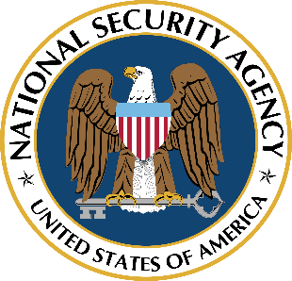        Become a Center of Academic Excellence! | Workshop hosted on Danville Community College campus in the Silverman Auditorium in the Foundation Hall building - located on the corner of South Main and Kimber Rd. Parking in front of building.  Address: 1008 S. Main St. Danville, VA 24541  How to become a CAE/CAE 2Y  - Presented by: Dr. Deanne Wesley  This workshop will cover how your institution can apply to be recognized as a Center of Academic Excellence in Cyber Security (CAE). The workshop will also go through each CAE application criteria and cover frequently asked questions and common pitfalls with the criteria.  Faculty will review NSA's expectations with regard to meeting Program Criteria and Knowledge Unit mapping.  CLICK HERE TO REGISTER!  Or copy and paste URL into your browser: https://goo.gl/forms/JJXuKM0CBL0lMFF42  Registration will open on July 26th and the registration deadline is August 31, 2017. If you are approved for a travel stipend, you will be notified by September 1st.  Travel Funding Available: A limited number of travel stipends for invited participants to attend are available. To receive a stipend you must register and be approved by the organizers. To be eligible for reimbursement or a travel stipend, attendees must participate in workshops and complete any travel reimbursement/stipend forms provided on site.  Funded by: NSA & DHS funded grants at the following community colleges  Danville Community College (CRRC) Director: Steven Carrigan  Forsyth Technical Community College (CRRC) Director: Dr. Deanne Wesley  Contacts:  Dr. Deanne Wesley dwesley@forsythtech.edu  Department Chair/CAE Program Director  Davis iTEC Cybersecurity Center at Forsyth Technical Community College  Gretchen Adkins gadkins@forsythtech.edu or 336.734.7638  Staff Assistant  Davis iTEC Cybersecurity Center at Forsyth Technical Community College

