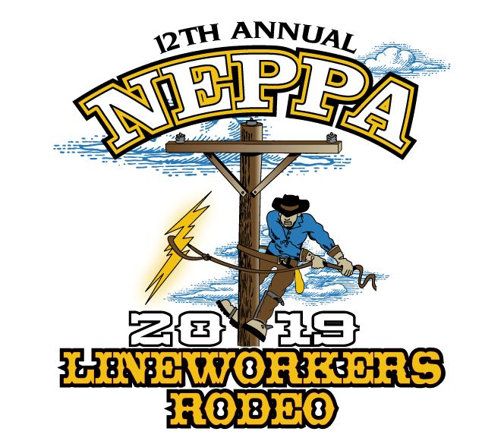
Lineworker’s Rodeo Subcommittee

Chair:

Ken Stone | Braintree Electric Light Department

Members:

Mike Cloutier | Middleton Electric Light Department
Gil Finch | Groton Electric Light Department
Jake Kennedy | Shamrock Power Sales
Scott Larsen | Littleton Electric Light & Water Department
David Schofield | Georgetown Municipal Light Department

