

A MONTHLY NEWSLETTER FOR BELD CUSTOMERS, PUBLISHED July 2022



BELD vs The Other Guys

BELD has been Braintree’s electric provider for 130 years. The world has changed considerably since then, but we still pride ourselves on offering superior service at low rates to all the residents and businesses of Braintree.

While the average residential customer in Massachusetts uses approximately 750 kWh per month, your use may be higher or lower depending on the number and types of appliances that you are using. Here is a quick comparison of BELD rates vs. The Other Guys in the area —just another reason why it’s so great to live in Braintree!

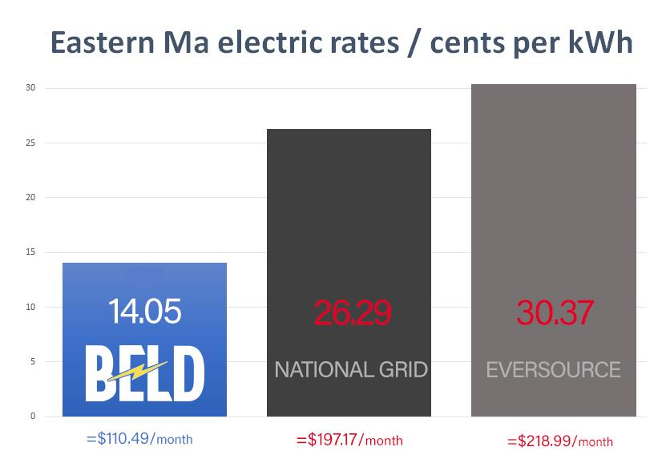

A quick look back in time …

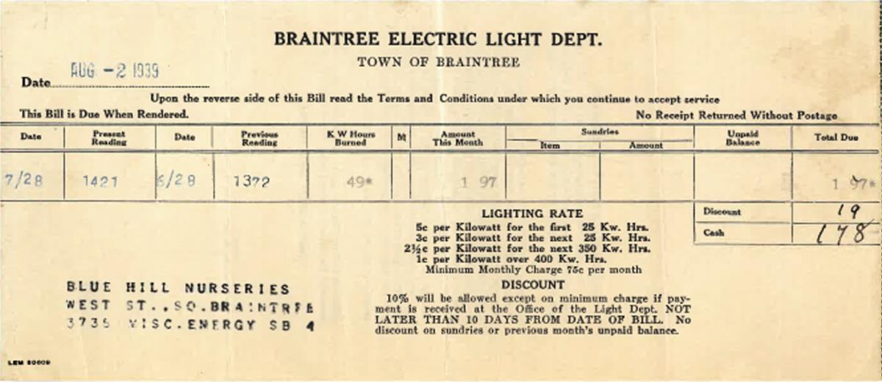

Take a look back in time, check out a Braintree Electric Light Department bill from 1939. 5 cents kWh, that’s less than a 10 cent increase over 83 years, pretty impressive if you ask us. Did you know, besides our low rates, after all this time we still offer an early pay discount—The Other Guys don’t.

“Pick up” an Electric pickup!

This year the first electric pickup trucks are at last arriving to driveways and garages. They come in all different shapes and sizes, for work, play or both. Automakers old and new are getting into this exciting new segment of the market. The success of these trucks will play a vital role in the transition to electrification.

In the next few years, we will see many more on the roads. With a wide range of specs, including high towing capacity, good payload, great range and performance. Some of these will also be a perfect fit for any fleet customers to save on high fuel and maintenance costs. The only issue may be that automakers have underestimated the huge demand for EVs in the coming years.

Here are three of the most popular that are already hitting the roads.

  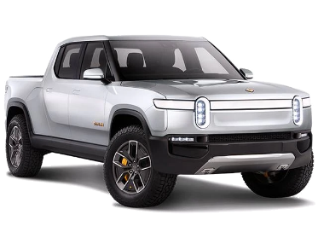
  Rivian R1T
  Price: $67,500-$100,000+
  Electric Range:
  313 Miles (est.)
  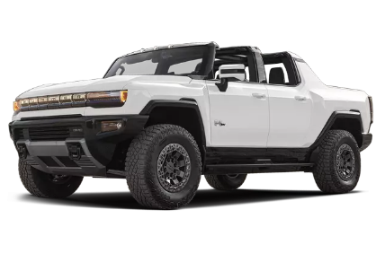
  GMC Hummer EV
  Price: $79,995 – $110,295+
  Electric Range:
  250-350Miles (est.)
  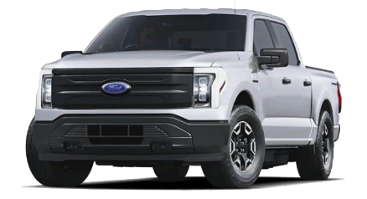
  Ford F-150 Lightning
  Price: $39,974 – $90,874+
  Electric Range:
  230-320 Miles (est.)

 | 
Learn more www.BraintreeDrivesElectric.com

Community Bulletin Board

Braintree Recycling
Effective July 1, 2022 Per MA D.E.P Regulations: Construction/Demolition materials CANNOT
be accepted at the Recycling Center except up to 3 bundles of wood (tied & in 3-4 ft. lengths). Unaccepted materials include: pallets, windows, doors, flooring, roofing materials, fencing, toilets, etc..

Household trash brought to the Center not bagged will cost an additional One Load Permit Fee of $30 per 300 lbs. as of July 1st. Available for purchase at Treasurer’s Office/Town Hall. All bags are subject to inspection. Learn more at www.braintreema.gov/recycling

  Holiday Closings:
  Independence Day, Monday, July 4

  
  COMMISSIONERS:
  
  Thomas Reynolds
  Chairman
  
  Anthony Agnitti
  Vice Chair
  
  James Regan
  Secretary
  BELD PAYMENT OPTIONS
  Sign up for AutoPay or call
  781-348-1001 to make
  a one-time payment
  PAYMENT LOCATIONS
  Secure Drop boxes
  - Top of Potter Road
  - Beside Town Hall
  Cash accepted only at
  South Shore Bank
  - 1010 Washington St.
  
  CUSTOMER SERVICE
  8 am – 4 pm
  Monday – Friday
  COMMISSION MEETINGS Public meetings are usually held monthly.
  Check dates/times

  Your hometown electric utility
   ‌  ‌  ‌  ‌

