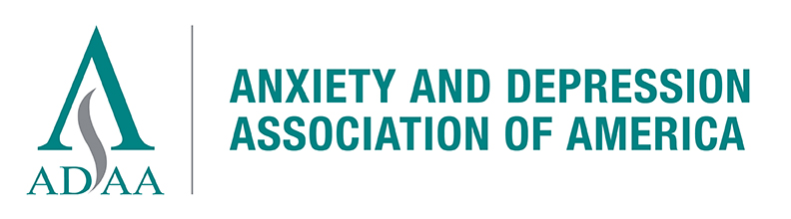
2019 Board of Directors Application
Submission Deadline: Midnight, March 5, 2019

Please attach a current CV and cover letter.

Please complete and email this form to sgurley@adaa.org by midnight March 5, 2019

Nominee Information:

Name_____________________________________ Degree(s) _______________

E-mail___ ________________________ Phone _________________________

Membership start date (year) _______________________

Have you been a continuous ADAA member since you joined? Yes No

Practice or Institution ________________________________________

Address: Street, City, State and Zip Code

_____________________________________________

_____________________________________________

Nominator Information (if different from nominee):

Name_____________________________________ Degree(s) ______________

E-mail ________________________ Phone __________________________

Membership start date (year) _______________________

Have you been a continuous ADAA member since you joined? Yes No

Practice or Institution ______________________________________________

Address: Street, City, State and Zip Code

_____________________________________________

_____________________________________________

Describe below (or attach in a separate document) in 750 words or less why you want to join the ADAA Board of Directors and what you hope to contribute and gain by serving; include relevant experiences and positions in other organizations.

_____________________________________________________________________

_____________________________________________________________________

_____________________________________________________________________

List your ADAA leadership involvement and specific contributions (ADAA committees, special interest groups, conferences attended, webinar hosting, etc.)

_____________________________________________________________________

_____________________________________________________________________

_____________________________________________________________________

Signature of nominee (or nominator) ______________ Date________________

∞

CV included
Cover letter of nomination for myself or from a nominator
___ I understand that nominations for the Board of Directors must be submitted by midnight, March 5, 2019, or they will not be accepted.

