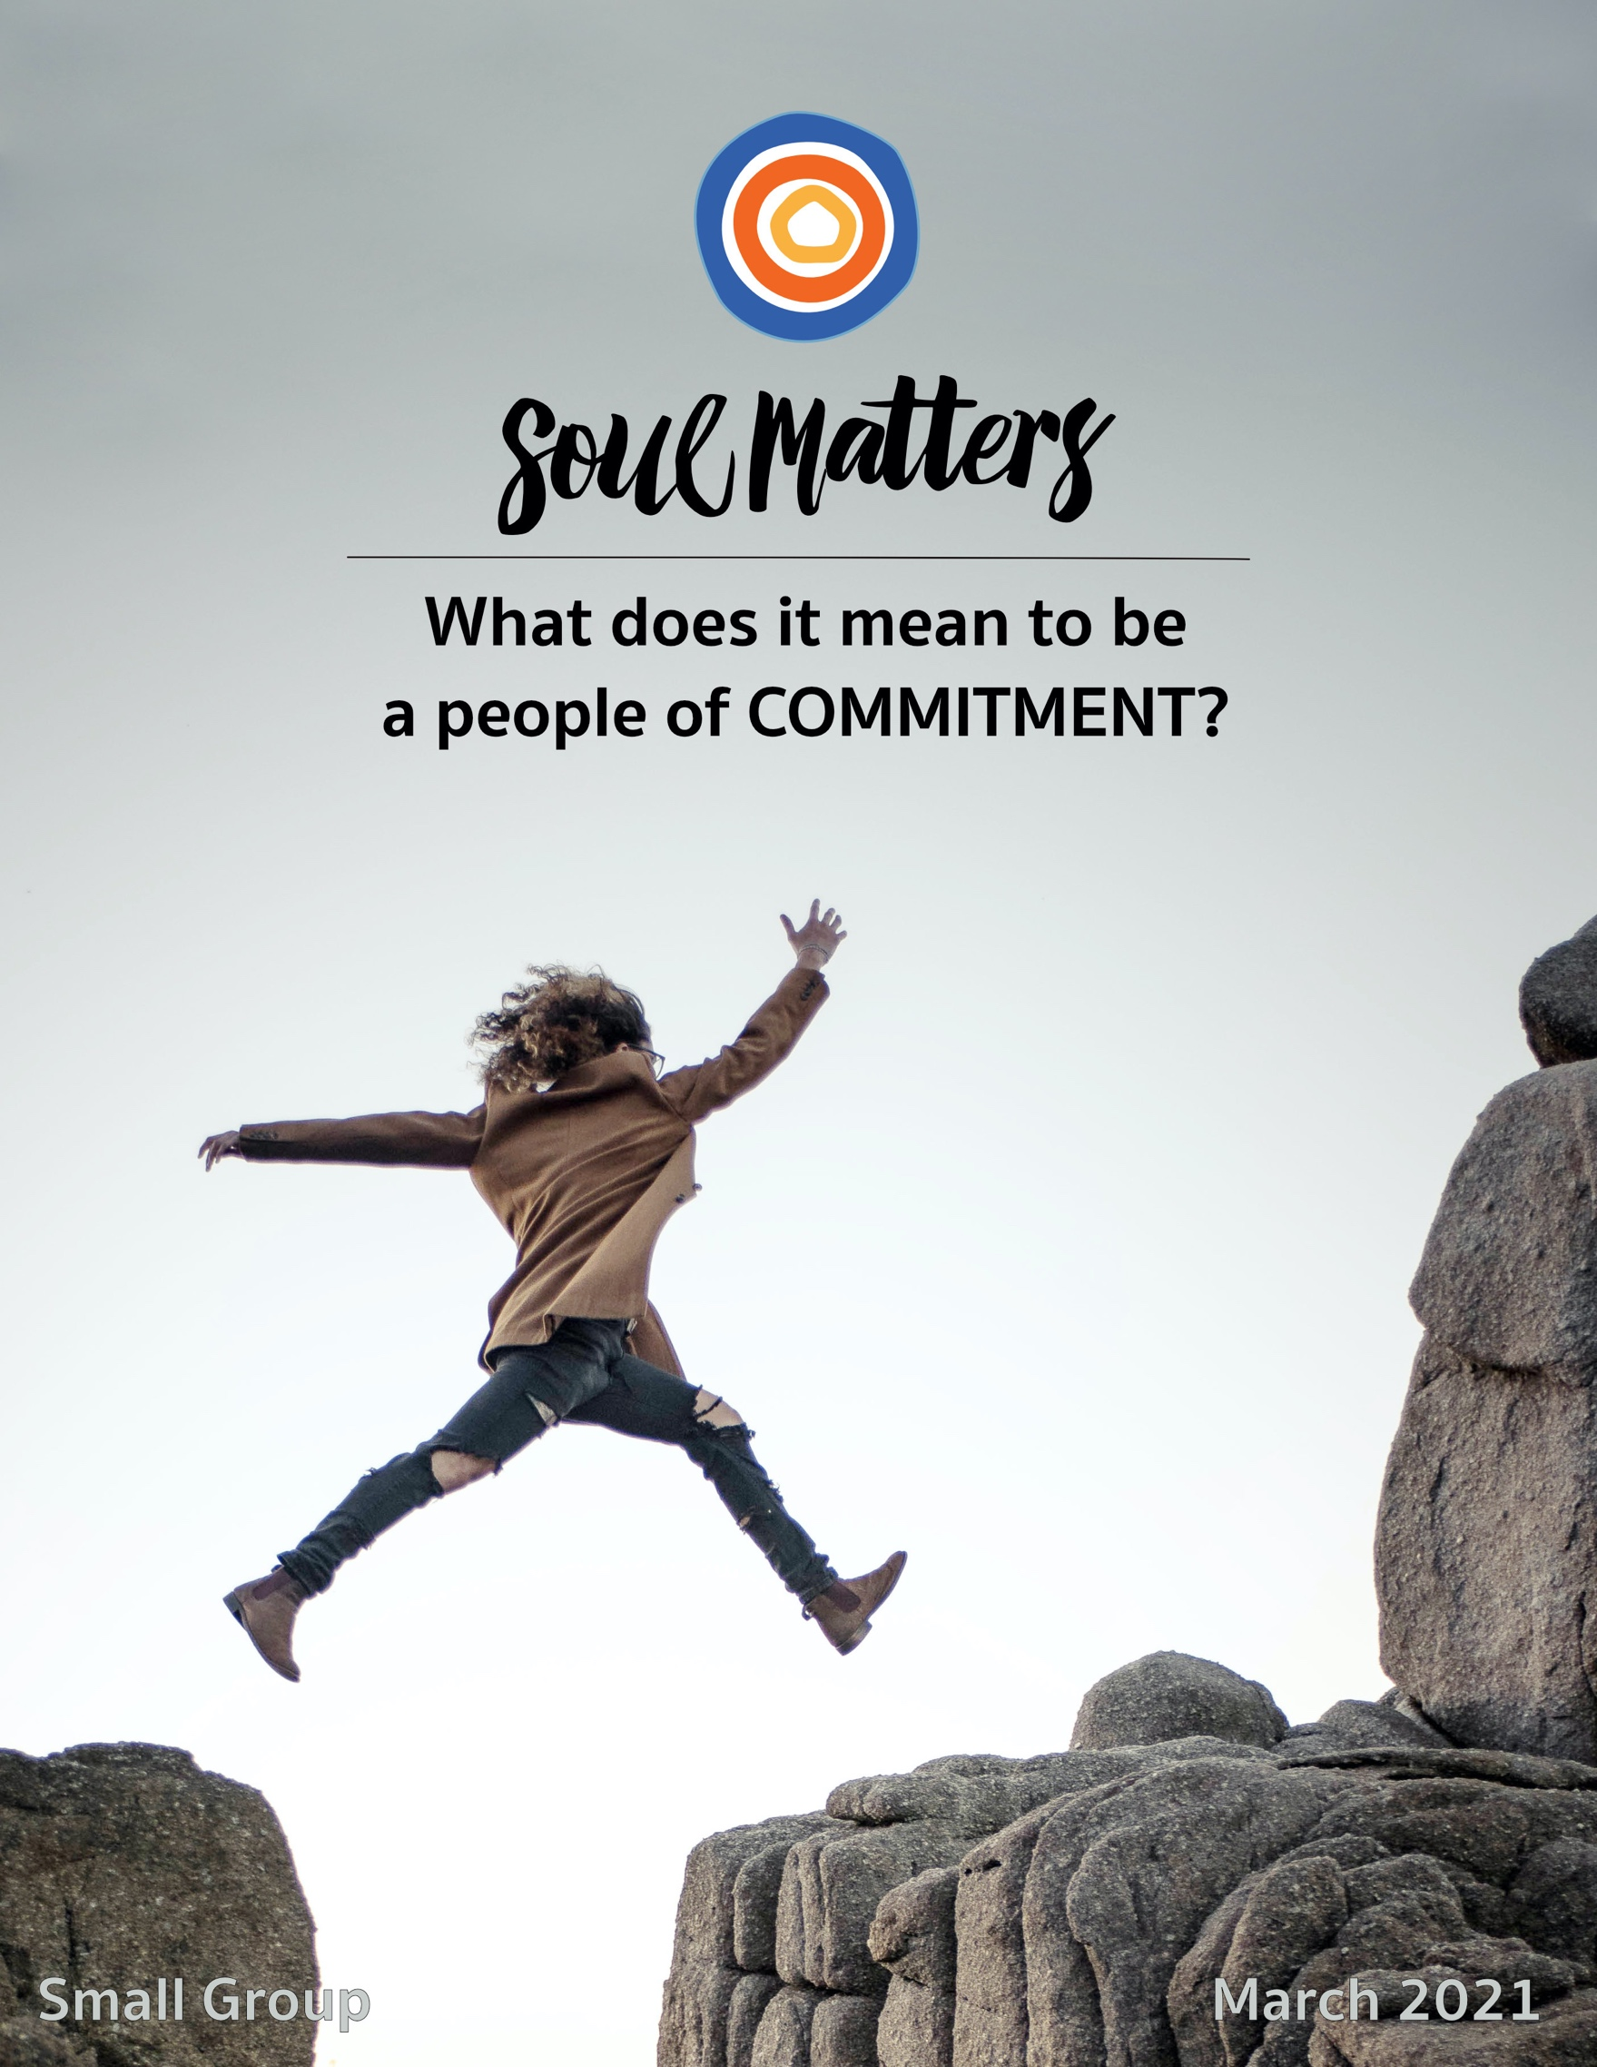

What Does It Mean To Be
A People of Commitment?

There’s a natural, and important, go-getter quality to this month. After all, huge payoffs come when we keep our commitments. Maintaining loyalty to healthy habits not only lengthens our lives but enriches them. Faithfully following through on our relationship commitments allows us to fully realize ourselves as the interdependent creatures we are, as well as increases just about every metric of happiness, meaning and success out there. And keeping the promises we make to ourselves ultimately gives us the strength, groundedness and self-confidence needed to follow through on all those promises we make to those around us.

Add it all up and what we get is a picture of commitment that looks a lot like climbing a mountain. The path is long and littered with challenges, but there’s definitely a beautiful view waiting for us at the top. Staying on course is the goal. What’s needed most in our backpacks are the qualities of endurance, focus, determination and grit. And of course no commitment climb would be complete without a handful of coaches offering us motivational words and strategic tips, along with a supportive crowd that lines the path and cheers us on with encouraging shouts of “You can do it!”

There is no doubt that such climbs are worth it. All of us certainly need a few of these successful journeys to feel fulfilled. But what about those we notice along the way? What about those we see sitting on the side of the trail, bruised and tending to their wounds? What about those we see walking the other way? Those who have stopped half-way up and are now traveling back down the path?

There’s the friend whose marriage was good for so many years but, through no real fault of her or her spouse, that relationship has now just grown thin. She is the one sitting there struggling to accept the sad reality that some marriages just weren’t meant to last a lifetime. There’s also the co-worker that is proud to have maintained a successful career for 20 years that supported his family, but who - because of that commitment to stable work - had to turn his back on an earlier dream of being a writer. And over by that turn in the road sits your sister who gave her faithfulness but only got betrayal and infidelity in return. Then, of course, there are the many fellow travelers who bravely remain committed to the long-haul goals of health and security, but who walk wearily because addictions or bad luck have turned their journey into a one of one step forward and two steps back.

All of which is to say that maybe what’s needed most this month is for us to tone down all the motivational talk so we can make at least a little room for mourning.

Yes, the path of commitment is a lot like climbing a mountain, but it is just as often more like trudging through a thick forest where all sorts of paths complicate our journey. Not every path of commitment is clear and long, with a reward waiting at the end. Some just lead to dead ends. Others start out along beautiful streams but mid-way through snakes slither out through the grass. Some trails are simply too steep and must be abandoned, not just for our safety but for the safety of those we love. And almost always there’s that fork in the road. We want to travel

both, but we are forced to choose. So commitment to one necessarily means traveling with regret and “What ifs.”

In such woods, our backpacks need to be filled with more than just endurance, focus and grit. Self-forgiveness, acceptance, and the ability to let go or admit “I was wrong” need to be tucked in there too.

In such woods, people need us to be more than coaches and cheerleaders. They need something more like pit stop crews. A trusted circle of people willing to offer them repair and rest.

We need to remember that for every person wanting to hear “push through the pain,” there are two needing someone to say, “It’s ok to tell me about your pain.” Sometimes the best advice is “break it down to one step at a time”; Other times the wisest words we can offer are “It’s ok to stop trying.”

Less pushing grit and more encouragement to forgive themselves.
Less shouting “You can do it!” from the sidelines, and more whispering “I’m here to listen.”

Yes, there’s no doubt that’s exactly what so many need this month.

And maybe that’s exactly what you need too...

Our Spiritual Exercises

Option A

Five Commitments to Yourself

It’s hard to imagine keeping commitments to others if we can’t keep commitments to ourselves. In fact, many say it is loyalty to ourselves that ultimately gives us the strength, groundedness and self-confidence needed to follow through on the promises we make to those around us. And yet we rarely devote the same level of intentionality to self-commitments that we give to our commitments to others.

So let’s use this month to be more intentional about the promises we make to ourselves!

First identify three commitments you’ve already made to yourself. We bet it will be harder than you think. Very few of us carry our self-commitments at the forefront of our awareness. But the importance of doing so can’t be overstated. As Stephen Covey has said, “Anything less than a conscious commitment to the important is an unconscious commitment to the unimportant.” If you find this harder than you expected, enlist a loved one or trusted friend. They can probably name your existing self-commitments easier than you can.

Next identify two new commitments you want to make to yourself. Odds are they’re long overdue.

Then write all five of your commitments on a 3*5 card and place it on your bathroom mirror, bedside table or desk for the remainder of the month. Treat this as both an act of awareness and an act of accountability.

To help you along your way, spend some time with this wonderful poem by Laura Mancuso: My Commitments to Myself: https://www.uua.org/worship/words/meditation/my-commitments-myself

Option B

Commit to Creating a Helpful Habit

(or Ending an Unhelpful One)

Habits are arguably our most pervasive and powerful commitments. Once in place, they happen so effortlessly and automatically that we don’t even consider them a chosen commitment. But it’s clear that our bodies, behaviors and emotions are without a doubt committed to them. And if you are wondering how much of our lives are dominated by these “cruise control commitments,” well, researchers tell us that at least 40% of our behaviors are dictated by habits. Some studies even suggest that by age 35, that percentage is as much as 95%! With so much of our lives shaped by these automatic behaviors, it seems it would do us all good to try a bit harder to shape them. So spend this month adding a new helpful habit to your life or removing an unhelpful one.

All it takes is a bit of intentionality, and as researchers tell us, a focus on small steps. Here’s some inspiration and guidance to help you one your way...

- Try it for 30 days, TED Talk:
https://www.ted.com/talks/matt_cutts_try_something_new_for_30_days?rid=tRBigzKBJt7F&utm_source=recommendation&utm_medium=email&utm_campaign=explore&utm_term=watchNow

- 6 Reasons Why 30-Day Challenges Will Change Your Life For Good:
https://medium.com/personal-growth-lab/6-reasons-why-30-day-challenges-will-change-your-life-for-good-2d78d2dc5665
- 30 Day Challenge Ideas – 75 Ideas To Create Your Own Challenge:
https://thegoalchaser.com/30-day-challenge-ideas/
- 23 Micro-Habits for Changing Your Life in 30 Days or Less:
https://medium.com/the-ascent/23-micro-habits-for-changing-your-life-in-30-days-or-less-2dbdc46bb180
- Keep Your Goals Secret, TED Talk:
https://www.ted.com/talks/derek_sivers_keep_your_goals_to_yourself

Option C

Deepen Commitment to Allyship

Many white, cis-gendered UUs are waking up to the call to be allies. And yet it is a more complex commitment than it may at first seem. With this in mind, we invite non-marginalized UUs this month to lean into learning more about that complexity so their commitment to allyship can make the difference we all hope for.

To help you on your way, we’ve gathered below some wise, compassionate and challenging voices. They lift up many guideposts to help you navigate this important work. But don’t just stop at exploration. Instead push yourself to identify 3-5 of the guideposts shared that call to you in particular - three to five lessons/challenges that not only offer you new insight but also point to clear changes you can make this month. Ultimately this is what commitment means: moving from awareness to action, hope to impact.

- 10 Things All ‘Allies’ Need to Know
https://everydayfeminism.com/2013/11/things-allies-need-to-know/
Support: https://everydayfeminism.com/support-everyday-feminism/

- Want To Be A Good Ally? Here Are Some Things To Ask Yourself
https://www.buzzfeed.com/victoriagasparowicz/how-to-be-an-ally-guide

- Guide To Allyship
https://guidetoallyship.com/#what-is-an-ally
Support: https://www.buymeacoffee.com/amelie?utm_source=guidetoallyship

- How to Be a Good Ally - Identity, Privilege, Resistance
https://www.youtube.com/watch?v=q7ElX4GFQpI
Support: https://www.patreon.com/AhsantetheArtist

- How to Tell the Difference Between Real Solidarity and ‘Ally Theater’
http://www.blackgirldangerous.com/2015/11/ally-theater/
Support: https://www.bgdblog.org/donate/

- The Women’s March and the Difference Between Unity and Solidarity
https://www.bgdblog.org/2017/01/the-difference-between-unity-and-solidarity/
Support: https://www.bgdblog.org/donate/

- How Non-Indigenous Activists Can Support Indigenous People
https://www.bgdblog.org/2016/09/support-indigenous-people/
Support: https://www.bgdblog.org/donate/

- Moving from Actor to Ally to Accomplice
https://www.whiteaccomplices.org
Also at http://www.racialjusticeallies.org/wp-content/uploads/2016/12/from-ally-to-accompliace.pdf

- How to be an Antiracist, Ibram X. Kendi
https://www.youtube.com/watch?v=TzuOlyyQlug

Option D

Commit it to Memory

The author John Irving wrote, “When you love a book, commit one glorious sentence of it to memory. That way you won’t forget the language of the story that moved you to tears.”

Who of us hasn’t been moved to tears by a book, poem, song lyric or quote? We stumble across it and it lights up as if neon lights. Like a gift sent by Life and meant just for us. Often those precious words heal us. Other times they guide us. Sometimes they even grab us by the shoulders and shake off the blinders we’ve had on for far too long.

And yet too often and too quickly the neon fades. The guidance is forgotten. The blinders return.

This is why Irving urges us to take the time to commit those words to memory. Indeed that act of memorization is an act of commitment. It binds us to the truth and gift of those words. It turns them from insights into life companions. It moves us from stimulating our minds to impacting our life.

So what life-giving sentence, poem, lyric or quote will you commit to memory this month?!

Option E

Find Commitment in Our Recommended Resources

Our recommended resources are full of wisdom about what it means to be a people of and a person of commitment. Engaging these resources and finding the one that especially speaks to you is a spiritual practice in and of itself. So, if none of the above exercises call to you, engage the recommended resources section of this packet as your spiritual exercise for the month.

Set aside some regular time throughout a week to go through them and meditate on them until you find the one that most expands or deepens your understanding of commitment. After you’ve found it, consider printing it out and carrying it with you or pinning it up so you can continue to reflect on it throughout the weeks leading up to your group meeting. Come to your group ready to share where the journey led you.

Your Question

Don’t treat these questions like “homework” or try to answer every single one. Instead, make time to meditate on the list and then pick the one question that speaks to you most. The goal is to figure out which question is “yours.” Which question captures the call of your inner voice? Which one contains “your work”? What is that question trying to get you to notice or acknowledge?
Often it helps to read the list to a friend or loved one and ask them which question they think is the question you need to wrestle with!

- What commitment has shaped you the most? What commitment most deeply defines you?
- Do you have a secret commitment? A promise to yourself that no one (or very few) know about?
- How has your relationship with commitment changed over time? For instance, are you better or worse at following through on commitments as you’ve grown older? Or have you grown more selective about the commitments you make? Maybe you now easily break commitments if they don’t feed you? Maybe you are now more committed to beauty than work? Or small things rather than “big things”?
- Do responsibilities and commitments drain you or motivate you? Do they give your life direction or leave you feeling tied down and hemmed in?
- When we commit to one path, we leave some other path behind. Is there a “path not chosen” that still haunts you?
- What are the covenants/commitments you were born into?
- What did your family teach you about “responsibilities we have to the world”?
- Have you kept your promises to yourself?
- If someone secretly monitored your life for a month, what would they conclude is your most sacred vow?
- Has anyone ever asked you to hold them accountable to their commitments? How has that changed and challenged you?
- It's been said that our very humanity lies in the way we carry out our promises. How have you made yourself more human through a promise?
- What promises have you made to your spiritual life?
- Are you keeping a commitment that is limiting your growth? Keeping you in a cage?
- Has society ever broken its promise to you?
- Some of us preempt heartbreak by leaving relationships before others have a chance to break their promises and our hearts. Did this self-protection strategy really work out for you?
- Do you over-promise? When you offer others your commitment, do they take it with a grain of salt?
- What’s your question? Your question may not be listed above. As always, if the above questions don't include what life is asking from you, spend the month listening to your days to hear it. Or maybe the question or call you need to hear is waiting in one of the quotes listed below. Consider looking there!

Companion Pieces

Recommended Resources for Personal Exploration & Reflection

The following resources are not required reading. We will not analyze these pieces in our group. Instead they are here to companion you on your journey this month, get you thinking and open you up to new ways of imagining what it means to be a people and a person of COMMITMENT.

Word Roots & Definitions

Commitment includes three Latin word roots:
com – together, mit – to send, and ment – a result. This shapes an idea that commitment is not experienced in isolation but with others and with all parts of ourselves. That commitment has an energy that moves, sends us along in a direction. And that commitment is the result of choice.
Source

Wise Words

Anything less than a conscious commitment to the important is an unconscious commitment to the unimportant.
Stephen Covey

The first step towards getting somewhere is to decide that you are not going to stay where you are.
J.P. Morgan

Unless commitment is made, there are only hopes, but no plans.
Peter F. Drucker

Choosing a path meant having to miss out on others. She had a whole life to live, and she was always thinking that, in the future, she might regret the choices she made now. “I’m afraid of committing myself,” she thought to herself. She wanted to follow all possible paths and so ended up following none.
Paulo Coelho

Most of life is choosing what you already chose, just as all writing is rewriting and all commitment-making is recommitment. Our lives are stories of recommitment.
David Brooks

We receive who we are before we choose who we will become… We are born into relationship before we shape relationships by our conscious intention. We inherit covenant before we create covenant… Covenant making must begin with the question, "What have we been given? What is the covenant we are already in?”
Rev. Rebecca Parker

The moment one definitely commits oneself, then providence moves too. All sorts of things occur to help one that would never otherwise have occurred. A whole stream of events issues from the decision, raising to one’s favor all manner of unforeseen incidents and meetings and material assistance. Whatever you can do or dream you can begin it. Boldness has genius, power and magic in it.
Johann Wolfgang Von Goethe

Faith is a commitment to live as if certain things are true, and thereby help to make them so. Faith is a commitment to live as if life is a wondrous mystery, as if life is good, as if love is divine, as if we are responsible for the well-being of those around us.
Rev. Galen Guengrich

If you are neutral in situations of injustice, you have chosen the side of the oppressor.
Bishop Desmond Tutu

Smoking dope and hanging up Che's picture is no more a commitment than drinking milk and collecting postage stamps. A revolution in consciousness is an empty high without a revolution in the distribution of power.
Abbie Hoffman

The heart of justice is truth telling, seeing ourselves and the world the way it is rather than the way we want it to be. More than ever before we, as a society, need to renew a commitment to truth telling.
bell hooks

We promise according to our hopes and perform according to our fears.
François VI de la Rochefoucault

The one who promises everything is sure to fulfill nothing.
Carl Jung

Those that are most slow in making a promise are the most faithful in the performance of it.
Jean Jacques Rousseau

We need to do a better job of putting ourselves higher on our own 'to do' list.
Michelle Obama

Never doubt that a small group of committed, thoughtful people can change the world. Indeed, it is the only thing that ever has.
Margaret Mead

You are not required to finish your work, yet neither are you permitted to desist from it.
Rabbi Tarfon

I am doing something I learned early to do, I am
paying attention to small beauties,
whatever I have–as if it were our duty to
find things to love, to bind ourselves to this world.
Sharon Olds

Say Yes. Whatever it is, say yes with your whole heart & simple as it sounds that’s all the excuse life needs to grab you by the hands and start to dance.
Brian Andreas
Music

We create two different playlists for each of our monthly themes: one in Spotify and another in YouTube. We organize these lists as a journey of sorts. So consider listening from beginning to end and using the lists as musical meditations. Follow the links below to connect with this month’s “ threshold songs.”

Click here for the Spotify playlist on Commitment.
Click here for all Spotify playlists.
Click here for the YouTube playlist on Commitment.
Click here for all the YouTube playlists.

In honor of Women’s History Month, also check out Soul Matters’ The Power of Women playlist.
On Spotify at https://open.spotify.com/playlist/3w6jIKainLELZmI6bBqQUl

Videos & Podcasts

Bold & Untold - Video series celebrating impactful women and their untold stories
A great way to engage March as Women’s History Month!
Season One: https://www.youtube.com/playlist?list=PLru7kHs-GAenoya0Cfo44IkUfYzagcaOi
Season Two: https://www.youtube.com/playlist?list=PLru7kHs-GAelsFehWUEm_-6dohLRS-uUw

A New Way to Mourn, The Daily Podcast
https://www.nytimes.com/2020/12/29/podcasts/the-daily/coronavirus-funerals.html
On finding new ways to fulfill our commitment to mourn and honor lives lost

On Commitment & Our Desire to be Consistent
https://embertelevision.co.uk/blog/psychology-of-persuasion-commitment-consistency/
Related article: https://theeveningproject.com/make-your-new-year-resolutions-stick/

Nothing’s Gonna Stop Us Now - epic lip sync scene
https://www.youtube.com/watch?v=77m3XlhQwaI

Fun will the classic song about indecisiveness and commitment:
https://www.youtube.com/watch?v=yW8mF2be0I0&feature=emb_logo

Articles & Books

Always Make Promises... and there's no pressure to exceed them
https://www.theatlantic.com/health/archive/2014/08/make-more-promises/379172/

Commitment as a Path to Happiness
https://www.patheos.com/blogs/labmind/2019/08/commitment-as-a-path-to-happiness.html

15 Promises All Couples Should be Able to Make to Each Other
http://www.lifehack.org/299342/15-promises-all-couples-should-able-make-each-other

Staying Put: Making a Home in a Restless World
Scott Russell Sanders
On staying committed to one place
Movies

We Are The Champions
Especially recommend the episodes “cheese rolling” and chili eating”!

Of Gods and Men

Other People

You Can Count on Me

Beautiful Boy

More Monthly Inspiration from Soul Matters!

Our Facebook Inspiration Page:
https://www.facebook.com/soulmatterssharingcircle/

Our Instagram Page:
Find us as “soul_matters_circle”

Music Playlists:
Click here for links to the Spotify playlists for each month.
Click here to check out the YouTube playlists.

Find support for bringing the
monthly themes home and into your family life with
Soulful Home: A Guide for Families:
https://www.soulmatterssharingcircle.com/soulful-home.html

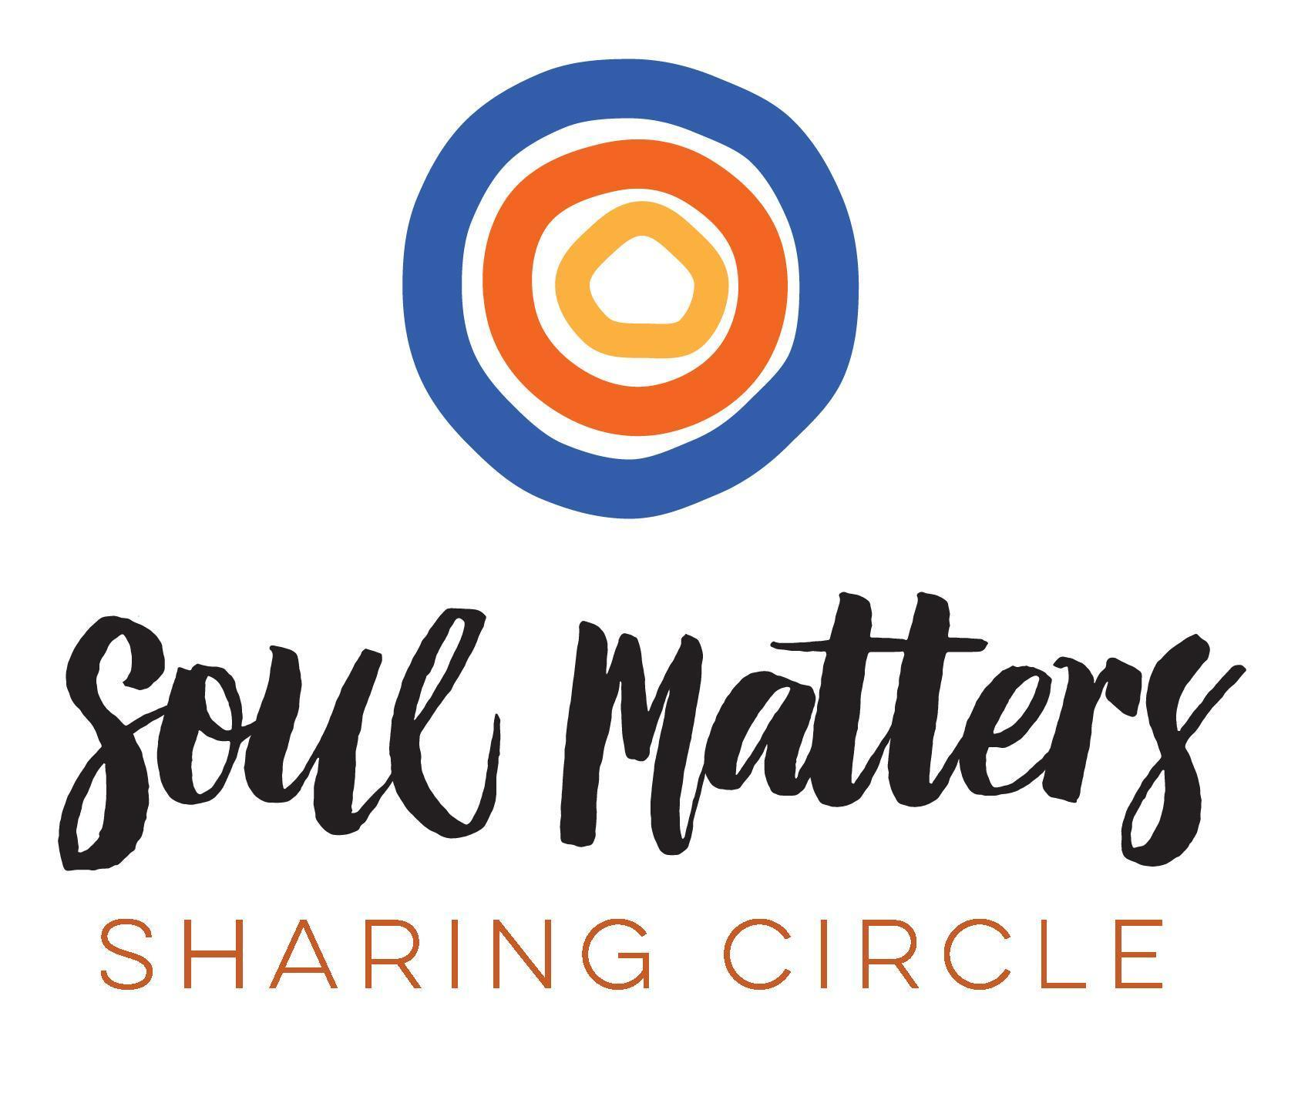
© 2019-20 Soul Matters ALL RIGHTS RESERVED

Packets are for use only by member congregations of the Soul Matters Sharing Circle.
Learn how to join at
https://www.soulmatterssharingcircle.com

