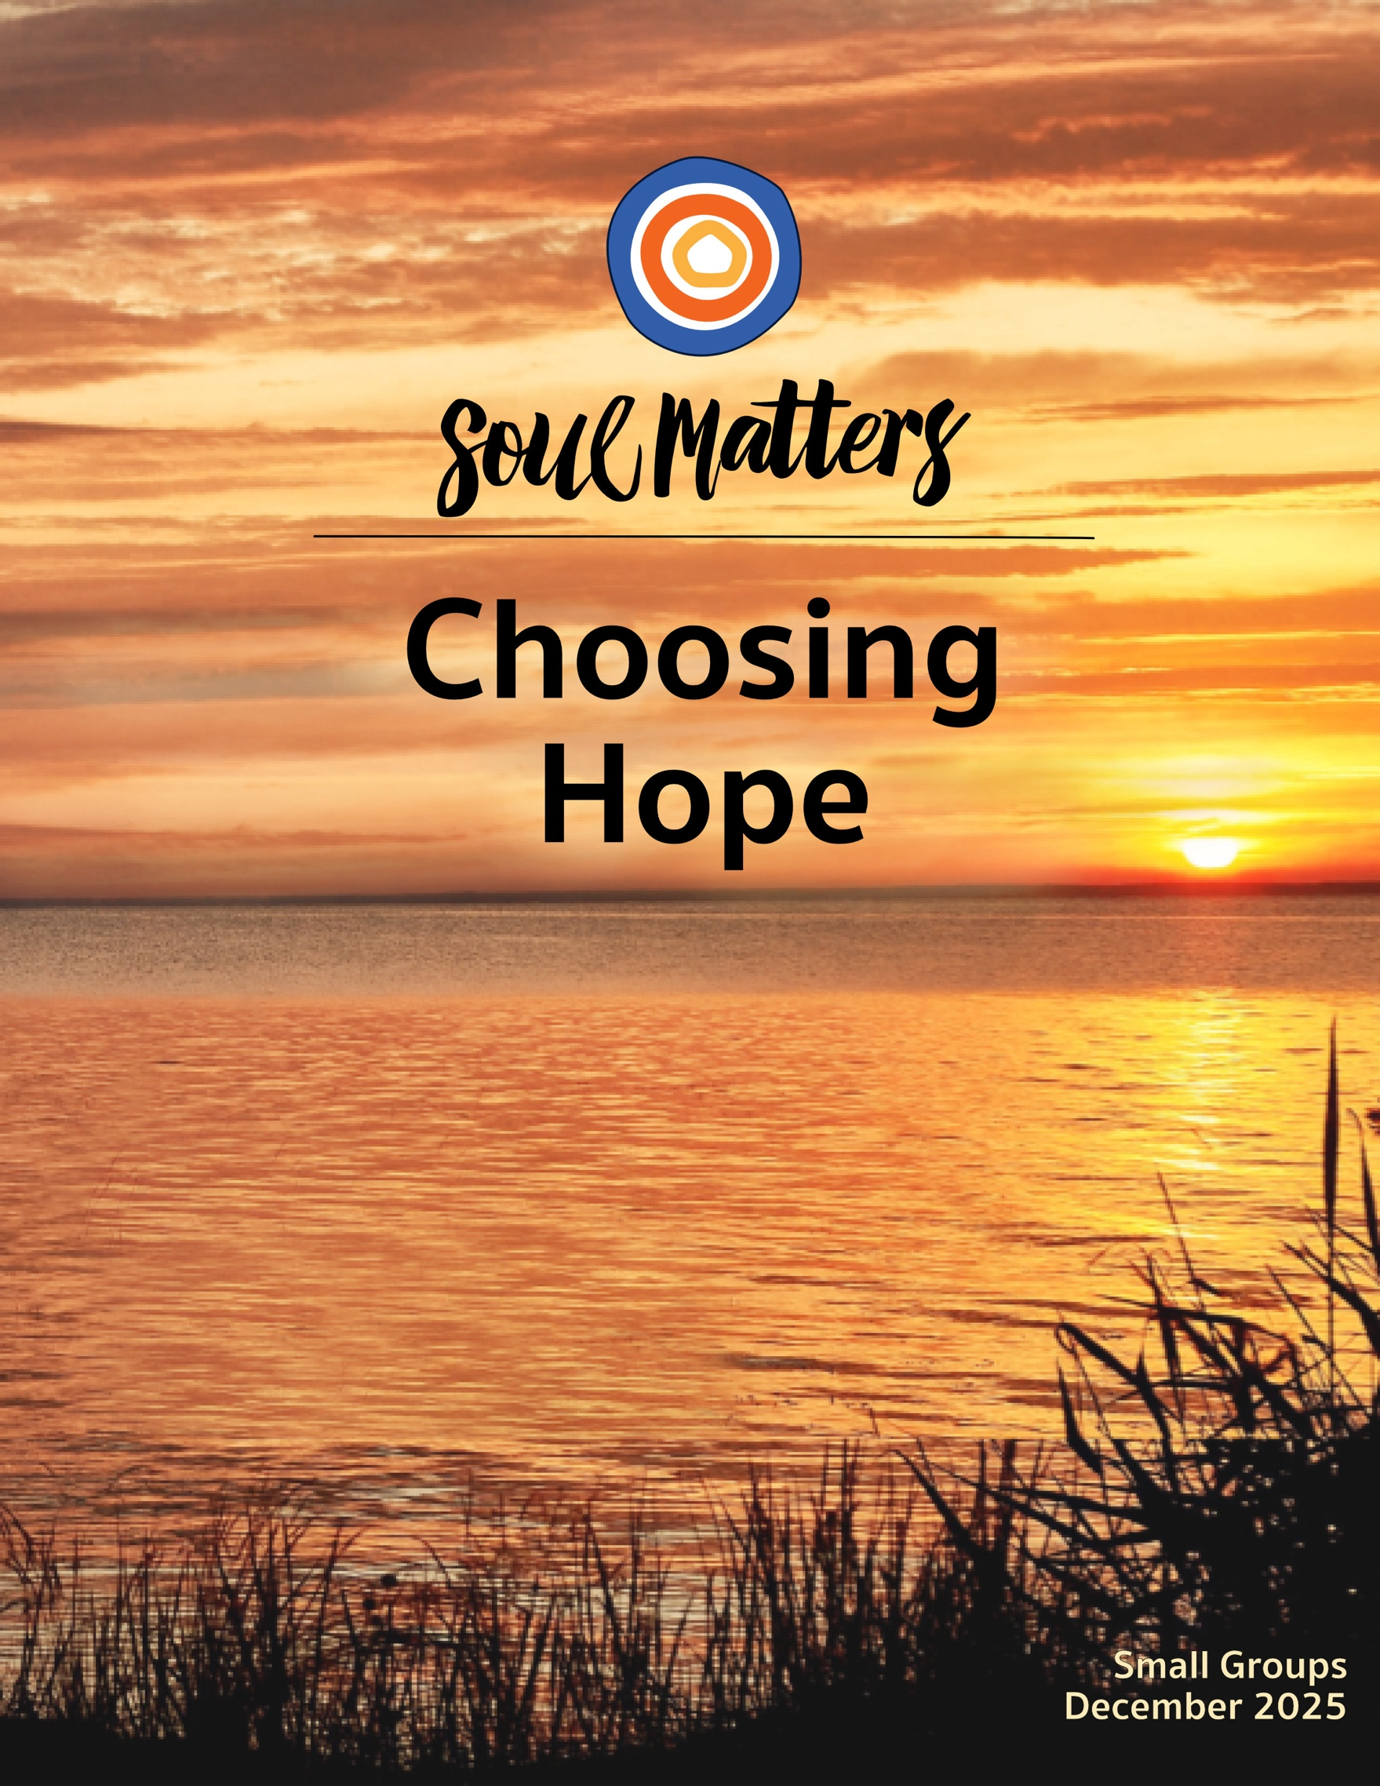

Welcome to Choosing Hope

Faith, wherever it develops into hope, causes not rest but unrest, not patience but impatience. It does not calm the unquiet heart, but is itself this unquiet heart in [all of us]. Those who hope… can no longer put up with reality as it is, but begin to suffer under it, to contradict it. [It] means conflict with the world, for the goad of the promised future stabs inexorably into the flesh of every unfulfilled present.”
- Jürgen Moltmann, Theologian

It’s not always easy to hear well this time of year, especially when it comes to hope. The dominant messages are about hope offering us calm: “The light will return.” “A new day is on its way.” “Justice and joy are growing in the womb and will soon be born.” Hope, from this point of view, is a voice that reassures. It’s a welcomed whisper that says, “Yes, the sky may be dark now. Yes, the road you’re on at this moment may be hard. But trust me, just over that horizon, there’s a new world waiting for us all.”

This soothing message comes to us as a gift. During dark days, we all get tired. The fruits of our efforts are hard to see. The cold seems to have set in deep. We feel small, and alone. So, the promise that things will change offers us relief. We are released from the burden of believing that “it is all up to me” or that it all must be solved now.

It’s a beautiful and needed message. But, as Moltmann and others remind us, it’s also only half of what hope is trying to say. Hope doesn’t just whisper “It will be different,” it also shouts, “It should be different” and “It can be different.” Yes, it speaks soothing words about trusting and waiting, but it also takes the form of a holy impatience that declares, “Enough is enough. The time is now!”

In other words, hope doesn’t just promise us that change will come in the future; it also changes who we are in the present. When we believe that a new day is possible, we don’t just sit down and wait to see what happens. We get up and go out to meet the light. When hope convinces us that there are unseen forces working for the good, we begin to look around more closely, and in doing so, we notice that darkness and pain are not all that is there. When hope’s holy impatience gets into our bones, we start acting as if we are worthy of that new day now. Which in turn changes others by convincing them that we all have waited long enough.

Bottom line: listening to hope, makes you dangerous, not just soothed! It doesn’t relieve us of duty as much as it reminds us that reality is more complex, unruly and open to change than the pompously powerful want us to believe. Yes, hope reassures, but it also emboldens. It doesn’t just offer us a promise; it gives us a push.

But all of this only happens if we listen fully. So maybe the most important question this month is: “Are we listening to everything that hope has to say?”

Spiritual Exercises
It’s one thing to analyze a theme; it’s quite another to experience it. By pulling us out of the space of thinking and into the space of doing, our spiritual exercises invite us to figure out not just what we have to say about life, but also what life has to say to us!

With that in mind, pick and complete the one exercise that speaks to you the most. Come to your group ready to share why you picked the exercise you did, how it surprised you and what gift it gave you.

Option A

Your Story of When All Seemed Lost

Poet Rubem A. Alves defines hope as “a suspicion that reality is more complex than realism wants us to believe and that the frontiers of the possible are not determined by the limits of the actual.” Writer Rebecca Solnit writes, “Hope is an embrace of the unknown and the unknowable.” Rev. Alison Cornish echoes them both, saying, “Change is inevitable – and with change comes a certain degree of uncertainty and instability – but these very conditions can offer hope fertile ground.”

These affirmations that hope is firmly rooted in uncertainty and change are not easy to remember. When loss, betrayal and disappointment darken our days, it’s hard to trust that the light will return. There is a solidity to despair that is hard to push against on our own. We all have a story of feeling certain that all is lost.

And…we all also have a story of unpredictability suddenly causing cracks through which hope snuck through. Telling these tales matters more than we know, because the gift of hope, more often than not, comes in the form of a story. Hearing tales of others finding their way through the dark helps us trust that light is waiting at the end of our tunnels too. Listening to others talk about being surprised by hope motivates us to be on the lookout for unlikely sparks of light. Simply put, hope doesn’t travel through the dark on its own. It hitchhikes on the tales we tell each other.

So, what’s your “all seemed lost” story? We need to hear it. We need reminding that our despair is not as impenetrable as it seems. We all need our faith in unpredictability and surprise restored.

Come to your group ready to share not only your “all seemed lost” story, but also consider finding and bringing in a symbol/token that represents the essence of your story. There’s something about an object that anchors our stories.

You might also want to keep that symbol/token close to you during the weeks before your meeting, as a way of engaging your story in a new way and allowing it to sink into you even more deeply than it has before.

Option B

Spread Some Positive Gossip

Whereas our first exercise option asks us to spread our stories, this exercise invites us to spread some gossip. But in a way we don’t regularly do.

Dr. Jamil Zaki researches hope and cynicism. He has identified numerous strategies to help us move from hopelessness and pessimistic views to hope and optimistic views of life and others. One of the most effective of
those strategies is what he calls “positive gossip.” It’s all about publicly pointing out good deeds, spreading positive tales about strangers you’ve encountered and lifting up underrecognized admirable qualities of those close to you. Zaki says this simple habit radically alters not only our attention but others’ as well, decreasing our innate negativity bias and expanding the ability of all of us to be open to the goodness that surrounds us. By altering our attentional patterns, this “good gossip” literally causes us to live in a more hopeful world.

So, here’s your challenge: For one week, keep an eye out over the course of your day for one example of being touched by the kindness, generosity, or goodness of another person. And then find a different person to “gossip” about it to. Along the way, notice how others react to your positive gossip. Do they welcome it or does it throw them off? Also notice your own reactions. Does sharing positive gossip feel natural or awkward? And, at the end of the week, see if you notice any trends or shifts, in you or the circles in which you share your anti-cynical scuttlebutt.

Come to your group ready to share what you learned and how this exercise offered you a challenge or comforting insight.

(p.s. To hear Dr. Zaki say a bit more about positive gossip, go to minute 25:25 of this video.)

Option C

Helped by the Hopes and Anxieties of Others

This exercise is also about sharing our hopefulness with each other. Inspired by Tibetan prayer flags and out of concern for our culture’s heightened levels of anxiety and isolation, artist Candy Chang and writer James A. Reeves worked with the Rubin Museum of Art to create a participatory art project they called A Monument for the Anxious and Hopeful. The project involved museum visitors filling out blank cards with their hopes and anxieties and then hanging them up on a public wall. You can read more about the project in this interview with the artist.

Their goal in creating this project was to increase people’s sense of hopefulness and break down their sense of isolation. They succeeded! Participants, as well as those who viewed the exhibit later, reported that reading others’ anxieties lowered theirs by making them feel like they weren’t alone in their worries. Further, reading other people’s hopes restored their sense of the world’s giftedness and goodness.

So with that in mind, this exercise invites you to engage the project’s list of hopes and anxieties and see if it offers you the same hopeful outlook it did for others. In particular, we suggest you:

- Read over the hopes and anxieties a couple of times by following this link (https://rubinmuseum.org/is-your-hope-my-anxiety/) and scrolling down to the section labeled “Hopes and Anxieties from Rubin Visitors.” We’ve also copied the list onto a google doc which you can view and download here.
- One your first read, just let the list wash over you. Don’t read it with any intention in mind, just open yourself to whatever feelings and thoughts arise. After you are done, spend some time getting in touch with those feelings and see if you experience the same feeling of less isolation and more hope that other readers of the list did. If you have a different experience, spend some time identifying why you think that is.
- Then read the list again. This time bring the same intentionality and “disciplined reading” to it that we do with our packet questions. In other words, as you read through the list of other people’s anxieties

and hopes, pay attention to which of them “shimmer” and have an emotional pull for you. Write them down as you go. (You can also download the list from here and highlight the ones that stick out for you as you go.)
- With the shimmering hopes and anxieties in front of you, reflect on them with these questions:
- What is going on in my life right now that makes these particular hopes and anxieties so pronounced for me?
- What might my inner wisdom be trying to say to me through these people’s hopes and anxieties?
- How might Life or my inner wisdom be trying to offer me a word of comfort or challenge through these people’s hopes and anxieties.

Come to your group ready to share your journey and the insights/gifts this exercise gave you.

Option D

A list of Hopes for You

This exercise is also about lists. But this time it’s you who will be doing the list-making.

Riya Roy has a weekly online newsletter called The Nook. Its purpose is to “welcome fellow scared folks to explore the tenderness of each moment by walking into its mysteries with me.” In one of her posts, she wrote a list of her hopes for her readers. This exercise invites you to read her list and then write a similar one of your own. Here’s what you are invited to do:
- First read the list as a recipient. In other words, read through the list and keep a lookout for the wishes that feel like they were written for you. As we regularly do in Soul Matters, then spend some time reflecting on the ones that feel like they were written for you, asking yourself how your inner wisdom might be trying to wake you up to a longing or offer you a message of comfort or challenge through them.
- Next, write your own list of hopes. Start by identifying your chosen audience. You could approach it like Roy and write your hopes for a general group of people, such as those you love, your church community, Americans you imagine are feeling anxious or even threatened right now, or the young people of today facing a frightening future. You could also write your hopes for a particular person in your life, like a child, a friend or even a stranger who has stuck in your imagination (the barista at your local coffee shop who seems to be carrying a weight on their shoulders or the enthusiastic librarian who always gives you great book recommendations, or the homeless person you see frequently outside your office building).
- After writing your list of hopes, put it away for a few days. Then come back to it with the following question in mind: “Which of the hopes on my list feel like I was also writing them for myself?”

Come to your group ready to share your journey and the insights/gifts this exercise gave you.

Option E

Ask Them About Hope

One of the best ways to explore our monthly themes is to have conversations about them with people who are
close to you. It’s also a great way to deepen our relationships! Below is a list of questions to guide your conversation. Be sure to let your conversation partner know in advance that this won’t be a typical conversation.
Remember to also answer the questions yourself as they are meant to support a conversation, not just a time of
quizzing them. Come to your group ready to share what surprised you about the conversation and what gift or
insight it gave you.

Hope Questions:
- Was your childhood home full of optimism or pessimism? How has wrestling with that legacy shaped who you are today?
- George Carlin famously said, “If you scratch a cynic, you will find a disappointed idealist.” Do you feel like this applies to you in some way?
- Has hope ever broken your heart?
- Do you have a story of someone helping you make your way out of the dark?
- If you could magically infect someone with hope, who would it be and why?
- Do you have an old hope you want to bring back to life?
- What would happen if your hopes suddenly grew one size larger?

Option F

Which Companion Piece Speaks to You?
Sometimes we come across a quote, song, article or movie and it perfectly captures what’s going on for us right
now or allows us to view our current circumstances in a new light.

With this in mind, spend some time this month going through the Companion Pieces section below to find the
one piece that speaks most powerfully to you. (Or “shimmers” most strongly for you.)

Come to your group ready to share the piece you picked, why it called to you and what insight, memory, or message of comfort or challenge it offered you.

Finding Your Question

This list of questions is an aid for deep reflection. How you answer them is often less important than the journey they take you on.

So, read through the list of questions 2-3 times until one question sticks out for you and captures your attention, or as some faith traditions say, until one of the questions “shimmers.” Or as we like to say, “Read over them until one of the questions picks you.”

Then reflect on that question using one or all of these questions:
- What is going on in my life right now that makes this question so pronounced for me?
- What might my inner wisdom be trying to say to me through this question?
- How might this question be trying to wake me up or get me to realize something through this question?
- How might Life or my inner wisdom be trying to offer me a word of comfort or challenge through this question?


- Was your childhood home full of optimism or pessimism? How has wrestling with that legacy shaped who you are today?
- Who is hope for you? Whose way of being in the world helps you believe that tomorrow will be better? What small strategy might you employ to keep their hope front and center for you?
- What might it mean for you to “be hope”? It’s one thing to believe in hope; it’s quite another to become it.
- If hope could speak, what do you think it would most want to say to you right now?
- If you could magically infect someone with hope, who would it be and why?
- Might life be inviting you to bring an old hope back to life?
- What is your cynicism protecting you from?
- We all carry within ourselves the hopes and fears of those we’ve loved. Is it time to put one of those down so you can make your path your own?
- How might surrendering an ego-driven hope for the future enable you to live more fully (and joyfully) in the here and now?
- What would happen if your hopes suddenly grew one size larger?
- Who carries hope for you when the weariness of the world wears you down? Who needs you to carry hope for them?
- What dreams have you silenced in yourself because of cynicism?
- What’s your question? Your question may not be listed above. As always, if the above questions don't include what life is asking from you, spend the month listening to your days to find it.

Companion Pieces

Recommended Resources for Personal Exploration & Reflection

The following resources are not required reading. Nor are they intended to be analyzed in your group.
Instead, they are here to companion you on your personal journey this month, get you thinking
and open you up to new ways of embodying this month’s theme in your living and loving.

Wise Words

What is hope? It is a hunch that the overwhelming brutality of facts that oppress and repress is not the last word. It is a suspicion that reality is more complex than realism wants us to believe and that the frontiers of the possible are not determined by the limits of the actual.
Rubem A. Alves

Hope is an embrace of the unknown and the unknowable, an alternative to the certainty of both optimists and pessimists. Optimists think it will all be fine without our involvement; pessimists take the opposite position; both excuse themselves from acting. It’s the belief that what we do matters even though how and when it may matter, who and what it may impact, are not things we can know beforehand.
Rebecca Solnit

Hope just means another world might be possible, not promised.
Rebecca Solnit

Hope causes not rest but unrest, not patience but impatience. It does not calm the unquiet heart, but is itself this unquiet heart in [all of us.] Those who hope…can no longer put up with reality as it is, but begin to suffer under it, to contradict it.
Jürgen Moltmann

Hope has two beautiful daughters. Their names are Anger and Courage. Anger at the way things are, and Courage to see that they do not remain as they are.
Author Unknown

People speak of hope as if it is this delicate, ephemeral thing made of whispers and spider's webs. It's not. Hope has dirt on her face, blood on her knuckles, the grit of the cobblestones in her hair, and just spat out a tooth as she rises for another go.
Matthew@CrowsFault

As usual Hope is a woman
herding her children
around her,
all she retains of who
she was…
Hope rises, and she puts on her same
unfashionable threadbare cloak
and, penniless, she flings herself
against the cold, polished, protective chain mail
of the very powerful…
Alice Walker

Hope has holes in its pockets. It leaves little crumb trails so that we, when anxious, can follow it.
Hope’s secret: it doesn’t know the destination— it knows only that all roads begin with one foot in front of the other.
Rosemerry Wahtola Trommer

Hope begins in the dark, it’s a stubborn hope that if you just show up and try to do the right thing, the dawn will come. You wait and watch and work!
Anne Lamott

Hope is a practice, an act you can do even as you mourn, or regret, or dread. Hope is an act of trust, regardless of what the future may hold, trust in the gravity of grace, the life that sings in all things… Hope is not wishing but acting. Birthing. Planting. Getting up.
Steve Garnaas-Holmes
Critical thinking without hope is cynicism. Hope without critical thinking is naïveté.

Maria Popava

Cynicism masquerades as wisdom, but it is the farthest thing from it. Because cynics don't learn anything. Because cynicism is a self-imposed blindness, a rejection of the world because we are afraid it will hurt us or disappoint us. Cynics always say no. But saying "yes" begins things. Saying "yes" is how things grow.
Stephen Colbert

For comfortably situated people, hopelessness means cynicism and letting oneself off the hook. If everything is doomed, then nothing is required.
Rebecca Solnit

The danger of hopelessness is that we can lose each other. In times of hopelessness, it’s easy to get scared of everything and everyone. It’s easy to start believing that your neighbor is the problem and that hoarding is a better strategy than generosity. The problem is that when community starts to break down, we lose the most important source of hope we have: each other.
Rev. Sean Parker Dennison

Be careful of who you let regulate your dreaming. All dreaming is dangerous to those who benefit from our hopelessness.
Cole Arthur Riley

Do not fall asleep inside your enemy's dream.
John Edgar Wideman

We are not saints, we are not heroes. Our lives are lived in the quiet corners of the ordinary. We build tiny hearth fires, sometimes barely strong enough to give off warmth. But to the person lost in the darkness, our tiny flame may be the road to safety.

Kent Nerburn

I imagine, somewhere in the future,
there is a better version of me.
He is watching this moment,
brandishing a smile and saying to himself,
I knew everything would work out.
Rudy Francisco
Lament is not anti-hope. It's not even a stepping-stone to hope. Lament itself is a form of hope. It's an innate awareness that what is should not be. As if something is written on our hearts that tells us exactly what we are meant for.
Cole Arthur Riley

In the depth of winter, I finally learned that within me there lay an invincible summer. And that makes me happy. For it says that no matter how hard the world pushes against me, within me, there’s something stronger — something better, pushing right back.
Albert Camus

When we finally release the hope that keeps us tethered to the past, we begin to feel a sense of freedom.
Sho

Even when the truth isn’t hopeful, the telling of it is… To honestly name the harm being done is the first step in creating a more just and compassionate world.
Andrea Gibson

Inside the word "emergency" is "emerge"; from an emergency new things come forth.
Rebecca Solnit

Hope is the salve that keeps our broken hearts soft.
Ann Voskamp

God of complicated hope, We confess that we have made for ourselves a dainty hope. It is difficult to accept the hope of inspirational quotes, when we see the traumas of this world clear and constant. Many of us have had language of "hoping in God" wielded against us as a way to keep us from the lament and anger and justice we were meant for.
Protect our hope from toxic positivity, that we could name the truth of our deepest longings and face a waiting marked by pain and want. Help us to allow our dreaming to be a deep guttural groan, a promise that we can recline into, a place where we can catch our breath.
Cole Arthur Riley

Videos & Podcasts

The Tiny Spark of Small Hope
https://www.youtube.com/watch?v=K3WVstXLsR0

Hopefulness Is the Warrior Emotion, Nick Cave
https://kottke.org/24/08/hopefulness-is-the-warrior-emotion

Hope Comes, The Bengsons
https://www.youtube.com/watch?v=K8AegG5en2g

Mary Oliver's I Worried
https://www.youtube.com/watch?v=e-FGNuWbNe8

Hope, by Lisel Mueller
https://www.tiktok.com/@aaronakidil/video/7346585271238053166

Beyond Hope, Derrick Jenson
https://www.youtube.com/watch?v=58tWEaqZ-GM

Finding Hope by Cultivating Fearlessness
https://www.youtube.com/watch?v=r2XCDYXSnUk
Longer interview found here

Hope in Difficult Times with Jamil Zaki
https://www.youtube.com/watch?v=DnvxyfDN1b8

Hope Is a Muscle, Krista Tippett & Jason Reynolds
https://www.aspenideas.org/sessions/hope-is-a-muscle

What if America is the Darkness of the Womb?
https://www.instagram.com/reel/DCB6AJapaAD/

Look for the Helpers, Fred Rogers
https://www.youtube.com/watch?v=K5NiO6Z2j0k

Movies & TV

Sing Sing
Station Eleven
Minari
Tick, Tick… Boom!
A Most Beautiful Thing
Children of Men

Articles

Living Between Stories: Another Story Being Born
https://www.pilotingfaith.org/p/living-between-stories

Reflection on The Way Through, by Lynn Ungar
https://janicefalls.wordpress.com/2025/10/15/the-way-through-by-lynn-ungar/

Don’t Fall Into the ‘Cynicism Trap’
https://www.nytimes.com/2024/09/20/well/cynicism-trap-health.html

How Beauty Fuels Hope
https://socialconcerns.nd.edu/virtues/magazine/how-beauty-fuels-hope/

9 Photographers Most Inspiring Pictures Of Hope
https://www.theguardian.com/lifeandstyle/2019/dec/16/hopeful-nine-photographers-most-inspiring-pictures

Books

Hope in the Dark: Untold Histories, Wild Possibilities, Rebecca Solnit

The Impossible Will Take a Little While: A Citizen's Guide to Hope in a Time of Fear, Paul Rogat Loeb

Hope for Cynics: The Surprising Science of Human Goodness, Jamil Zaki

The Book of Hope: A Survival Guide for Trying Times, Dr. Jane Goodall and Douglas Abrams

Make Believe: Poems for Hoping Again
Victoria Hutchins

Music
Our thematic playlists - on Spotify and YouTube - are organized as a journey, so consider listening from beginning to end and using them as a personal musical meditation.

Click here for the Spotify playlist on Choosing Hope
Click here for the YouTube playlist on Choosing Hope

More Monthly Inspiration from Soul Matters!

Our Facebook Inspiration Page: https://www.facebook.com/soulmatterssharingcircle/
Our Instagram Page: Find us as “soul_matters_circle”

Packet Introduction Credit Note: Unless explicitly noted otherwise, the introductions of these packets are written by our Team Lead, Rev. Scott Tayler. Rev. Scott gives permission for his pieces to be used in any way that is helpful, including in newsletters, worship and online service/recordings.


© 2025-26 Soul Matters ALL RIGHTS RESERVED
Packets are for use ONLY by member congregations of the Soul Matters Sharing Circle.
Learn how to join at https://www.soulmatterssharingcircle.com

