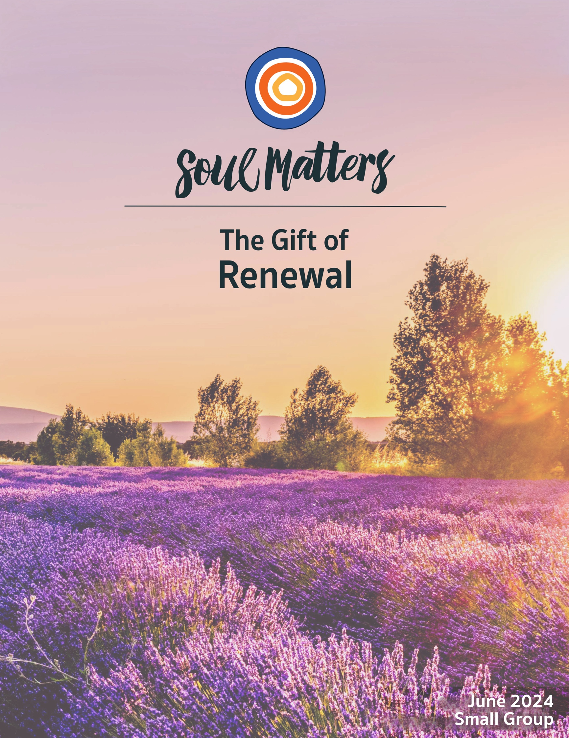

Welcome to the Gift of Renewal

We are renewed by so many things: nature, each other, memory, music, play, solitude, silence, and - of course - our faith. Through small groups, calls to justice work, worship, caring for one another, covenant and accountability, our faith breathes new life into us.

But it also renews us in a way that often goes unnoticed: through questions! Or to be more precise, our faith has a sneaky way of changing our lives by changing the questions we ask.

Questions around renewal are a great example of this.

For instance, the “renewal questions” lifted up by our secular culture revolve mainly around health (Are you drinking enough water? Are you getting enough sleep?) and work/life balance (Are you making enough time for family, play and rest?). Those are fine questions, but they only go so deep and push us so far.

Here’s where our faith comes in. It enters the scene and in effect says, “Hey, look over here. There’s a box with an entirely different set of renewal questions that nobody’s opened yet.” Questions like:

Are you sure it’s your body that’s tired, or could it be your soul?

What if “time away” isn’t about restoring yourself in order to return to work, but rather making space to decide if it’s time to re-imagine what your “true work” really is?

Is it time to renew your responsibility to those who will come after you?

Is it time to renew your commitment to carry on the work of those who came before?

What if you saw your daily living and loving as an opportunity (even a calling) to renew others’ faith in humanity?

Could it be that continual self-improvement is not the path to renewal, but instead compassionate acceptance of who you already are?

And those are just the questions sitting on top of the pile!

So friends, this month, let’s renew and refresh the questions we ask.
Let’s remind ourselves that, indeed, we change our lives by changing our questions.
And, maybe most importantly, let’s each ask ourselves, “What renewing question do I want to take with me into the summer?”

Our Spiritual Exercises
It’s one thing to analyze a theme; it’s quite another to experience it. By pulling us out of the space of thinking and into the space of doing, these exercises invite us to figure out not just what we have to say about life, but also what life has to say to us!

Pick the exercise that speaks to you the most. Come to your group ready to share why you picked the exercise you did and what gift it gave you.

Option A

Saunter, for a long while!

Walking, ideally, is a state in which the mind, the body, and the world are aligned, as though they were three characters finally in conversation together, three notes suddenly making a chord. Walking allows us to be in our bodies and in the world without being made busy by them.
Rebecca Solnit

Saunter. Stroll. Meander. Whatever word you use, summer invites us to walk in a different way, a way that leads to renewal.

Length is one part of what allows walking to achieve the alignment that Rebecca Solit speaks of in her quote. The other secret ingredient is altered attention. Some get at this through the idea of mindfulness, but perhaps the best way of describing it is how one short story writer did when he talked about “walking with love.”

So this month, challenge yourself to go on a longer walk/stroll/hike than you usually do. For some, this might mean a two-day hike. For others, two hours may be pushing beyond what you normally do. For those of us in wheelchairs or with aging knees, your sauntering needs to be as long as fits your unique self. Ultimately, the exact length doesn’t matter. It just has to be long enough to get you lost in the meandering, and present enough to your surroundings that presence becomes the one strolling at your side.

As for the altered attention part, we’ve put together a list below to help you sort out for yourself what that entails. The kind of attentive strolling that renews us will differ from person to person. Reading and watching this list of resources is an essential part of this exercise, offering you inspiration to try strolling/hiking/rolling/sauntering in a way you’ve not done before.

However you end up going about this, may you encounter the renewing music from which Solnit’s quote arises!

A List of Long Sauntering Advice

- What I learned about America at 3 miles per hour
https://www.washingtonpost.com/opinions/2023/03/29/neil-king-american-ramble-walk/

- Wanderlust: Rebecca Solnit on How Walking Vitalizes the Meanderings of the Mind
https://www.themarginalian.org/2015/06/03/wanderlust-rebecca-solnit-walking/

- The Art of Sauntering
https://downeast.com/land-wildlife/art-of-sauntering/

- Renewal: A meditation on hiking after a long year
https://www.youtube.com/watch?v=CEJ4CrMobeI

- Mindful Strolling
5-Minute Walking Meditation: https://www.youtube.com/watch?v=OHxSwimT6wU
10-Minute Walking Meditation: https://www.youtube.com/watch?v=oa6palX-odg

Option B

Take a Few “Weird Walks”

“Weird walks” are an entirely different take on strolling. Instead of heading out with the goal of getting in steps or tapping into mindfulness, “weird walkers” go until they stumble on something weird. It’s all about being renewed by playfulness and curiosity.

So, this month turn your strolls into strange little scavenger hunts! (Be sure to take your cell phone or camera to document and show your group members the weird things you stumble upon.)

Here’s a couple of links with a bit more guidance:
- https://www.bustle.com/wellness/sunshine-guilt-tiktok
- https://ca.style.yahoo.com/why-people-taking-weird-walks-125811943.html

And here are a few weird walk examples:
- https://www.tiktok.com/@leuvenzoekt/video/7190026311904054534
- https://www.tiktok.com/@littleguardiansphl/video/7188886634249686314
- https://www.tiktok.com/@emilieleyes.hypnosis/video/7188212467749653802

Option C

Your Way to Keep Going?

At one time or another, we’ve all asked, “How do I keep going?” It’s a question that comes up not only when life is especially challenging, scary or disorienting, but also when it is especially routine and repetitive. In those moments, we hunger for renewal and new energy. Some strategy that will center us or at least help us put one foot in front of the other.

Wanting to remember how to find this kind of renewal led the writer, Lisa Olivera, to create a personal “How To Keep Going Manifesto.” Basically, she wrote out a list of the ways that have enabled her to keep going in the past so that she can more easily grab ahold of them in her present. ,

Engaging her manifesto makes for a great spiritual exercise. Here are your instructions:

- Read through the Keep Going Strategies in her manifesto: https://lisaolivera.substack.com/p/how-do-i-keep-going
- As you go through Olivera’s list, identify one that you’ve also used and treasure. Spend some time with the memory of this moment when you “kept going.” Ask yourself how this memory might be trying to speak to you. Is it trying to offer you a word of comfort or challenge for your life today?
- Finally, go through the list again and identify another strategy of hers that you want to remember and lean into this summer.

Extra Mile Idea: If you want to go deeper with this exercise, you could spend this month creating your own How To Keep Going Manifesto using Olivera’s as a guide.

Option D

Begin Your Own Garden Library

Lyn Swett Miller describes herself as a “micro-climate photographer celebrating transformation and renewal at the convergence of compost, climate and creativity.” One of her most compelling photography projects is what she calls her Garden Library. In short, this library is a set of books she puts out among the nature of her backyard so that they will compost.

As we know, composting is one of life’s greatest renewal processes, as it breaks down the “old,” allowing it to re-emerge as soil for new life. And so Miller’s Garden Library provides her with the opportunity to reflect on what she needs to let go of and return to the earth, so her own life can be renewed. This has led her to compost status-centered diplomas, male-centered history books, and even sheet music that represents a part of her childhood.

So, what would your Garden Library involve? What needs composted in your life to make room for renewal? And what books or paper-based material represents that? More about Miller’s Garden Library can be found in the four links below. Use those links to inspire you as you create your own garden library this month.

- The Red Book
- Re-Composing Shakespeare
- Books, Still and In Motion
- Composting & Composing A Life

Option E

Let Your Good Fortunes Renew You

In his book American Ramble: A Walk of Memory and Renewal, the author Neil King Jr. writes about a spiritual exercise he loves to do:
“As the year began, I wrote a tally of my good fortunes, a practice I highly recommend. If you start small and build out, it can clarify the magnitude of your blessings. You start with elemental things, like: A heart that beats. Eyes that see. Blood that flows. Lungs that breathe unimpeded by gunk. A mental windshield not too splattered with bugs. Failing to note the absences will cut any proper list of good fortunes in half. The bones that aren’t broken, the illnesses or hates you don’t have, the aches you don’t feel. Like many things that are unswervingly good—oxygen, say, and water—health is likewise transparent and easy to miss when you have it. Then you get to the meaty stuff. A wife you love. A house that isn’t falling down.”

With King’s words as your guide, make some time this month to create your own Good Fortunes List!

Option F

Which Renewal Companion Piece Calls to You?

Sometimes we come across a quote, song, article or movie and it perfectly captures what’s going on for us right now. Or it allows us to view our current circumstances in a new light.

With this in mind, spend some time this month reading through the Companion Pieces section below to find the one that speaks most powerfully to you.

We encourage you to use the same discernment practice with the Companion Pieces as you do with the packet’s list of questions: Go through them with an eye for the one that “shimmers” the most.
Come to your group ready to share your quote and the journey it took you on.

Your Question

This list of questions is an aid for deep reflection. They are not meant to be answered as much as to take you on a journey.

Read through the questions 2-3 times until one question sticks out for you and captures your attention, or as some faith traditions say, until one of the questions “shimmers.”

Then reflect on that question using one or all of these questions:
- What is going on in my life right now that makes this question so pronounced for me?
- How might my inner voice be trying to speak to me through it?
- How might Life or my inner voice be trying to offer me a word of comfort or challenge through this question?


- Whose way of being in the world renews your faith in humanity?
- How does your body tell you it is in need of renewal? What is it telling you now?
- Which of your senses most reliably leads you to renewal? What might you do this week to make room for its gift?
- If one were to propose that you make room for a day in which you produce nothing, don’t check a single thing off your to-do list, confront no problems and search for no solutions, what would your first reaction be?
- Which summer of your life renewed you the most?
- How would your life change if you saw rest as “a form of resistance”?
- How would your life be renewed if you put presence before productivity?
- Have you ever been renewed by failure?
- Have you ever been renewed by vulnerability?
- Has an animal ever renewed your relationship with life?
- If rest could speak, what do you think it would say to you?
- If someone gave you a box of everything that has renewed you, what is the first thing you would look for?
- Renewal often happens through becoming lighter. So, what might your inner wisdom be nudging you to shed, let go of, or give up this summer?
- What’s your question? Your question may not be listed above. As always, if the above questions don't include what life is asking from you, spend the month listening to your days to find it.

Companion Pieces

Recommended Resources for Personal Exploration & Reflection

The following resources are not required reading. We will not analyze these pieces in our group.
Instead they are here to companion you on your journey this month, get you thinking
and open you up to new ways of imagining the gift of renewal

Word Roots & Definitions

Renewal…
to begin or take up again, as an acquaintance, a conversation, etc., resume.
to make effective for an additional period:
to restore or replenish
to restate or reaffirm a promise
to make valid or effective for a further period
to regain or recover vigor or strength
to replace an old or worn-out part or piece
source

Antonyms: impair, deteriorate, exhaust, discontinue, corrupt, weaken, defile, deprave

Wise Words

A day when one has not pushed oneself to the limit seems a damaged, damaging day, a sinful day. Not so! The most valuable thing one can do for the psyche, occasionally, is to let it rest, wander, live in the changing light of a room.
May Sarton

Each person deserves a day away in which no problems are confronted, no solutions searched for. Each of us needs to withdraw from the cares which will not withdraw from us.
Maya Angelou

When we live and work in twenty-four-hour shifts without rest – we are on war time, mobilized for battle. Yes, we are strong and capable people, we can work without stopping, faster and faster, electric lights making artificial day so the whole machine can labor without ceasing. But remember: No living thing lives like this.
Wayne Muller
You can’t live life at warp speed without warping your soul.
Lance Witt

Even if my body and spirit are asking for a break, I expect myself to power through. But if I power through, I am not leaving room for guidance of the spirit.
Rev. Darcey Laine

Sabbath time can be a revolutionary challenge to the violence of overwork, mindless accumulation, and the endless multiplication of desires, responsibilities, and accomplishments. Sabbath is a way of being in time where we remember who we are, remember what we know, and taste the gifts of spirit and eternity… Like a path through the forest, Sabbath creates a marker for ourselves so, if we are lost, we can find our way back to our center.
Wayne Muller

There is deep power in taking a break, honoring your body and actively participating in your deprogramming from grind culture. We have been brainwashed to be violent towards our own bodies by pushing it to exhaustion… Rest is a form of resistance because it disrupts and pushes back against capitalism and white supremacy.
Tricia Hersey

Black joy is not this toxic positivity where we force ourselves to ignore the realities of the world and avoid the problems in our life. It’s a moment of reflection and happiness in which we are able to tell ourselves there is more to this life and world than just pain… Part of Black joy is a hope that things will soon get better and another part of it is a celebration of still being around, still being here.
Miracle Jones

You know that the antidote to exhaustion is not necessarily rest? … The antidote to exhaustion is wholeheartedness.
David Whyte

Listen, are you breathing just a little, and calling it a life?
Mary Oliver

Practice not getting frustrated when your daughter takes 45 minutes to walk around the block. Learn something from her unabashed desire to take forever. Follow her lead instead of assuming she’s slowing you down.
Lisa Olivera

Humanity is on a treadmill that is moving fast. And if you were to ask, “Where are you going? The answer may very well be, “I don’t know but I have to get there quickly.”
Betty Goedhart

Presence is far more intricate and rewarding an art than productivity. Ours is a culture that measures our worth as human beings by our efficiency, our earnings, our ability to perform this or that. The cult of productivity has its place, but worshiping at its altar daily robs us of the very capacity for joy and wonder that makes life worth living
Maria Popova

There is no way to repress pleasure and expect liberation, satisfaction, or joy.
adrienne maree brown

The world of play favors exuberance, license, abandon. In it, selves can be revised.
Dianne Ackerman

To be a people of renewal is to ask not simply, “How do I refresh?” but also “How do I return?” The challenge of life is not just about moving forward but moving forward without losing touch with all we have held dear.
Rev. Scott Tayler
If we will have the wisdom to survive,
to stand like slow growing trees
on a ruined place, renewing, enriching it...
then a long time after we are dead
the lives our lives prepare will live here...
On the steeps where greed and ignorance cut down
the old forest, an old forest will stand.
Wendell Berry

All you can do for another person is be an environment in which if they wanted to come up for air, they could.
Ram Dass

Every day is a renewal, every morning the daily miracle. This joy you feel is life.
Gertrude Stein

Music

We create two different playlists for each of our monthly themes: one in Spotify and another in YouTube. They are organized as a journey of sorts, so consider listening from beginning to end and using the playlists as musical meditations.

Click here for the Spotify playlist on Renewal
Click here for another special Spotify playlist for this month: Renewed by Joy

Click here for the YouTube playlist on Renewal
Click here for the YouTube of our special June playlist Renewed by Joy

Click here for all Spotify playlists
Click here for all the YouTube playlists

Videos & Podcasts

Slow Down - Hidden Brain
https://hiddenbrain.org/podcast/you-2-0-slow-down/
On savoring and the renewal of pleasure

A Word from the Nap Bishop
https://www.youtube.com/watch?v=3u3OvzFKuQY
On rest and renewal as a form of resistance

Renewed by the Worth of the Ordinary
https://www.youtube.com/watch?v=3jA4FJtrLNE&list=RDCMUCcPPUszZ4-7yzZNgAAYwJjg&index=14

Renewing our relationship with enough
https://www.youtube.com/watch?v=MRXc0G3Njg8&t=339s

On What Makes Poetry and Gardens A Perfect Pair
https://www.npr.org/2022/06/21/1106424791/heres-what-makes-poetry-and-gardens-a-perfect-pair-according-to-2-poet-gardeners

When I am Among The Trees - Mary Oliver
https://www.youtube.com/watch?v=BFCbjit2zmI

Wild Geese - Mary Oliver
https://www.instagram.com/reel/C1_-s2BvsFw/?igsh=MW5ramlsbHU2NnMycw%3D%3D

The Renewing Power Of Black Joy*
https://www.ted.com/talks/miracle_jones_the_revolutionary_power_of_black_joy

Fatherhood Teaches you the Simplest Truth*
https://www.youtube.com/watch?v=XmipaszEL5Q
On how fatherhood renews us with unconditional joy and unconditional love

On Renewing Our Understanding of How Fatherhood Alters Us*
https://www.youtube.com/watch?v=cul4L441x9o

Senior Prom: LGBTQ+ Seniors Get the Prom of Their Dreams *
https://www.youtube.com/watch?v=rFBv6Mc77Ys
This will renew your faith that the world can change and become kinder, more open and joyous.

We Need Better Narratives about Gender*
https://www.youtube.com/watch?v=h4PVn7_BX0Q
On renewing our commitment to understanding queer life more expansively
How often does our body renew and regrow itself?
https://www.youtube.com/watch?time_continue=61&v=Nwfg157hejM&feature=emb_logo

Renew Your Sense of Play with a Rube Goldberg machine!
Here, here, here and here.

These dancers will renew your spirit with joy
Check them out here, here and here

Articles

It’s a Right, Not a Privilege: The Napping Resistance Movement
https://elemental.medium.com/its-a-right-not-a-privilege-the-napping-resistance-movement-54fc147ba32b

Black Gardeners Find Refuge & Renewal in the Soil
https://www.nytimes.com/2021/10/26/special-series/black-gardeners-pandemic.html

Why We Need Gender-Inclusive Terms for 'Father' and 'Mother' *
https://www.vice.com/en/article/4awa8d/gender-inclusive-definition-father-mother-parent
On using Father’s Day to renew and expand our terms

This Is How We Juneteenth*
https://www.refinery29.com/en-us/2021/06/10512518/how-to-celebrate-juneteenth-this-year
On the renewal rooted in Juneteenth

On Remembering How Fun Renews Us
https://www.nytimes.com/2022/09/02/opinion/how-to-have-fun.html

* identifies items that explore the connection between the monthly theme of renewal and the major holidays that occur in June: Pride Month, Juneteenth and Father’s Day

Books

American Ramble: A Walk of Memory & Renewal
“an exquisite account of both personal and national renewal”
https://www.washingtonpost.com/opinions/2023/03/29/neil-king-american-ramble-walk/
Video: https://www.youtube.com/watch?v=H5KZ-WZq8lw&t=1s

The Book of (More) Delights, Ross Gay
Celebrating gardens and gratitude as sources of summer renewal

Movies

The Last Repair Shop Must watch!!
Perfect Days
Miss Juneteenth
Juneteenth: Together We Triumph
Children of Men

More Monthly Inspiration from Soul Matters!

Our Facebook Inspiration Page
https://www.facebook.com/soulmatterssharingcircle/

Our Instagram Page:
Find us as “soul_matters_circle”

Packet Introduction Credit Note: Unless explicitly noted otherwise, the introductions of these packets are written by our Team Lead, Rev. Scott Tayler. Rev. Scott gives permission for his pieces to be used in any way that is helpful, including in newsletters, worship and in online service/recordings.


© 2023-24 Soul Matters ALL RIGHTS RESERVED

Packets are for use only by member congregations of the Soul Matters Sharing Circle.
Learn how to join at https://www.soulmatterssharingcircle.com

