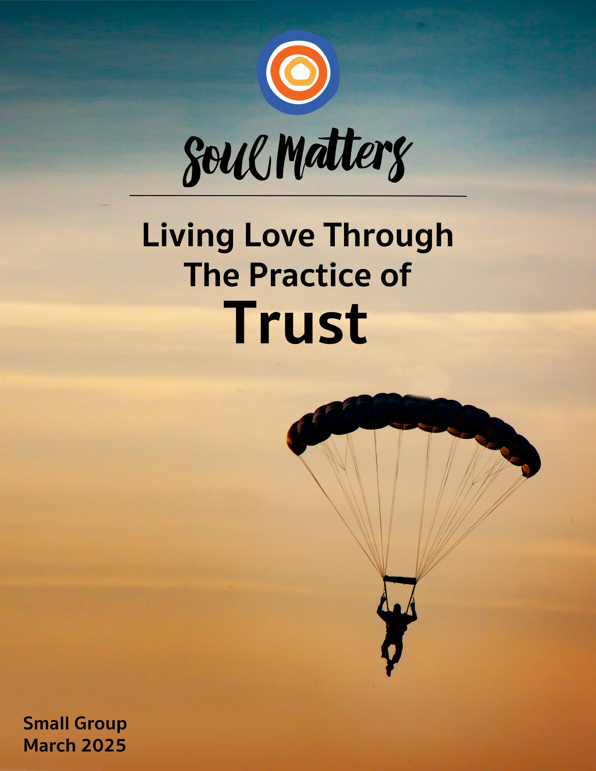

Welcome to the Practice of Trust

In religious circles, talk of trust most often revolves around having faith that life will look after us. For instance, our Christian friends sing hymns about God “watching over us” and keeping “an eye on the sparrow.” Our Jewish friends lift up the Exodus story to encourage faith that God will help us make our way even when things look bleak. Likewise, prayer practice for our Muslim friends is all about reminding oneself that you are in Allah’s safe hands. We UUs voice similar sentiments through the language of trusting “a Love that will not let us go.”

This call to trust Life comes to us as a gift. After all, it can be quite easy to convince ourselves that life is a foe. So we need our faith communities to restore our faith that life is ultimately a friend. We need the reassurance that when we fall, we can count on being picked up.

But what about being pushed? Don’t we need to count on that too? A Love that won’t let us go is essential, but isn’t it just as important to have faith in a Love that won’t let us get too comfortable? Especially as March asks us to honor women’s history, the anniversary of the Selma–Montgomery March and Transgender Day of Visibility, we certainly don’t want to forget about a Love that disturbs. We need a Love that keeps us “creatively maladjusted” to the inhumane and unjust parts of our society. We need a Love that exposes privilege and unsettles those of us who have it. We definitely need a Love that tells those of us who are marginalized and tired, “I won’t let your pain be ignored.”

And just when that type of trust seems the one we all should place at the center of our hearts, another voice adds itself to the mix. This one reminding us to trust that it’s not all up to us. That sometimes it’s ok to rest. A voice that doesn’t disturb and push but instead assures us that we can let go. That tells us to trust that we can - for a while - put the work down because others are ready to pick it up, knowing that we will be there to pick it up when rest calls to them.

So, friends, where does that leave us? What is it?
Trust life to pick us up?
Trust life to push and poke us?
Trust that it’s ok to put the work down for a while?

It is all of them, of course. And more.

But maybe it’s mostly about trusting that we’ll know which call is right for us. Maybe it’s about having faith in ourselves and not letting anyone tell us what we need to trust in the most.

Another way to put this is to say that we need to make room for everyone’s uniquely broken heart. We all experience a loss of faith in our own way. The trust you need to repair is likely different from mine. But what we both long for is safe space. Space to say how hard that work of repair is. Space to say how much our experience of broken trust hurts.

So, how about it friends? This month, let’s prove to each other that we can be trusted to offer safe and wide-open space for each other’s broken hearts.

Our Spiritual Exercises
It’s one thing to analyze a theme; it’s quite another to experience it. By pulling us out of the space of thinking and into the space of doing, these exercises invite us to figure out not just what we have to say about life, but also what life has to say to us!

Pick the exercise that speaks to you the most. Come to your group ready to share why you picked the exercise you did, how it surprised you and what gift it gave you.

Option A

What Do You Turn To?

We trust in more things than we may realize. And one of the ways we reveal and remember that is to think about what we turn to when things get hard, stressful, confusing or even frightening. That’s what this complete-the-sentence exercise is all about. The link below lists a bunch of universally challenging moments and then leaves space for you to name what you turn to in these situations. The goal is to remind yourself that life has surrounded you with more sources of trust than you can imagine.

Here’s the link to the complete-the-sentence document: https://docs.google.com/document/d/1MMJEir8f8rgG24yZnb4Oa-PGDMc4H9nI6OnvG3I8wFs/edit?usp=sharing

A few things about it:
- The document can be downloaded to your computer so you can complete it by typing in your responses.
- We encourage you to go off-script as needed, changing, deleting, skipping or adding to the “When…” statement scenarios we put in.
- The “When…” statements are purposely written in both poetic language with the hope that it might open you to responses you may not expect. It will help to not overthink your responses, but instead allow yourself to free-associate and listen to answers that rise up on their own.

To help you on your way, we suggest you read through this beautiful poem and reflection by writer and therapist Lisa Olivera: https://lisaolivera.substack.com/p/what-do-you-turn-toward

Option B

Tip Toe Toward Trusting Yourself

Facing our fears takes a whole lot of self-trust. Getting over self-doubt can seem an impossible hurdle. That’s why some advise us to simply “Jump!” “Take a leap of faith,” and “Go all in!”

But what if the secret path to overcoming our fears and believing in ourselves is not one big leap, but instead a bunch of baby steps?

This exercise is all about those trusting those baby steps rather than the big leap.. Here’s your challenge in a nutshell:

Identify one of your prominent fears and then find one small way of facing it.
Or to put it another way:
Find one manageable way to build your ‘I believe in myself’ muscle!

Your options are endless. Have you longed to write a book but are too scared to even voice that dream? Well, baby step your way into it by writing a short story or poem inspired by the courage or wisdom of a friend, and
then give it to them as a gift. Is social anxiety your nemesis? Forget forcing yourself to go to those office parties and just make yourself start a conversation with a co-worker or two, or take the bigger step of inviting them to join you for a coffee. Terrified of public speaking? Don’t start by volunteering to do a lay sermon but instead sign up to teach an RE class. Doubting your courage to pursue that entrepreneurial dream you’ve had for so long? Don’t quit your job and leap in. Instead simply commit to drawing up a business plan for it this month. Don’t trust yourself to pull off a conversation with your sibling or partner about a concern you have about your relationship with them? Don’t dive in with a direct confrontation, but start with writing down what you want to say to them; then write another piece imagining what you think their responses might be. Been afraid to stick up for your worth at work and ask for a raise? Don’t boldly walk into your boss’ office just yet. Instead just sit down and write the raise you want on a napkin and carry it around in your pocket all month.

Bottom line: No need to jump into self-trust head first. Just tip toe toward it instead!

Option C

Test the Trust Formula with Your Partner
(Or Your Child or Friend)

Building trust in our marriages and partnerships is tricky business. We want our partners to believe we love them and will keep their needs front and center. But doubts can easily creep in. So what’s the secret to building the trust needed to keep our relationships loving and strong? Psychologist and researcher, John Gottman, claims that our usual answers have it upside down. Common wisdom advises us that grand gestures are the key to making the magic happen: surprise romantic getaways or the ability to have “deep conversations” all the time. Gottman objects. He says, “Nope, it’s the small stuff!” Tiny things, like bringing your partner coffee in the morning or putting down your phone when they’re talking to you or remembering that they have a big presentation coming up next week and checking in about how they are feeling about it. Gottman has even created a formula: If you average five of these small positive interactions to every one negative or failed interaction, you are guaranteed a loving and trust-filled relationship!

Sounds too simple, right? Well, this month, you are invited to test it out. Take some time to learn about Gottman’s theory by watching the below videos. Then commit yourself to five of these small gestures a week (or even a day!) and see what happens!

Note: This works with our friendships and relationships with our children too! So for those of us who are single, consider testing it out with a family member or friend whose relationship you want to deepen or improve.

Videos to Watch:
- https://www.youtube.com/watch?time_continue=58&v=QHN2EKd9tuE
- https://www.youtube.com/watch?time_continue=39&v=ib7Ain2aVR0
- https://www.youtube.com/watch?time_continue=172&v=rgWnadSi91s
- https://brenebrown.com/videos/anatomy-trust-video/

A Couple Books to Dig Deeper:
- The Relationship Cure
- What Makes Love Last?: How to Build Trust and Avoid Betrayal

Option D

Three Objects of Trust

Identifying where trust resides in our lives is most often a mental exercise of examining our thoughts and memories. But this route can end up masking how much trust is embodied in the physical objects surrounding us.

For instance, our favorite garden gloves represent our faith in the living processes of life, not to mention our trust that being close to the earth and burying our hands in the soil will bring us back to life too. That heirloom necklace we wear represents the trust our family members put in us to hand it - and family stories - down to future generations. Lotions, bath fragrances and silk sheets capture how much we trust our bodies to tell us what they need. For those horse riders among us, our bridles and saddles contain the story of how much we trust these magnificent creatures and how much they trust us. Our old typewriter or new keyboard represents how much we trust ourselves and the creative muses within to generate meaningful words.

So now let’s turn to you? What objects sing your special relationship with trust? This month, honor them by going on a treasure hunt to find three objects that represent three important or under-recognized sources of trust for you.

If possible, bring one or two of them to your group and be ready to share what they say about your unique relationship to and journey with trust.

Option E

I Trust the People Who…

Here are four people who have clearly worked hard to know what kind of people they trust and what kind of people they don’t.

I don't trust people who don't love themselves and tell me, 'I love you.' ... There is an African saying which is: Be careful when a naked person offers you a shirt.
Maya Angelou

trust the people who move towards you and already feel like home…
trust the people who revel in pleasure after hard work.
trust the people who let children teach/remind us how to emote, be still, and laugh.
trust the people who see and hold your heart.
trust the people who listen to the whales.
adrienne maree brown

Everybody loves butterflies. But I trust the caterpillars more. I trust the ones who know they aren’t done.
Andrea Gibson

Distrust all in whom the impulse to punish is powerful.
Friedrich Nietzsche

With these people and their quotes in mind, spend some time this month thinking as hard as they have about the types of people you deeply trust and the types you don’t. We suggest you limit your two lists, keeping them to no more than five types each. This will force you to get at more meaningful lists that speak to your core values and stories. Come to your group ready to share not only your lists but what making them taught you about yourself.

Option F

Ask Them About Trust

One of the best ways to explore our monthly themes is to have conversations about them with people who are close to you. It’s also a great way to deepen our relationships! Below is a list of questions to help you on your way. Be sure to let your conversation partner know in advance that this won’t be a typical conversation. Telling them a bit about Soul Matters will help set the stage. Remember to also answer the questions yourself as they are meant to support a conversation, not just a time of you quizzing them.

Come to your group ready to share what surprised you about the conversation and what gift or insight it gave you. As always, keep a lookout for how your inner voice is trying to send you a message of comfort or challenge through these conversions with others.

Trust Questions:

- What have you trusted since childhood and never lost faith in?
- Has trusting people gotten easier or harder as you’ve grown older?
- At what stage in your life were you most trustworthy? At what stage were you the least trustworthy?
- Have you ever been made trustworthy by someone who risked putting their trust in you?
- Do you regret the time you were too scared to trust the unknown and take that leap of faith?
- Have you done more battling with your body than trusting it?
- What would happen if you trusted life enough to let go?
- Do you think your future self will be better or worse at trusting life and people than you are now?

Option G

Which Companion Piece Speaks to You?

Sometimes we come across a quote, song, article or movie and it perfectly captures what’s going on for us
right now or allows us to view our current circumstances in a new light. With this in mind, spend some
time this month going through the Companion Pieces section below to find the one piece that speaks most powerfully to you.

Go through them with an eye for the one that “shimmers” the most.
Come to your group ready to share the piece you picked, why it called to you and the journey it took you on.

Your Question

This list of questions is an aid for deep reflection. How you answer them is often less important than the journey they take you on.

So, read through the list of questions 2-3 times until one question sticks out for you and captures your attention, or as some faith traditions say, until one of the questions “shimmers.”

Then reflect on that question using one or all of these questions:
- What is going on in my life right now that makes this question so pronounced for me?
- How might my inner voice be trying to speak to me through it?
- How might Life or my inner voice be trying to offer me a word of comfort or challenge through this question?


- What have you trusted since childhood and never lost faith in?
- Have you ever been made trustworthy by someone who risked putting their trust in you?
- When did trust in the Divine show up in your life? Is there anything about that moment that might help you navigate your life right now?
- When did trust in the Divine leave your life? Do you ever feel a longing for it to return?
- When broken trust left you broken-hearted, what voice in your head or word from a friend helped you pick up the pieces?
- Has it ever been hard to trust that your children will find their way?
- It’s been said that trust is choosing to risk making something you value vulnerable to another person’s actions. Does this make you see yourself or any of your relationships in a new light?
- Is it time to start trusting yourself again?
- Do you have doubts that deserve to be more deeply trusted?
- Have you done more battling with your body than trusting it?
- What would happen if you trusted life enough to let go?
- What has your life partner taught you about trust?
- Are you upset because you were lied to or because, from now on, you can’t believe the one who lied?
- Do you regret the time you were too scared to trust the unknown and take that leap of faith?
- How would your life change if you stopped believing that people can’t be trusted?
- What have you learned about trusting grief, rather than resisting it?
- What’s your question? Your question may not be listed above. As always, if the above questions don't include what life is asking from you, spend the month listening to your days to find it.

Companion Pieces
Recommended Resources for Personal Exploration & Reflection

The following resources are not required reading. Nor are they intended to be analyzed in your group.
Instead they are here to companion you on your personal journey this month, get you thinking
and open you up to new ways of embodying the practice of trust in your life.

Wise Words

Trust is a confident engagement with the unknown.
Rachel Botsman

Trust is choosing to risk making something you value vulnerable to another person’s actions. Distrust [is when] what is important to me is not safe with a person in this situation or in any situation.
Charles Feltman

To have faith is to trust yourself to the water. When you swim you don’t grab hold of the water, because if you do you will sink and drown. Instead you relax, and float.
Alan Watts

I’ve come to trust not that events will always unfold exactly as I want, but that I will be fine either way.
Marianne Williamson

It’s a good thing to have all the props pulled out from under us occasionally. It gives us some sense of what is rock under our feet, and what is sand.
Madeleine L’Engle

Daughter, believe me,
when you tire on the long thrash
to your island, lie up, and survive.
As you float now, where I held you
and let go, remember when fear
cramps your heart what I told you:
lie gently and wide to the light-year
stars, lie back, and the sea will hold you.
Philip Booth

A bird sitting on a tree is never afraid of the branch breaking, because her trust is not in the branch but in her own wings.
Charlie Wardle

As soon as you trust yourself, you will know how to live.
Johann Wolfgang von Goethe

In relationships, trust isn’t a promise to never hurt each other. It’s acceptance of the risk that we will hurt each other and the confidence that, if we do, we will come together to heal.
Esther Perel

The best way to find out if you can trust somebody is to trust them.
Ernest Hemmingway

A team is not a group of people that work together. A team is a group of people that trust each other.
Simon Sinek

I don't trust people who don't love themselves and tell me, 'I love you.' ... There is an African saying which is: Be careful when a naked person offers you a shirt.
Maya Angelou

trust the people who move towards you and already feel like home. trust the people to let you rest…
trust the people who revel in pleasure after hard work. trust the people who see and hold your heart.
adrienne maree brown

Everybody loves butterflies. But I trust the caterpillars more. I trust the ones who know they aren’t done.
Andrea Gibson

Distrust all in whom the impulse to punish is powerful.
Friedrich Nietzsche
Our mistrust of the future makes it hard to give up the past.
Chuck Palahniuk

I don't trust people who are alive and paying attention and don't feel pain about what's happening
adrienne maree brown

You may be deceived if you trust too much, but you will live in torment if you don’t trust enough.
Frank Crane

Trust is the easiest thing in the world to lose, and the hardest thing in the world to get back.
R. M. Williams

I'm not upset that you lied to me, I'm upset that from now on I can't believe you.
Author unclear

The same voices that cannot be trusted with our histories, certainly cannot be trusted with a story unfolding. When you don’t know who to trust, listen first to the one who’s still bleeding.
Cole Arthur Riley

If your wounds are still open, trust
they are doors to an answer and walk through.
You don’t have to be healed to be whole.
You don’t have to know where you’re going
to stop doubting what you’re made of.
Andrea Gibson

Trust in what you love, continue to do it, and it will take you where you need to go.
Natalie Goldberg

I don`t trust anyone who doesn`t laugh.
Maya Angelou

Trust in trust.
Trust in the fact that
trusting won’t always take you
where you want to go.
But not trusting
never will.
Jeremy Lent

Music
Click here for our Spotify playlist on Trust.
Click here for the YouTube playlist on Trust.

Remember! Our playlists are organized as a journey, so consider listening from beginning to end and using the playlists as musical meditations.

Videos & Podcasts

The Anatomy of Trust, Brené Brown
https://brenebrown.com/videos/anatomy-trust-video/
Trust is built in the small moments not the grand gestures!

Why Trust Is Worth It
https://www.youtube.com/watch?v=cWypWe9UAhQ
A spoken and movement meditation on trust.

Who Can You Trust? - The Moth Stories
https://player.themoth.org/#/?actionType=ADD_AND_PLAY&storyId=769
YouTube version here
A remarkable series of trust-breaking and trust-making events (which led to the grant that enabled the discovery of the inherited breast cancer gene.)

When You Need It To Be True - Hidden Brain
https://hiddenbrain.org/podcast/when-you-need-it-to-be-true/
Can we trust our own instincts?

Deception - Radiolab Podcast
https://www.wnycstudios.org/story/91612-deception
Explores the flipside of trust and asks whether it is possible for anyone to lead a life without deception. How are we to understand the strange power of lying to yourself and others?

Rethinking Infidelity
https://www.ted.com/talks/esther_perel_rethinking_infidelity_a_talk_for_anyone_who_has_ever_loved

The Trust Shift
https://www.bbc.co.uk/programmes/m001xlw5/episodes/player
Five short episodes. Start from the bottom up, with “Local Trust” as the first and “New AI Frontiers” as the last.

Explores three major shifts of trust in human history that have profoundly changed the dynamics of our lives; whether that's how we bank or buy goods, vote, learn, travel, date, and importantly, find and consume information.
RELATED BOOK: Who Can You Trust?

Wait, Galway Kinnell
https://www.youtube.com/watch?v=vB2rqRkQbLY
Trust the waiting…

Drowning Fish, Rudy Francisco
https://www.youtube.com/watch?v=sTx57o-M20c
On trusting yourself to float and not give up.

Articles

Why You Can Not Trust Yourself?
https://markmanson.net/trust

Can You Trust Your Gut?
Eric Barker
https://www.bakadesuyo.com/2013/01/malcolm-gladwell-accurate-judgments-blink/

We’ve Misunderstood Human Nature for 100 Years
https://www.nytimes.com/2024/12/22/opinion/human-nature-polarization-predator.html
On how we can overcome the mistrust and outrage that so often politically divide us.

The Importance of Trusting Yourself: Nick Cave on the Relationship Between Creativity and Faith
https://www.themarginalian.org/2023/10/07/nick-cave-faith/
“To create anything of substance and originality — be it a song or a painting or a theorem — requires that you give yourself over to something you don’t fully understand, in the act of which you better understand yourself and the world…”

Anne Lamott on Trusting Love
https://soulboom.substack.com/p/soul-boom-dispatch-anne-lamott-on
When life has lost its promise, or disappointed us one too many times, when it is hard to trust again or feel alive and curious again, love beckons us over and asks, “Got a minute?

Books

The Science of Trust: Emotional Attunement for Couples
Hello Beautiful

Movies

Inside the Yellow Cocoon Shell
Conclave
Knives Out
Good One
Sword of Trust
The Darjeeling Limited

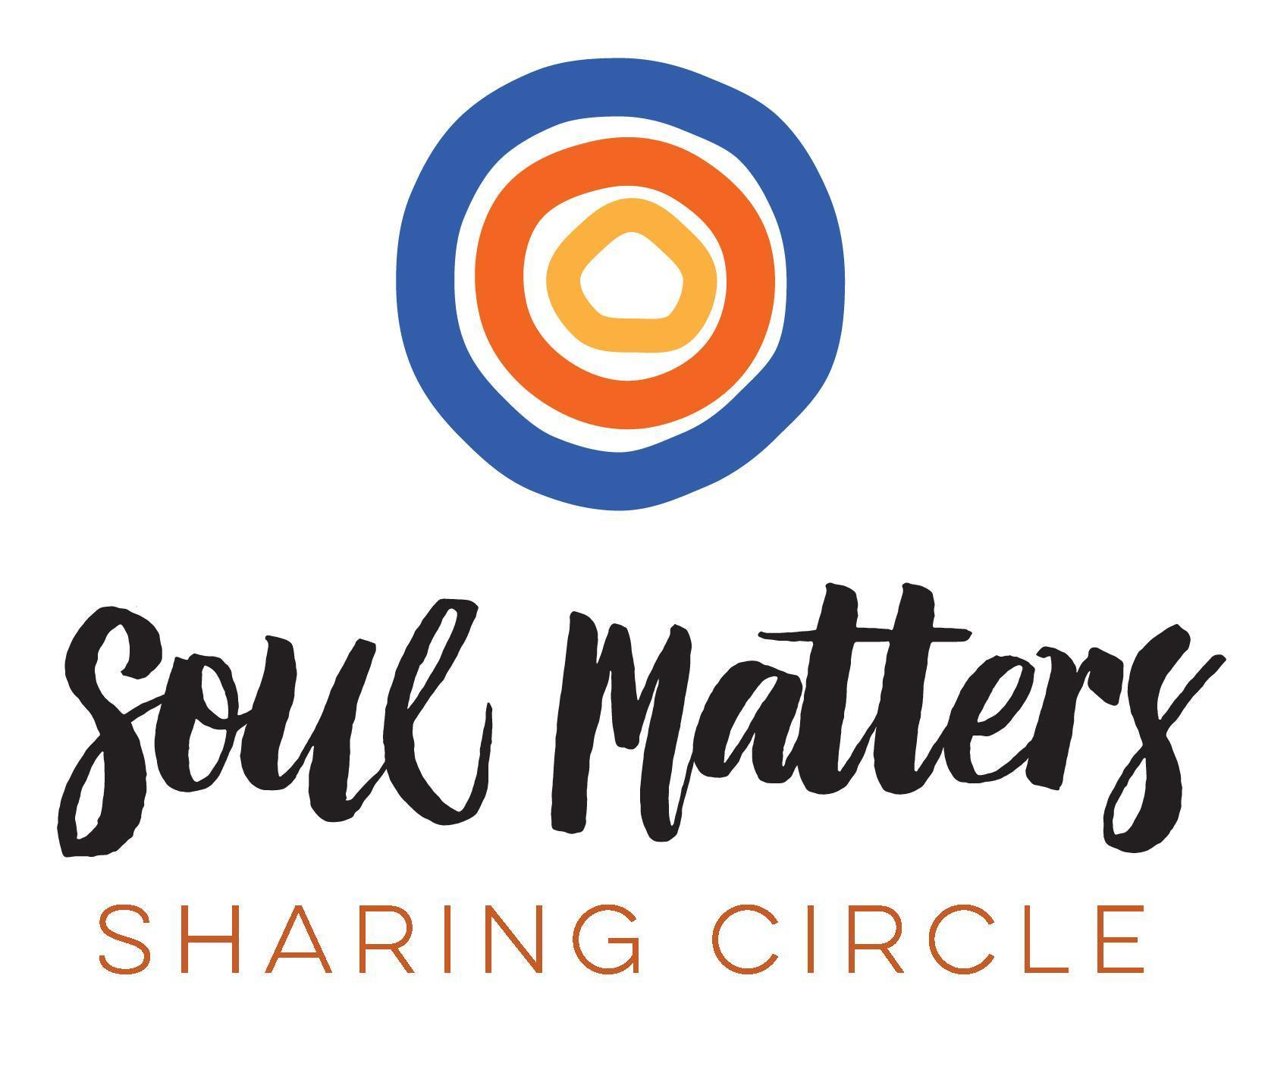
© 2024-25 Soul Matters ALL RIGHTS RESERVED
Packets are for use only by member congregations of the Soul Matters Sharing Circle.
Learn how to join at https://www.soulmatterssharingcircle.com

