Dismantling White Supremacy Culture at UUCSR 2024

Congregational Questionnaire Results
Total number of responses = 63 (About 25% of all members)

Question #1
What is your interest in dismantling white supremacy culture within UUCSR?
extremely interested very interested interested somewhat interested not interested
(Please circle one)

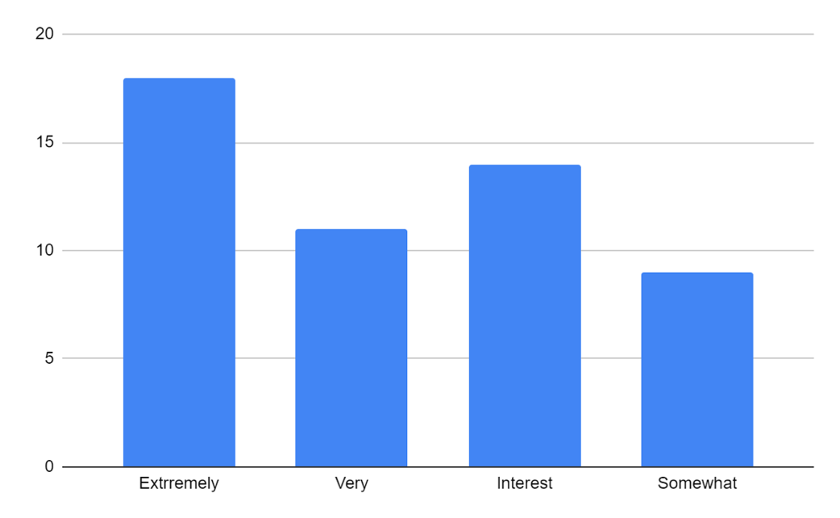

Summary of results
The survey indicated that there is strong interest in dismantling white supremacy culture within UUCSR, with more than 80 percent saying they were extremely interested, very interested, or interested.

More than 80 percent…
Extremely interested = 18 Very interested = 11 Interested = 14

About 20 percent…
Somewhat interested = 9

No one answered “not interested”

Question #2
What is your definition of white supremacy?

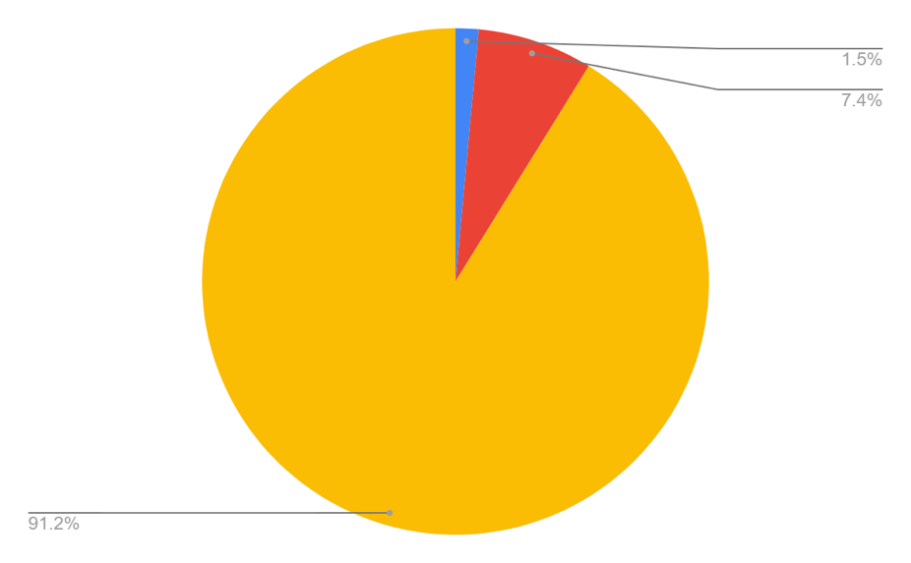
White Supremacy Understanding Scale
- 1 Beginning understanding of white supremacy 1.5%
- 2 Developing an understanding of concept of white supremacy 7.4
- 3 Toward a deeper understanding of concept of white supremacy 91.2

Summary of Results
Most members (more than 90 percent) have a good understanding of what white supremacy culture is.

Summary of General Ideas
Most members expressed a general understanding that there is an unconscious bias toward people with darker skin, and that perhaps there are unearned advantages and privileges for the dominant white population. Although there was uneven depth of analysis or awareness of how white supremacy plays out in the world, there was consensus that there are harmful impacts (particularly) on people of color. Although no one had the opportunity to fully describe white supremacy, all expressed at least one of the thoughts bulleted here:
- Invisibility and negating of thoughts, feelings, voices of POC resulting in marginalization.
- Colorism as the indicator of worth and caste as a means of perpetuating privilege
- Entitlement, power, and privilege of folks with white skin, although folks are largely unaware of their privilege; economic and educational advantage over POC; health outcomes and advantages for dominant culture; loss of safety and oppression for POC folks.
- Based on a legacy from colonialist history and part of the historical culture of conquest and domination and from Europe where violence was the enforcing means of subjugation; although lessened in modern times, still deeply ingrained and normed
- The interpretation of history from a Euro-centric perspective
- At its worst, seen in modern times through organized hate groups or sustained through propagandizing ideas like the “replacement theory.”

Question #3
What is your first reaction when you hear the phrase dismantling white supremacy culture within UUCSR? (enthusiasm, curiosity, confusion, fear, anger, defensiveness, other)?

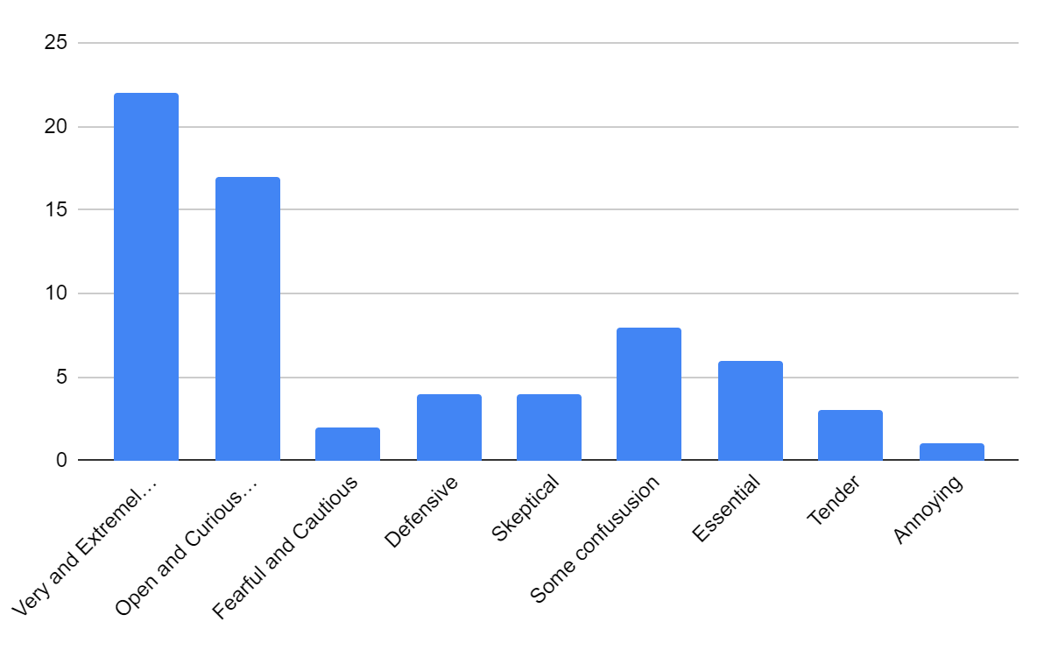

Summary of Results
Most said they were enthusiastic to work on dismantling white supremacy culture or were open or curious about it. Some, however, expressed degrees of confusion or uncertainty.

Question #4

Summary Of Results
- Nearly 75% of respondents think that, in many ways, discussions of white supremacy are important, even essential, for our congregation.
- About 25% are less positive: scared, hesitant, oppose the phrase white supremacy, or are otherwise concerned about discussions.

More Detailed Analysis (Comments edited for length and duplication)
- The most mentioned feeling was essential – mentioned by 39% of respondents, either by itself or with other feelings – tender, exciting, fearful and scary. Some examples include:
- Exciting, essential, tender. The fact that the congregation is so white suggests to me that, when people of color have come to UUCSR events, the majority of them have found something uninviting about it.
- Essential. Very tender because talking about and acting on the idea can bring up so many basic fears.
- Exciting and essential. I want to learn more. It may be scary at times, but I’m OK with that, and feel supported by my loving community.
- Another 30% saw discussions about dismantling white supremacy as positive, were curious about the process, and thought that having the conversation was necessary. A few respondents also remarked on the importance of making changes and not just having a dialog. Some examples are listed below.

- It’s a positive effort, to raise consciousness.
- I am curious and interested in finding places where WSC is imbedded at UU and bringing it to light to be dismantled.
- Having the conversation is necessary and also exciting in how our action can impact our beloved UUCSR community now and going forward.
- Walk the walk! It has been studied enough to know what positive steps can be taken.
- I get tired of rhetoric and want to hear/talk about WHAT TO DO.
- Over 25% of respondents felt talking about dismantling white supremacy is scary, concerning, confusing and daunting. See some examples below.
- Scary. Don’t feel very courageous as I wish I could be. Don’t want to hurt people but this is painful difficult work and takes a lot of effort – a lot of soul searching. To be truly committed one needs to do this work for the rest of your life.
- [We are] a very white congregation taking on a very big beast. How will this work?.. Concerned it may become an empty promise.
- Open to discussion but concerned that only white people were featured in a panel discussion. BIPOC shouldn't have to do ALL THE WORK of dismantling racism, but theirs, if willing, should be the leading voices.
Respondents also talked about how the church was not “a safe place” and “not worth the risk of alienating people.” Other folks felt like they supported the idea of addressing white supremacy culture but are concerned that if their views are not the same as the committee then they will be “labeled as a white supremacist.” Other folks did not believe that dismantling white supremacy was a term that belonged at UUCSR. See examples below.
- UUCSR doesn’t feel like a safe space to have an open discussion of this topic. I believe the boundaries for what is considered acceptable opinion are very tight and narrow. It feels like any dissent from the party line would get me labeled as a ‘white supremist.’ It is not worth the risk of alienating people I consider friends to express my opinions on this topic for attribution.
- It (dismantling white supremacy) is a phrase that does not belong here. That is not to say that we couldn’t be more self-examining about our structures, budget, sermon designs and behaviors.
- I feel very cautious about talking about this within UUCSR. While I am totally supportive of addressing racism and white privilege in the congregation and broader community, I fear that if I am not in total agreement with the wording used or actions taken by the committee, I risk being labeled as a white supremacist, being seen as ignorant, or at the very least, insincere about my desire to address the issue of racism.

Question #5

Summary Of Results
- Yes, it definitely shows up (55%)
- Generally agree that it probably shows up (20%)
- No, I don’t think it shows up (10%)
- Don’t know, not aware of it (15%)

More Detailed Analysis

The section below represents 75% of the respondents:
Yes, I’m sure it does but is Unconscious, Subtle, Difficult to explain, Difficult to understand.
Yes because of who we are- mostly white therefore it must exist here, otherwise more people of color would be attending this church. Decisions are made based on internal biases. Most non-white visitors feel unwelcomed. There is an assumption that all individuals have more or less the same experiences and that culturally, the way we do things is the right way to do things.
Yes because of our UU Culture: rules, procedures, rituals, music, organizational hierarchal structure, and majority-based elections. In addition, there is also economic discrimination that is not spoken of regarding who is included, excluded, and in charge.
The section below represents 10% of the respondents:
All participants did not think that white supremacy was present at UUCSR.
The section below represents 15% of the respondents:
All participants were doubtful that white supremacy could be a part of this congregation ie., “I don’t know how our community of UUCSR is that of a white supremacist-supporting fellowship.”

Question #6
Do you have ideas for how our congregation might do the work of dismantling white supremacy, and/or implementing the 8th Principle? If so, please share them.

Summary Of Results
Respondents offered many promising ideas for how our congregation might do the work of dismantling white supremacy. These included:
- Taking individual responsibility to educate oneself
- Inviting the congregation to examine how our structures and culture invite or disinvite, empower and disempower others
- Getting out in the community to work with people not like ourselves
- Having DWSC take a leading role in educating the congregation
- Having the Adult Ed committee provide more focus on anti-racism
- Getting more people involved with NBOP
- Providing more diversity dialogs and guest speakers
- Using UUA for more resources, small group dialogs
- Breaking down the hierarchy and going more towards a “Community of Communities”
- Promoting honesty, openness, and bravery
- Providing opportunities for people to engage in book groups around anti-racist literature
- Participating in role play
- Joining up in efforts with other congregations, including UU congregations
- Weaving other issues into our anti-racism work (such as climate change)
- Looking at how we welcome folks or make them feel unwelcome when making decisions around safety and security.

Question #7
Please share any other thoughts you may have.

The vast majority of respondents offered thanks and gratitude for doing this anti-racism work. A few respondents noted that this work is life-long and there is not an overnight solution to white supremacy culture, but that also a culture of white supremacy actually hurts all of us. Several folks expressed curiosity about the experiences of marginalized people within our community. Some people noted that we are all at different points in our journey in understanding white supremacy. A few people expressed frustration that our community is being labeled white supremacist or they do not agree with the terminology or otherwise feel that they are not being heard.

