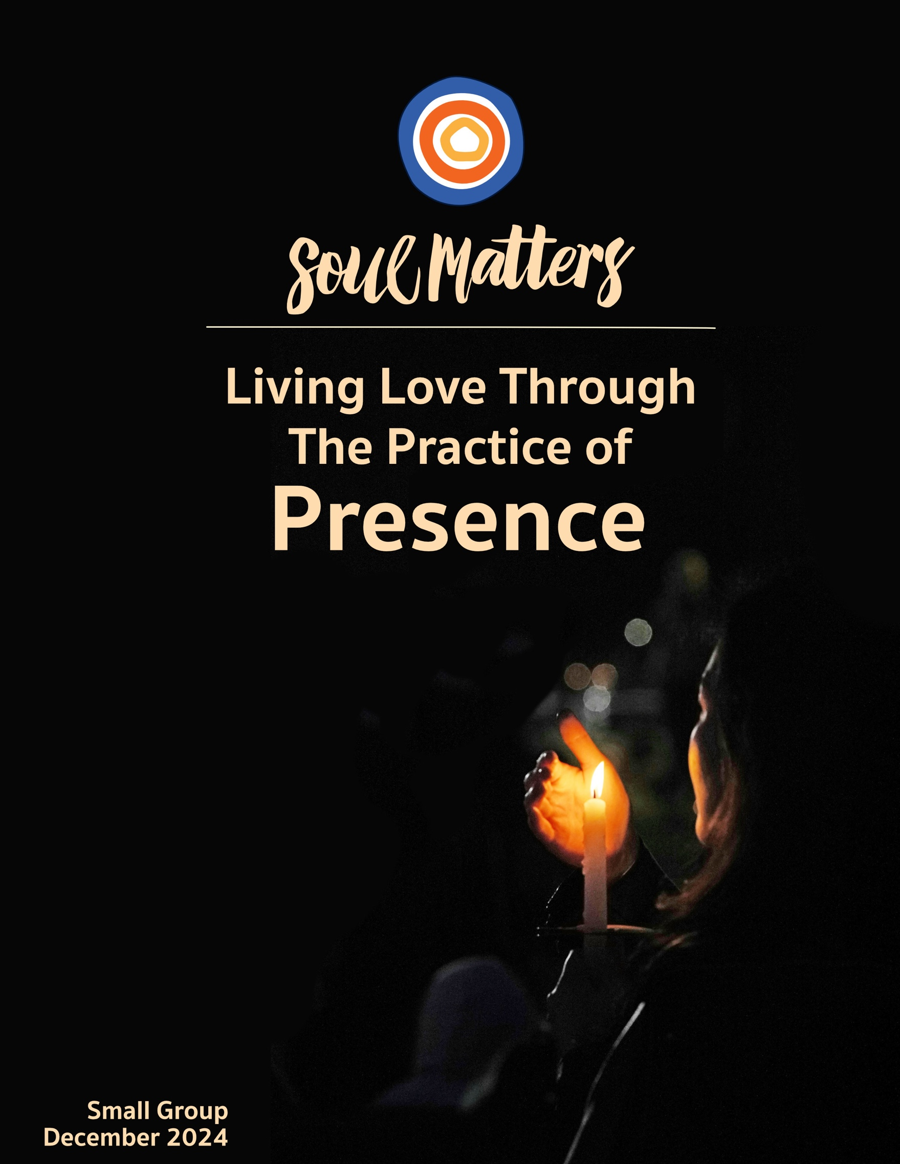

Welcome to the Practice of Presence

The moment one gives close attention to anything, even a blade of grass, it becomes a mysterious, awesome, indescribably magnificent world in itself.
Henry Miller

Spiritually, presence can mean two quite different things. On the one hand, contemplatives talk of “being present.” Presence from this perspective is all about awareness and remembering to “live in the moment.” On the other hand, theologians tend to come at presence from the perspective of a hidden and divine “otherness.” Their concern is not just that we pay attention to the present moment, but that we notice a transcendent Presence woven through all moments.

This month, we refuse to take sides. Attentiveness or otherness? Who says we have to choose? After all, isn’t it true that, more often than not, they dance together more than they compete? Haven’t we all felt that when we are fully present, the most powerful presences emerge? Pay attention to your child and slowly (and mysteriously) a confidence and unique self reveals itself. Pay attention to the flow of your breathing or the flow of the ocean and something bigger than yourself enters the scene. Look for a long time at a single tree or flower and eventually it presents itself to you as a world in and unto itself.

The underlying message here is that the world is shot through with unnoticed gifts and grace. It’s a message perfectly fit for this holiday month that so often celebrates presents over presence. In the face of commercials and billboards that tell us our lives will finally be complete if we stuff them with a few more shiny objects or plastic gadgets, our spiritual traditions come along and remind us that our lives are already whole, and home. Their message: The greatest gift of the holidays is noticing the many gifts that have been sitting there all along.

So, friends, how will you engage this dance? What powerful and meaningful presence is waiting for you to be present to it? What gift is waiting and wanting to emerge? What will your awareness bring into being this month?

Our Spiritual Exercises
It’s one thing to analyze a theme; it’s quite another to experience it. By pulling us out of the space of thinking and into the space of doing, these exercises invite us to figure out not just what we have to say about life, but also what life has to say to us!

Pick the exercise that speaks to you the most. Come to your group ready to share why you picked the exercise you did, where it surprised you and what gift it gave you.

Option A

Be Present with the Day You Just Had
(The Practice of One Sentence Diaries)

Our days can easily drift by us, and sometimes steamroll us. Either way, we lose hold of them, and they lose hold of us. Holding on and being present to our days is what diary writing has long been about. But complex and extensive diary entries are a hard commitment to keep. That’s why one-sentence diaries are so helpful. They enable us to be present with our days in a manageable and sustainable way.

So give this practice of one-sentence diaries a try, either by testing it out for a month or by using this month to begin a long-term commitment to the process. Learn a bit more about it here. Get some tips about how to approach it here and here. Wondering what exactly to write? Here and here are a bunch of great prompts. And what about the diary itself? Well, we recommend this simple and thoughtfully-designed “five-year” one. You could also use an online diary or make your own.

Come to your group ready to share not only how doing one sentence a day was meaningful, but also why you were drawn to it in the first place. Enjoy holding on to your days!

Option B

Five Objects; Fifteen Parts

Consider the tulip…
Consider the six red petals,
the yellow at the center,
the soft green rubber of the stem,
how it bows to the world. How,
the longer we sit beside it,
the more we bow to it…
~ Rosemerry Wahtola Trommer

There is a hiddenness to things. Only when we are completely present to them do they offer their full presence to us. As the poet Jane Hirshfield puts it, “Only when I am quiet for a long time, and do not speak, do the objects of my life draw near.” And when they do draw near, they unfold their details by the dozens. Like Trommer, we no longer see this single thing called a tulip, but instead notice its almost innumerable and revelatory parts. Look at my red petals, my yellow center. Notice the way my color is the same shade that was your mother’s favorite. See how my steadfastness or my strength is what you long for or once had. The list (and unfolding) goes on and on.
With this in mind, take on the challenge this month of offering your presence and attention to five different objects or creatures. Sit quietly with each, long enough for them to reveal at least fifteen meaningful aspects of themselves to you. As you notice each object's details, capture them on a list, similar to what Trommer did for her tulip. Why fifteen details? Well, the first five details will likely come from simply looking. The remaining ten will require you fully being there.

And keep in mind that picking your five objects is as significant a part of this exercise as the lists of what you notice about them. Will you pick a tulip too? Or choose a snowdrop instead? When was the last time you looked, really looked, at your spouse or your child? In the cold of winter, the logs in your living room fireplace or your favorite tea cup and kettle might be calling to you. The whole point of this is to figure out what in your life has been waiting to reveal itself to you. And why it wants - or maybe needs - you to notice the fullness of what it is.

Option C

The Absence that Feels Most Present

There’s something about winter and the holidays within it that invite back into our awareness the presence of those we have loved and lost. So many things become doorways through which these beloveds return. An old ornament. A Christmas carol. The lights of the menorah or a simple candle flickering in a window. The smell of their favorite pie. Wrapping paper and the memory of how much they loved matching it with the gift inside. Or just everyone laughing and you noticing the absence of theirs.

So whose absence feels most present to you during the holiday season? And, maybe more important, what can you do this month to honor them and feel their presence more deeply? With those questions in mind, consider engaging one - or more - of the below activities to make a doorway through which your loved one might feel more present to you:

- Pick an object that brings your loved one’s presence to mind and place it somewhere that will keep it and your loved one in your awareness. Then, at some point in the month, spend some time with this poem and let it help you figure out what message from your loved one might be contained in the object you choose.

- Spend a quiet morning or evening going through old photos of your loved one or just calling memories of them to mind. And then once you are immersed in memory, figure out what you would want to say to them if they were still alive. Consider writing your thoughts in a journal or notebook so you can hold on to them. You might also want to keep that notebook handy because you will likely think of more things you wish you could say to them as the month goes on.

- Wear or use something of theirs for the month. Maybe a piece of their jewelry, one of their hats or scarves, their watch, their favorite pen or quilt.

- Prepare their favorite meal and tell stories about why it was their favorite to those you eat it with.

- Pick a night and, by yourself, go out into a natural environment where you can be all alone. Then in that space of solitude, read aloud one of their favorite poems or play out loud one of their favorite pieces of music as if you were saying it or playing it to them. When done, stay in the stillness and quiet for at least 5 minutes, and open yourself to what comes.

Option D

Devote a Day to Ichigo ichie
(The practice of being present to impermanence)

The Japanese concept of Ichigo ichie translates into “one time, one meeting” and invites us to engage the moments of our lives with an awareness that it will never be experienced again in the exact same way. It is not a simplistic call to live every moment as if it were your last, but instead encourages us to bring a more reverent, attentive and intimate presence to the people and experiences in front of us.
This exercise invites you to you engage Ichigo ichie in two ways:

- First, read through this article and identify 3-4 sentences or ideas that stand out to you or “shimmer for you,” to use our language of spiritual discernment. Then set aside reflective/meditative time to figure out how your inner wisdom might be using those sentences/ideas to offer you reconnection with a memory, a message of comfort or a message of challenge.

- Second, spend one day in which you find at least five moments to say to yourself, “I will never experience this again.” It will help to repeat the phrase twice. Then come to your group ready to share how that altered your day as you went through it, and maybe how it altered your experience of the day after.

Option E

Meditate with Alan Watts

The British philosopher, eclectic mystic and unrelenting advocate for living with presence, Alan Watts, was a key voice in the countercultural moment of the 1960’s and now, well after his death, has become influential again due to the embrace of those who define themselves as spiritual but not religious. His call to live with greater presence can be found in the many books he wrote, but for today, maybe the best way to allow his words to speak to you is through the creative videos below.
So for your spiritual exercise this month, weave these two videos into your reflective practice. As you listen (and watch), do so with our Soul Matters discernment questions: “How is my inner wisdom/voice trying to speak to me through these videos?” and/or “How are they trying to reconnect me with a memory or offer me a message of comfort or challenge?”

Live Now: Being tricked by the ladder of reaching

In the Presence of The Unspeakable World

Option F

Which Presence Companion Piece Speaks to You?

Sometimes we come across a quote, song, article or movie and it perfectly captures what’s going on for us right now or allows us to view our current circumstances in a new light. With this in mind, spend some time this month going through the Companion Pieces section below to find the one piece that speaks most powerfully to you.

Go through them with an eye for the one that “shimmers” the most.
Come to your group ready to share the piece you picked, why it called to you and the journey it took you on.

Your Question

This list of questions is an aid for deep reflection. How you answer them is often less important than the journey they take you on. So, read through the list of questions 2-3 times until one question sticks out for you and captures your attention, or as some faith traditions say, until one of the questions “shimmers.”

Then reflect on that question using one or all of these questions:
- What is going on in my life right now that makes this question so pronounced for me?
- How might my inner voice be trying to speak to me through it?

- How might Life or my inner voice be trying to offer me a word of comfort or challenge through this question?

- What did you learn from your family of origin about stillness and being present?
- How has age altered the way you are present in the world?
- Do you remember the first time you felt completely comfortable in someone’s presence? So comfortable that words seemed unnecessary, and the stillness felt like a second home?
- What do you know now about being in the present moment that you didn’t know when you were younger?
- Do you ever feel like you want to learn how to be present to the days that are left?
- Do reminders about the brevity of our lives and calls to “live every day as if it were your last” help or get in the way of you being present to the preciousness of your days?
- Has the absence of a loved one ever felt as powerful as their presence was?
- How do others most often feel in your presence? Loved? Accepted? Heard? Held? Judged? Unimportant? Understood? And how do you want others to feel in your presence?
- How do regularly practice remaining present to the injustice and suffering of others? How do you intentionally let it touch you, even as our culture tells you, in a thousand tricky ways, that it’s ok to ignore it and shut it out?
- Do you long to be more comfortable with solitude and with being in the presence of just yourself?
- Are your efforts to ensure future security costing you the richness of your current days?
- Would you be more present to your life if you weren’t trying to perfect it or win at it?
- Whose absence feels most present to you during the holiday season? If you could say something to them, what would it be?
- What if winter is a time of being present to the need to withdraw from the world and enter into a time of healing hibernation? How might honoring this alter the way you approach the holiday season?
- Do you remember ever sitting back in the dim evening light and saying to yourself, “Wow. I just got to be present for a perfect day”?
- What’s your question? Your question may not be listed above. As always, if the above questions don't include what life is asking from you, spend the month listening to your days to find it.

Companion Pieces
Recommended Resources for Personal Exploration & Reflection
The following resources are not required reading. Nor are they intended to be analyzed in your group.
Instead they are here to companion you on your personal journey this month, get you thinking
and open you up to new ways of embodying the practice of presence in your life.

Wise Words

At the end of the day: do others feel loved in your presence? This is the spiritual bottom line.
Masin Kipp

Presence is removing judgment, walls and masks so as to create a true and deep connection with people or experiences.
Amy Cuddy

One of the best feelings in the world is knowing that your presence and absence both mean something to someone.
Anonymous

Stop measuring days by degree of productivity and start experiencing them by degree of presence.
Alan Watts

Abundance is not the money you have in your bank account, the trophies on your shelf, the letters after your name, the list of goals reached... Abundance is your connection to each breath, how sensitive you are to every flicker of sensation and emotion in the body. It is the delight with which you savor each unique moment, the joy with which you greet each new day… It is the freshness of each morning unencumbered by memory or false hope… It is your rootedness in the present moment, knowing that you are always Home, no matter what happens… It is you, before every sunrise: fresh, open, and awake. You are rich, friend! You are rich!
Jeff Foster

Starting here, what do you want to remember?...
Are you waiting for time to show you some better thoughts? ...What can anyone give you greater than now, starting here, right in this room, when you turn around?
William Stafford

You could ask what would be a good use of my life, thinking the answer is going to be a career choice or something, but I would say the most important thing is using your life to train in being present—in being here with an open heart. Synchronizing your mind with your body—having them be in the same place at the same time with a brave, honest, but also gentle attitude towards yourself and towards what you see.
Pema Chödrön

Most of us have spent our lives caught up
in plans, expectations, ambitions for the future; in regrets, guilt or shame about the past. To come into the present is to stop the war.
Jack Kornfield

Nothing in the past is as powerful as what we choose to do in the present moment.
Louise Hay

In an age of speed, I began to think, nothing could be more invigorating than going slow. In an age of distraction, nothing can feel more luxurious than paying attention. And in an age of constant movement, nothing is more urgent than sitting still.
Pico Iyer

The Persian poet Kabir wrote: “I laugh when I hear that the fish in the sea is thirsty.” Are you thirsty for the divine? The sacred? The clear light of awakening? All around you, the world is wet with it.
Daniel Shkolnik

We cannot attain the presence of God because we’re already totally in the presence of God. What’s absent is awareness.
Richard Rohr
The most characteristic element of Christmas is what we call the Christmas spirit, its joy, its reassessment of life as good. This persistent presence is difficult to explain, but none question it.
Unknown

There must be in every [person’s] life some place for the singing of angels, some place for that which… throws all the rest of life into a new and creative relatedness… The commonplace is shot through with new glory; old burdens become lighter, deep and ancient wounds lose much of their old, old hurting.
Howard Thurman

There’s something about the holidays that invites the presence of lost loved ones into our awareness. So many things become doorways through which these beloveds return. An old ornament. A Christmas carol. The lights of the menorah or a simple candle flickering in a window. The smell of their favorite pie. Wrapping paper and the memory of how much they loved matching it with the gift. Or just everyone laughing and you noticing the absence of theirs. So many doorways. But only if we keep an eye out will they step through.
Scott Tayler

Sometimes, the emptiness left by a loved one's absence is more powerful than their presence ever was.
Simon Van Booy

I didn’t know I would be
the kind of woman
who talks to the dead,
who narrates the day,
who believes they hear me
after midnight when I whisper
I miss you…
How strangely wondrous
life can be after a loss.
I feel their presence in the listening,
feel how the listening wraps
its tender arms around me,
feel how gently the listening
leans in to cradle my face
with silence.
Rosemerry Wahtola Trommer
Few skills are more essential than the ability to settle your body… When your body settles, it relaxes into its own experience in the present moment. It accepts whatever is happening, including any pain that you may need to acknowledge and metabolize.
Resmaa Menakem

Drink your tea slowly and reverently, as if it is the axis on which the earth revolves – slowly, evenly, without rushing toward the future. Live the actual moment. Only this moment is life.
Thich Nhat Hanh

If I were much wiser, and much more patient, and had much greater concentration, I could sit in silence in my chair, look out my windows at a green tree and the blue sky, and know that breathing is a gift; that a breath is sufficient for the moment; and that breathing air is breathing God.
Andre Dubus

Beauty and grace are performed whether or not we will or sense them. The least we can do is try to be there.
Annie Dillard

I urge you to please notice when you are happy, and exclaim or murmur or think at some point, 'If this isn’t nice, I don’t know what is.'
Kurt Vonnegut

Music
Click here for our Spotify playlist on Presence.
Click here for the YouTube playlist on Presence.

Remember! Our playlists are organized as a journey, so consider listening from beginning to end and using the playlists as musical meditations.

Movies

Perfect Days

Patterson

Won’t You Be My Neighbor

The Little Prince

Videos & Podcasts

On The Beauty of Stillness & Being Present to the Suffering of the World
https://www.youtube.com/watch?v=OkHypImEY84&t=2s

In the Presence of The Unspeakable World
https://www.instagram.com/_logamotion/reel/C3vcZo9vEM1/

Stopping the Noise & Being Present to Our Lives
https://www.youtube.com/watch?v=lEabO53wzws

It’s Not Your Fault You Can’t Pay Attention
https://www.nytimes.com/2022/02/11/opinion/ezra-klein-podcast-johann-hari.html

On Winter as a time of making space for the presence of grief

- The Resonance of Grief
https://www.youtube.com/watch?v=E3urhLzuS7A

- Grief as a Portal (begins at minute 3:00)
https://pod.link/1684164706/episode/6146141e355badda417b35f33aa43f9a

On Solitude & Being in the Presence of Yourself
https://vimeo.com/3850863

On the Possible Presence of the Soul
https://www.facebook.com/reel/422253477530306

What's Left - Kerry Hardie
https://www.youtube.com/watch?v=IheNAIGAiFk
On being present to the time that remains

Bridges - Ani DiFranco & Utah Phillips
https://www.youtube.com/watch?v=BHcQ0XkiGU8
On how sometimes being fully in the present requires us honoring how the past remains.

Still
https://aeon.co/videos/a-zen-buddhist-priest-voices-the-deep-matters-he-usually-ponders-in-silence
On the thoughts of a Buddhist priest while he ponders in the presence of silence

Heart Valley: A Shepherd's Life
https://www.youtube.com/watch?v=qNl7qmKIEAs
On the thoughts of a Welsh shepherd while he ponders in the presence of “his” valley

For Use in Your Meditation Practice

- Joining George Clooney in the Present Moment
https://www.youtube.com/watch?v=5HwIZ3pMTLc

- A Call To Presence
https://insighttimer.com/ruthking/guided-meditations/a-call-to-presence

- Plotting Practice
https://sebeneselassie.substack.com/p/plotting-practice-pattern-plotting

Articles

Equanimity: A Practice for our Times
https://ruthking.net/equanimity/
On how to remain grounded in presence even in the midst of aggression and extremes.

The Gift of Presence, The Perils of Advice
https://onbeing.org/blog/the-gift-of-presence-the-perils-of-advice/

Dementia: Teacher of Presence
https://livingthepresentmoment.com/dementia-teacher-presence/

Is Mental Time Travel Good For Us?
https://www.discovermagazine.com/mind/is-mental-time-travel-good-for-us
On ditching the present moment and spending some time in the past and future!

Join Our Facebook Inspiration Page: https://www.facebook.com/soulmatterssharingcircle/

© 2024-25 Soul Matters ALL RIGHTS RESERVED
Packets are for use only by member congregations of the Soul Matters Sharing Circle.
Learn how to join at https://www.soulmatterssharingcircle.com

