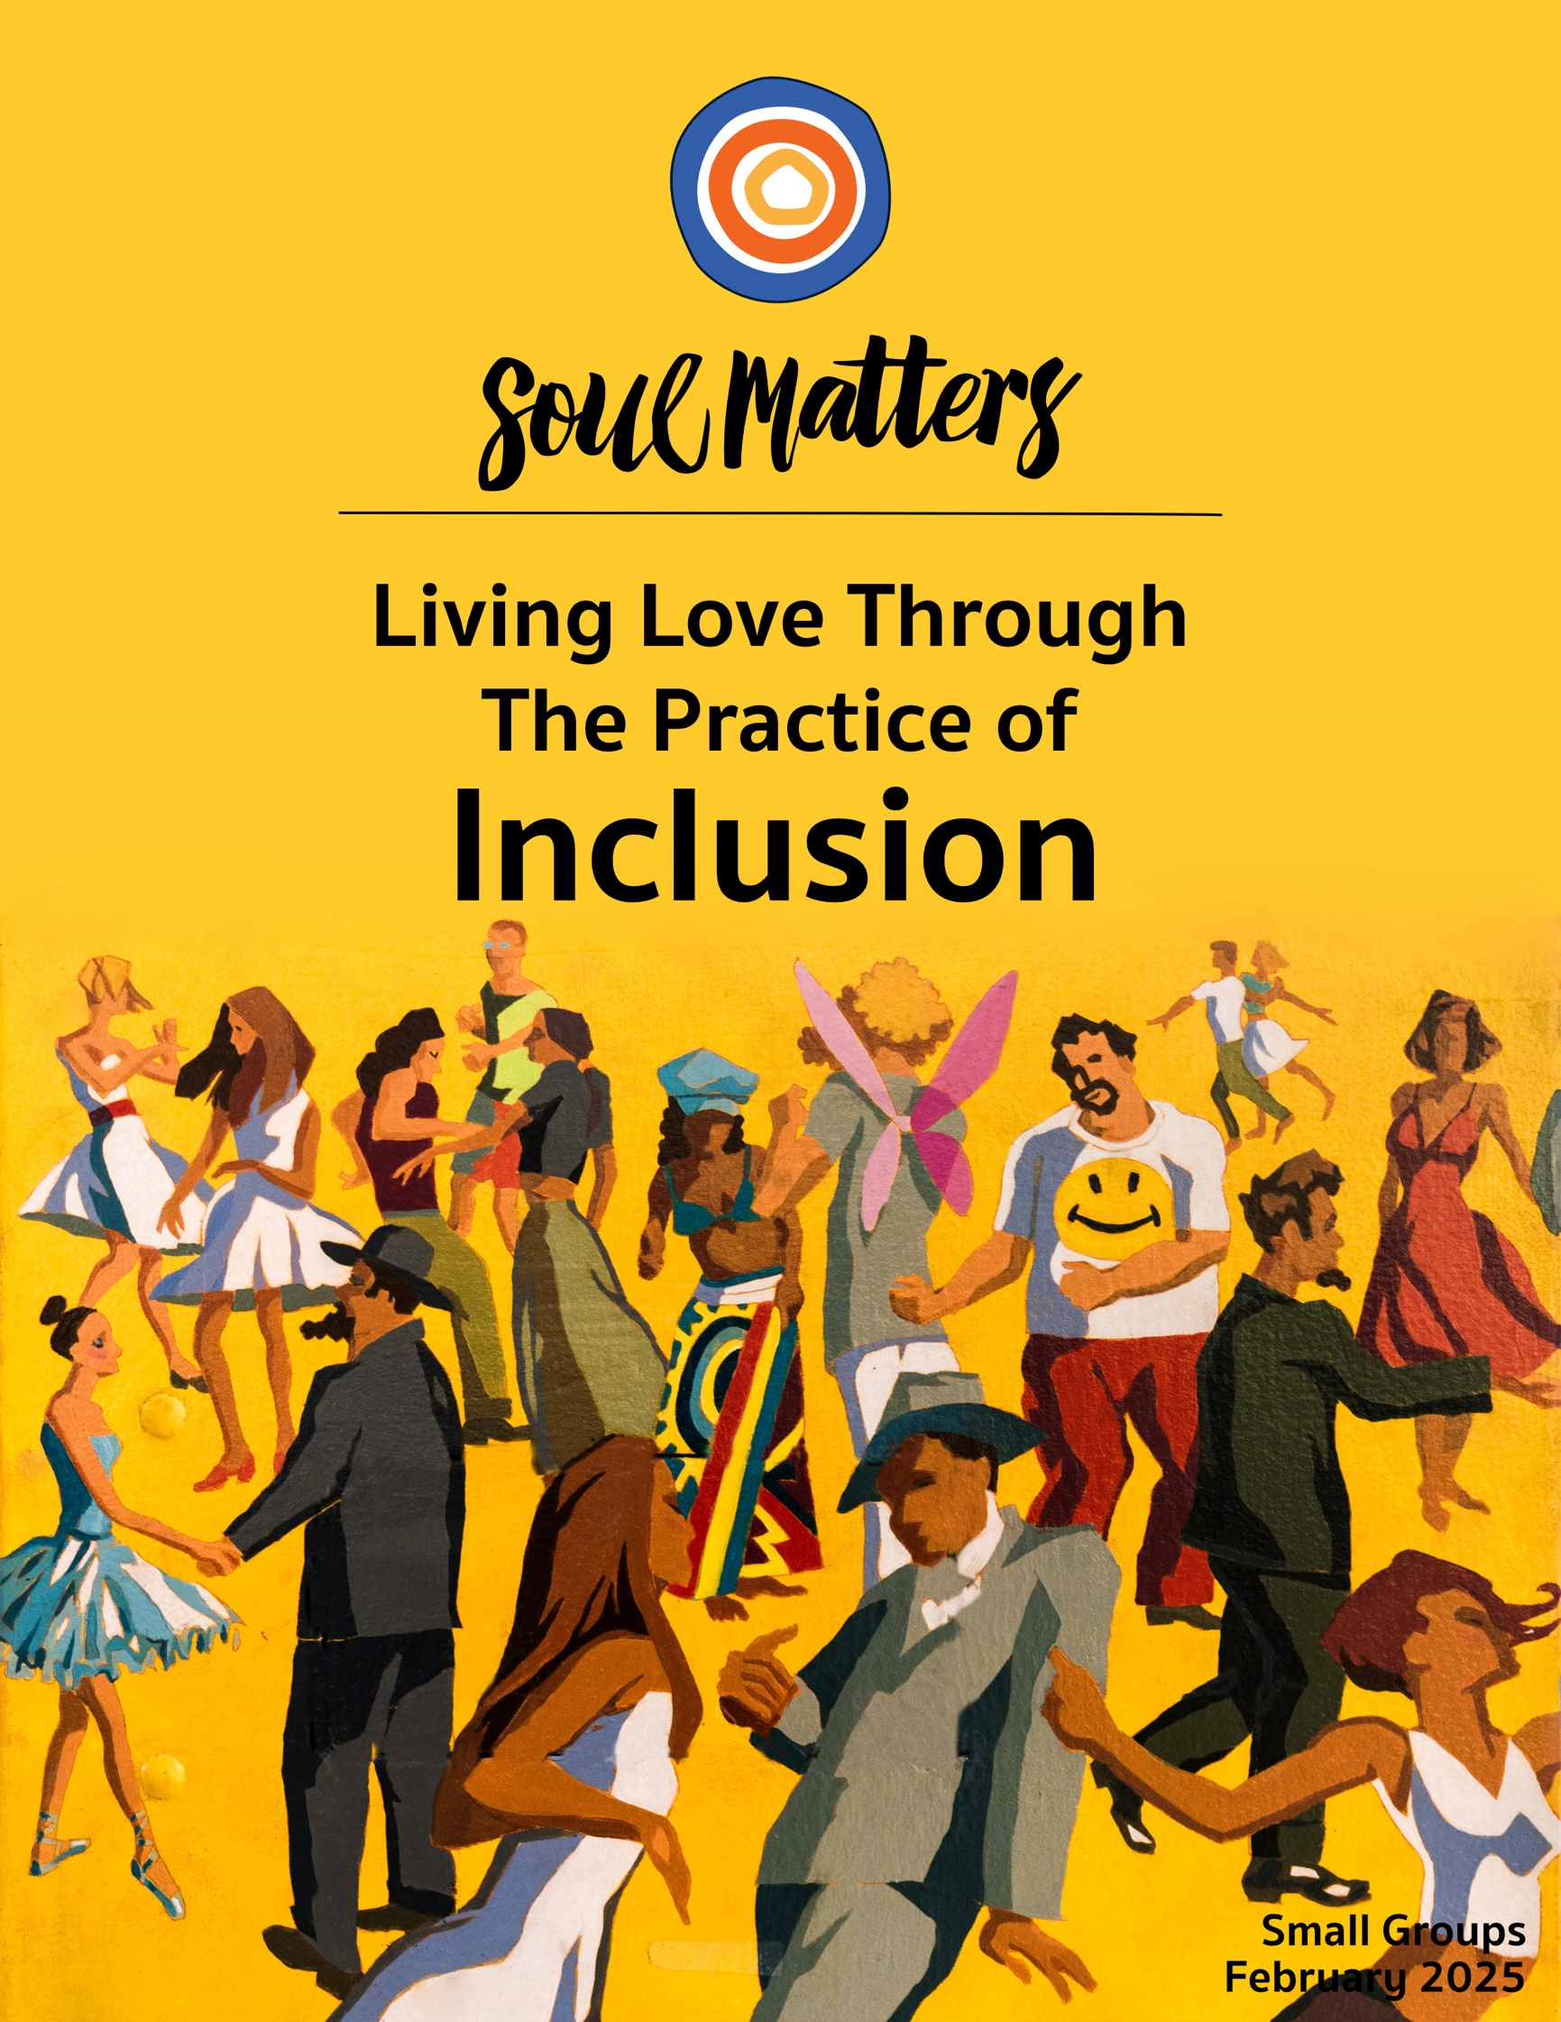

Welcome to the Practice of Inclusion

You hardly knew
how hungry you were
to be gathered in,
to receive the welcome
that invited you to enter
entirely...
You began to breathe again...
You learned to sing.

But the deal with this blessing
is that it will not leave you alone,
will not let you linger...
this blessing will ask you to leave,
not because it has tired of you
but because it desires for you
to become the sanctuary
that you have found...
- Jan Richardson

Jan Richardson begins with hunger. And so do we. Just saying the word “inclusion” conjures it up: The primal hunger to belong; the longing to be let in. No one likes standing outside the circle. No one likes leaning against the locked door listening to everyone else laughing inside. From the time we are little, inclusion and belonging is the thing we seek. It’s the hoped for Holy Grail. The promised resting place.

But Richardson will have none of that. To belong is only the beginning. That’s what she wants us to know. One minute she’s wrapping us in comforting words about settling in and allowing ourselves to finally breathe. The next she’s shaking us awake and telling us to get up and go.

That shaking should tell us something.

Or to put it another way, hers is not a gentle invitation. It’s not some sweet reminder to think of others. It’s a warning: Beware of the kind of belonging that only wants to bless you!

Deep down we know this. The hard part is to remember it. To use Richardson’s language, if we find ourselves being invited to linger rather than leave, alarm bells should go off. We need to be weary of those who welcome us with a members only card and a soft couch. They may have let us in, but soon they will enlist us into the work of keeping others out. There will likely even be a part of us that wants to keep others out. After all, closed circles don't just set us apart, they also sit us above.

But they also keep us small. Maybe this is why Richardson’s blessing is so intent on not leaving us alone. It knows that we only grow when the circle does. Circles that keep others out also keep the air out. No one inside a closed circle truly sings; they only suffocate, slowly.

It’s all one big reminder that the true blessing of inclusion is not that you get to come inside the circle; it’s that you get to participate in expanding it. As the circle grows, so do we.

Our Spiritual Exercises
It’s one thing to analyze a theme; it’s quite another to experience it. By pulling us out of the space of thinking and into the space of doing, these exercises invite us to figure out not just what we have to say about life, but also what life has to say to us!

Pick the exercise that speaks to you the most. Come to your group ready to share why you picked the exercise you did, how it surprised you and what gift it gave you.

Option A

Trade Your Differences

We often have more access to diversity than we realize. Our friends, co-workers, neighbors, and family members differ from us in many ways. We just usually run away from it, avoid it or downplay it.

This month, let’s tap into it! Here’s how: Pick that friend, colleague or family member who is different from you in some way and then exchange suggestions about how you two can expose each other to your respective different worlds. There are so many ways to do this. You could each recommend a book, movie or music playlist to each other and then discuss them. Or you could challenge each other to attend one of your favorite events; for instance, if you are liberal and they are conservative, they might take you to a NASCAR race and you might take them to an LGBTQ+ event, or they might bring you to their evangelical church one Sunday and you bring them to your UU service the next. If you are from different cultures, consider suggesting restaurants to each other that serve your ethnicity’s food.

You get the idea. The key thing is to empower each other to decide the best way to introduce their difference.

Finally, be sure to carve out space ahead of time to tell each other why each of you picked the thing you did, along with sharing whatever background - personal or historical - will help the other get the most out of the experience. And afterward, debrief your experiences, asking questions of each other and talking about why the experiences you recommended to each other are so important to the two of you.

Option B

Include the Other Side’s News

News has become one of the biggest walls between us and one of the greatest impediments to inclusion. It’s not just that we don’t agree about the news; it’s that we literally listen to different sets of news stories. And on top of that, we don’t even know what the other is listening to! So let’s use this month to learn what’s going on on the “other side” and get some perspective on how biased our news might be!

Here are two great ways to go about it:
- Listen to a Podcast from Across the Aisle - Check out this list of the top ten podcasts from the left and the right. Pick one or two and listen to them regularly for at least a week.
- Get Your News Labeled Left or Right: Another option is to sort your news for the entire month through one of the many apps out there that identify how biased the source is. We recommend these two:
  - Tangle: Gives you the left and right’s take on each news story.
  - Ground News: Identifies which way each news story leans.

Come to your group ready to share whatever insights, challenges and personal change that arose for you from digesting the news in this new way.

Option C

Include a Different Kind of Love

This is the month of love. Love letters to and love poems about the people we love fly all around. But what about the things and objects we love? Can we make a little room for that?

If you agree, get out your pen and paper or open your laptop and get to work on a poem about or letter to a thing you love.

Three suggestions for going about this:
- Write a letter to or poem about your love for a beloved object. Here are some examples: the lava lamp from high school, the only trophy you ever won, your first bike, your first guitar, being single, the cigarettes you broke up with, the movie, It’s a Wonderful Life, that made you fall in love with everyone, the joy of buttoning buttons, thrift stores, the sound of walking on fresh snow that never fails to return, that cup of black coffee that startles you awake to the wonder of another day.
- Write a poem to a bunch of things you love. Why pick one?! Make a list of all the objects that have your heart. Here’s an example: https://www.youtube.com/watch?v=hWOd_UNCYZ8
- Write a letter or love poem between two objects. This one will take a bit more effort, but it’s well worth it. Here’s an example that proves why: https://www.youtube.com/watch?v=BIAQENsqcuM

Option D

Make Room for Them in Meditation

Inclusion is about opening doors; it’s also about opening hearts. And heart work takes time. It requires a willingness to let the struggle and pain of others slowly wash over you until you are turned into something softer, something able to feel the needs of others as your own.

This slower and softer path is what meditation is all about. So we’ve created a playlist of 16 videos for you to meditate on this month. They aren’t meant to be watched and listened to all at once. Rather, you are invited to spread them out and weave them into your morning or evening meditations just one or two at a time.

You might consider journaling about them in each sitting, but the most important thing is to pay attention to how they alter the way you travel through your days.

Here’s the link to the playlist:
https://youtube.com/playlist?list=PLvXOKgOQVYP7Rxv7fhqhaDCTOIf5UIhbV&si=JtUBJksn4t4uUnuO

Option E

Ask Them About Inclusion

One of the best ways to explore our monthly themes is to have conversations about them with people who are close to you. It’s also a great way to deepen our relationships! Below is a list of questions to help you on your way. Be sure to let your conversation partner know in advance that this won’t be a typical conversation. Telling them a bit about Soul Matters will help set the stage. Remember to also answer the questions yourself as they are meant to support a conversation, not just a time of quizzing them. Come to your group ready to share what surprised you about the conversation and what gift or insight it gave you.

Inclusion Questions:

- If you could go back and change a moment of being excluded or excluding someone else, what would it be?
- Have you ever invited and included something or someone in your life that unexpectedly (and wonderfully) altered the trajectory of it?
- What aspect of your personality do you need to do a better job of embracing and welcoming in? Your judgmental self? Your lazy self? Your vulnerable self? Your bitter self? Your easily frightened self? Your quick-to-anger self? Your jealous self? Your petty self? Your selfish self?
- What part of your personality do you wish your family of origin would have included and welcomed more enthusiastically?
- What types of people do you have the hardest time being open to? What experiences in your past have led to you being reactive to this type of person? What mental tools and tricks do you use to push yourself to be more open to them?
- How has aging impacted your feelings of being included or excluded?
- Have you ever had an experience that gave you a cosmic sense of being included? A feeling of being at one with everyone and everything around you? Or a feeling of being embraced and loved by the universe itself? If so, how did that experience change you?

Option F

Which Companion Piece Speaks to You?

Sometimes we come across a quote, song, article or movie and it perfectly captures what’s going on for us right now or allows us to view our current circumstances in a new light. With this in mind, spend some time this month going through the Companion Pieces section below to find the one piece that speaks most powerfully to you.

Come to your group ready to share the piece you picked, why it called to you and the journey it took you on.

Your Question

This list of questions is an aid for deep reflection. How you answer them is often less important than the journey they take you on.

So, read through the list of questions 2-3 times until one question sticks out for you and captures your attention, or as some faith traditions say, until one of the questions “shimmers.”

Then reflect on that question using one or all of these questions:
- What is going on in my life right now that makes this question so pronounced for me?
- How might my inner voice be trying to speak to me through it?
- How might Life or my inner voice be trying to offer me a word of comfort or challenge through this question?


- When were you first “saved” by someone who widened a circle to let you in? If you could talk to them today, what would they say to them?
- If you could go back and change a moment of being excluded or excluding someone else, what would it be?
- Has an experience of being excluded permanently left a mark on you?
- Have you ever invited and included something or someone in your life that unexpectedly altered the trajectory of it, something or someone that broke you out of a stifling rut, challenged you to finally face something you were avoiding, or forced you to grow in a way that you wouldn’t have on your own? If so, what did the experience teach you about courage, risk, luck or grace?
- Do you belong to a community or relationship that demands a version of you that no longer is true? Or requires you to remove parts of yourself to belong?
- What aspect of your personality do you need to do a better job of embracing and welcoming in? Your judgmental self? Your lazy self? Your vulnerable self? Your bitter self? Your easily frightened self? Your quick-to-anger self? Your jealous self? Your petty self? Your selfish self?
- What aspect of your life partner, child or close friend do you need to do a better job of embracing and welcoming in?
- What excluded and painful memory of yours wants to be welcomed back in and better understood?
- Have you or the communities you are a part of invited diverse people into your “house” but not allowed them to “rearrange your furniture”?
- Is it possible the community that has welcomed you with open arms has also burdened you with an unhealthy or unfair understanding of “us and them”?
- What if Black History Month is not just a call to remember but also a form of reparations? If so, what might Black History Month be asking of you to include in your awareness and action this month?
- How is the pain and struggle of those less fortunate than you included in your life?
- Have your efforts to exclude risk from your life gone too far?
- What’s your question? Your question may not be listed above. As always, if the above questions don't include what life is asking from you, spend the month listening to your days to find it.

Companion Pieces
Recommended Resources for Personal Exploration & Reflection

The following resources are not required reading. Nor are they intended to be analyzed in your group.
Instead they are here to companion you on your personal journey this month, get you thinking
and open you up to new ways of embodying the practice of inclusion in your life.

Definitions

Diversity is being invited to the party; inclusion is being asked to dance.
Verna Myers

Inclusivity is not ‘how do we make you a part of what we are?’ but ‘how do we become more of what you are?’
angel Kyodo williams Sensei

Inclusion is being invited to a house and being able to rearrange the furniture.
Jane Silber

Wise Words

It is not our differences that divide us. It is our inability to recognize, accept, and celebrate those differences.
Audre Lorde

If you've known the sting of betrayal, you can end up manufacturing an identity from your alienation. To protect yourself from the reminder or risk of exclusion, you begin initiating distance on your own by calling yourself ‘loner’ or ‘independent’... But a life lived with trust only in the self is exhausting. It is not freedom; it is a yoke.
Cole Arthur Riley

Being excluded kills. It kills the spirit and sometimes it kills the body. So, here’s my thought. If – like me – you’re attachment rich, if you are included in most or many circles, if you belong in almost any place you find yourself, we have the opportunity and responsibility to include the unincluded… Look for someone who appears not to belong today and choose them.
Jan Edmiston

There is something to being chosen that is uniquely healing.
Cole Arthur Riley

The most peaceful people that I know, and the most wise people that I know, are the ones who have created enough internal space to be able to allow all the parts of themselves to coexist despite the contradictions… They have room for the parts of themselves that are glorious and divine and wonderful. And they have room for the parts of themselves that are petty and jealous and ridiculous. They create this big, huge auditorium of a landscape inside themselves. They don't kick any parts out, because guess what? You can't.
Elizabeth Gilbert

It’s amazing really. As a human being all you have to do is enumerate exactly the way you don’t feel at home in the world, and the moment you’ve uttered the exact dimensionality of your exile, you are already on your way home.
David Whyte

To be free, you must embrace the breadth of your own existence without apology…
But to actually be free, you must
know and you must fight for the entire
Universes inside of everyone else.
Julián Jamaica Soto

It’s okay to distance yourself from spaces that demand a version of you that no longer is true. Belonging shouldn’t depend on an illusion.
Cole Arthur Riley

The situation facing trans and gender non-conforming people in the United States right now is really bleak. And I really want to have an earnest plea that people stop framing this as a minority issue and reframe this as a universal attack
on self-determination. Every one of us should be
able to determine our own gender. No one else should be able to tell us what we should look like, how we should act, and what we should do with our bodies. So we need you to show up in this moment, not just out of an ethics of allyship. That doesn’t feel like enough for me, but out of an insistence and your own dignity, your own capacity to transform, your own love of self.
Alok Vaid-Menon

They want thinking you’re bad at being a girl
Instead of thinking you’re great at being yourself…
They want you to blend in,
like you’ve never seen a blender…
Andrea Gibson

Inclusion isn’t better just because it’s kinder. We should bring disabled perspectives to the center because these perspectives create a world that is more imaginative, more flexible, more sustainable, more dynamic and vibrant for everyone who lives in a body.
Rebekah Taussig

I believe every inch of America is sacred, from sea to shining sea. I believe we make it holy by who we welcome and by how we relate to each other.
Eboo Patel

Not like the brazen giant of Greek fame,
With conquering limbs astride from land to land;
Here at our sea-washed, sunset gates shall stand
A mighty woman with a torch… and her name
Mother of Exiles… cries she, with silent lips.
“Give me your tired, your poor,
Your huddled masses yearning to breathe free…
Send these, the homeless, tempest-tost to me…
Emma Lazarus

If justice is what love looks like in public, then inclusion is what love looks like among groups.
Rev. Matthew Johnson

This is almost always the by-product of expanding the table: God is right-sized. Rarely, if ever, do you do the work of hospitality, authenticity, diversity, and agenda-free relationships and encounter a smaller, more selective God.
John Pavlovitz
Put the mantle of your protection
Around the bodies of
The young and defenseless…
Take the hand of the despised
And diseased and walk proudly with them
In the high street.
Some might see you and
Be encouraged to do likewise
Maya Angelou

Music
Click here for our Spotify playlist on Inclusion.
Click here for the YouTube playlist on Inclusion.

Remember! Our playlists are organized as a journey, so consider listening from beginning to end and using the playlists as musical meditations.

Videos & Podcasts

Watch the World Unfold, Gaelynn Lea
https://www.youtube.com/watch?v=Tib4lRmvQ-M

Your Life, Andrea Gibson
https://www.youtube.com/watch?v=gsUp6Wd_o8I

Birds Aren’t Real?
How we create conspiracy theorists by excluding them
https://www.youtube.com/watch?v=3VEkzweBJPM
More here

Separating Yourself from the Pack
On how the same forces that instill a sense of inclusion also create an “us versus them” world.
https://hiddenbrain.org/podcast/separating-yourself-from-the-pack/

How To Talk To The Worst Parts Of Yourself
https://www.youtube.com/watch?v=gUV5DJb6KGs

Blessing for Kin, Rev. Sean Parker Dennison
https://www.youtube.com/watch?v=yKrjIGgAUJo

A Poem For The Multiracial Kids
https://www.youtube.com/watch?v=Nv7crT0PiTc

The New Colossus: A Vision of Refuge & Inclusion
https://www.youtube.com/watch?v=ONmCVERPLy0

On Inelasticity & Excluding Ideas, Roxane Gay
https://www.facebook.com/reel/1145838809850315

The Science Behind ‘Us vs. Them’
https://www.youtube.com/watch?v=14XSzWT4vI0

Whose Faith Is It Anyway? On Black UU Theology
https://www.youtube.com/watch?v=yLCH1tl_fmE

On the “Cathedral of the World”
https://www.tiktok.com/@revjo.uu/video/7157480430634175790

That Which Holds All, Nancy Shaffer
https://www.youtube.com/watch?app=desktop&v=3prjmO1GpBk
Read the text here

Articles

Black History Month Isn't Racist, It's a Form of Reparations

Who’s Afraid of Black History?

In Order To Understand The Brutality Of American Capitalism, You Have To Start On The Plantation
Are Boys Really Being Excluded From Our Attention And Care?
Books

Under the Skin: The Hidden Toll of Racism on American Lives and on the Health of Our Nation
Sitting Pretty: The View from My Ordinary Resilient Disabled Body
Authentic Selves: Celebrating Trans and Nonbinary People and Their Families
Pretty: A Memoir
Rian Krieger's Journey, By UU Author, Roger A. Smith (author website)
Bone of the Bone: Essays on America by a Daughter of the Working Class

Movies

The 1619 Project
Origin
The Last Black Man in San Francisco
Blitz
Shut Up and Paint
The Disruptors
Will & Harper
The Man Card (watch here)
Leave No Trace

Packet Introduction Credit Note: Unless explicitly noted otherwise, the introductions of these packets are written by our Team Lead, Rev. Scott Tayler. Rev. Scott gives permission for his pieces to be used in any way that is helpful, including in newsletters, worship and in online service/recordings.

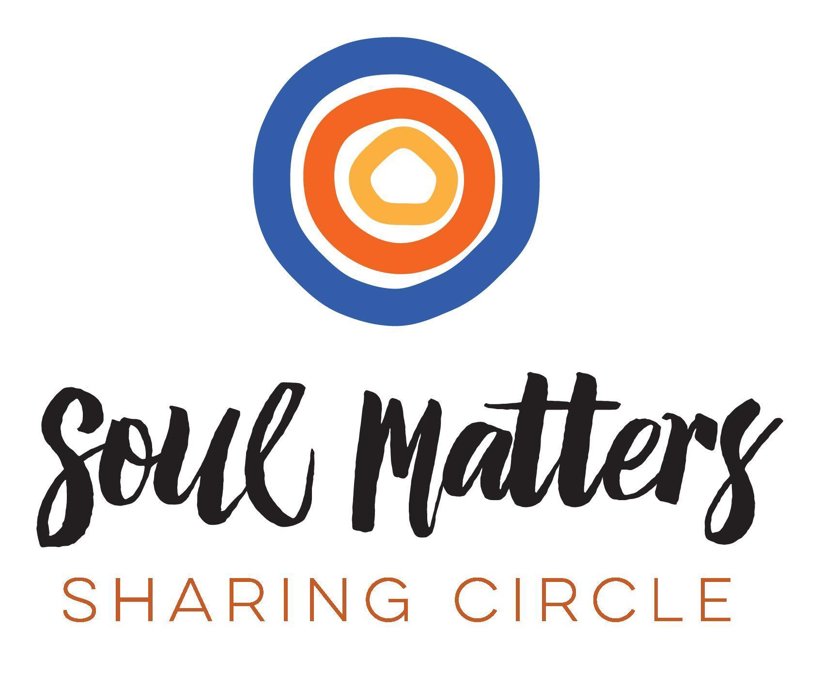
© 2024-25 Soul Matters ALL RIGHTS RESERVED
Packets are for use only by member congregations of the Soul Matters Sharing Circle.
Learn how to join at https://www.soulmatterssharingcircle.com

