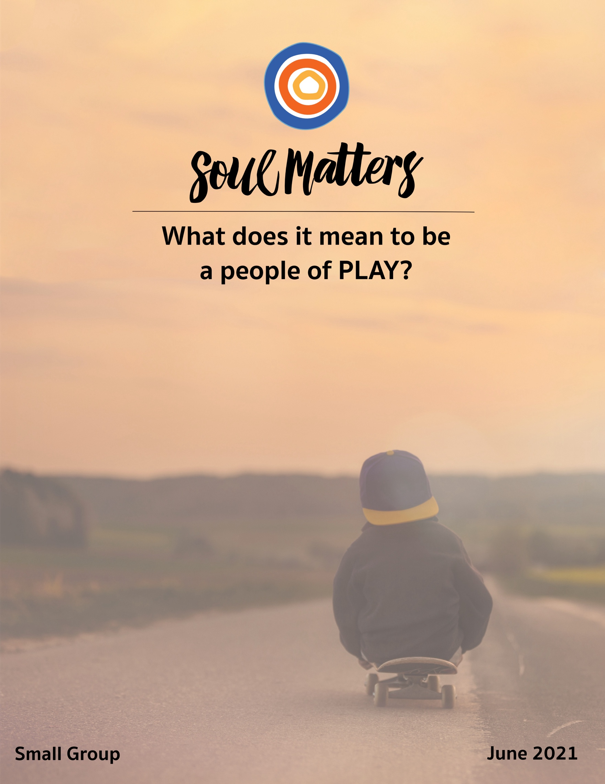

What Does It Mean To Be
A People of Play?

We all are playing.
Playing it up, playing it down, trying to play fair.
Playing for keeps, playing favorites, playing it safe,
sometimes too safe.
He plays hardball; They’re playing house; I’m playing it by ear,
or at least learning to play it by ear.
She’s tired of playing second fiddle; He’s playing right into their hands.
Please God, can’t we all just throw out the playbook and start again?
Sometimes we’re just played out; it’s not always bad to play possum.
And what about playing with fire?
Let’s hope so friends.
Don’t you want to feel again that burning within,
and let it loose?

Welcome to the month of play. May we all take it seriously!

Our Spiritual Exercises

Option A

Do It, Don’t Just Talk About It!

Why talk about play when we can do it?! That’s right, this exercise invites your group to carve out some time to play together. Sometimes we get so lost in thinking about the benefits of play for individuals that we lose sight of play’s core gift: it connects us! It’s an entirely different way of being together, one that helps us deepen relationships and understand each other in a way that few other things can.

So, is your group willing to give it a try? Just set aside the first hour of your meeting and play a game. And to make it easier, we’ve pulled together a bunch of simple and fun games for you to choose from. Check them out at https://docs.google.com/document/d/1MhV8dVJpxyrHsHbFmifLlQYwdDhuCnl4or3fusOE3J8/edit?usp=sharing

Option B

Skip the Games and Tell a Joke

Games are great but who doesn’t love to tell and hear jokes?! Play together by having everyone hunt down, bring in and tell two of their best jokes!

Now be careful; this is trickier than it may seem. You might already know your two ringers. Good for you. You could certainly leave it at that. But an alternative might be to spend a week asking your family and friends what their favorite jokes are and then picking your two favorites from those choices! This way you get to play at receiver and teller of the joke!

Option C

Go On a Playdate

This is another way to actually play rather than just talk about it all month: Ask your partner or friend to go on a “play date.” What makes up that play date is up to you. That’s half the fun! And half the exploration. By deciding together what to do, you might discover something entirely new about how your partner or friend defines play and fun.

While you need to figure it out for yourself, here are some ideas to spark your imagination: Get lost on purpose, axe throwing, a mini road trip, giving paddle boarding a try, hit the golf driving range, fly a kite, play cornhole, mini golf or better yet frisbee golf. Or maybe make it a double or triple play date and invite over other couples to play The Newlywed or Best Friend Game.

Option D

Find Play in Our Recommended Resources

Engaging our recommended resources and finding the one that especially speaks to you is a spiritual practice in and of itself. So, if none of the above exercises call to you, set aside some time to go through the recommended resource section of this packet and meditate on them until you find the one that most expands or deepens your understanding of play. After you’ve found it, consider printing it out and carrying it with you or pinning it up so you can continue to reflect on it throughout the weeks leading up to your group meeting. Come to your group ready to share where the journey led you.

Your Question
Don’t treat these questions like “homework” or try to answer every single one. Instead, make time to meditate on the list and then pick the one question that speaks to you most. The goal is to figure out which question is “yours.” Which question captures the call of your inner voice? Which one contains “your work”? What is that question trying to get you to notice or acknowledge?
Often it helps to read the list to a friend or loved one and ask them which question they think is the question you need to wrestle with!

- What makes something play for you? When you feel free from the burden of producing an outcome? When creativity is involved? When you lose time? When you can just be yourself? All of the above? Something else?
- What forms of childhood play have lasted into your adulthood? What has enabled that? What makes you especially grateful for it?
- What did you learn from the games you played as a child? Monopoly, King of the Hill and Dodge Ball certainly instill different lessons than Red Light; Green Light, Clue, Jump-Rope, Pictionary or Hopscotch. What lessons from your favorite childhood games do you notice “playing out” for you in the present?
- What is the opposite of play?
- Can worship be play?
- Can play lead to transcendence?
- Can play be a form of political resistance?
- When has play saved or healed you?
- Who keeps you playful?
- What would it look like to sneak a bit of playfulness into your daily chores? Your dinner prep? Morning commute? Exercise routine? Workday? Your relationship?
- Do you remember “a perfect day of play”?
- Are you a good winner? How about a good loser?
- What saying regarding play captures a key storyline in your life right now: playing it up, playing it down, playing fair, playing for keeps, playing favorites, playing it safe, playing hardball, playing house, playing it by ear, playing second fiddle, playing right into their hands, throwing away the playbook, played out, playing hard to get, playing possum, playing with fire?
- If you could give your younger self advice about play, what would it be?
- What’s your question? Your question may not be listed above. As always, if the above questions don't include what life is asking from you, spend the month listening to your days to hear it. Or maybe the question or call you need to hear is waiting in one of the quotes listed below. Consider looking there!

Companion Pieces

Recommended Resources for Personal Exploration & Reflection

The following resources are not required reading. We will not analyze these pieces in our group. Instead they are here to companion you on your journey this month, get you thinking and open you up to new ways of imagining what it means to be a people and a person of play.

Word Roots & Definitions

“Across the globe, many of the etymological roots of the word ‘play’ locate it in the visceral: ludere in Latin refers to leaping fishes and fluttering birds. The Anglo-Saxon lâcan means to move like a ship on the waves, or to tremble like a flame. The Sanskrit kridati also, as in Germanic languages, describes the movement of wind. In play, we are rarely immobile. We’re alive.”
Source

This embodied sense of play extends to other sources of the word. The Proto-West Germanic plegōjanan meaning occupy oneself about" and the Middle Dutch pleyen "to rejoice, be glad.
Source

Wise Words

Let us arrive as children to this huge playground – the universe.
Roger Bourland

In play we move below the level of the serious,
as the child does; but we can also move above it—
in the realm of the beautiful and the sacred.
Johan Huizinga

If I get to pick what I want to do, then it's play... if someone else tells me that I have to do it, then it's work.
Patricia Nourot

They are enlightened who join in this play knowing it as play, for people suffer only because they take as serious what the gods made for fun.
Alan Watts

In rare moments of deep play, we can lay aside our sense of self, shed time’s continuum, ignore pain, and sit quietly in the absolute present, watching the world’s ordinary miracles. No mind or heart hobbles. No analyzing or explaining. No questing for logic. No promises. No goals. No relationships. No worry. One is completely open to whatever drama may unfold.
Diane Ackerman

To play is to listen to the imperative inner force that wants to take form and be acted out without reason. It is the joyful, spontaneous expression of oneself.
Michelle Cassou and Stewart Cubley

You can discover more about a person in an hour of play than in a year of conversation.
anonymous

We don’t stop playing because we grow old, but rather we grow old because we stop playing.
Karl Groos

To truly laugh, you must be able to take your pain, and play with it!
Charlie Chaplin

It is interesting that Hindus, when they speak of the creation of the universe, do not call it the work of God, they call it the play of God, the Vishnu-lila, lila meaning "play." And they look upon the whole manifestation of all the universes as a play, as a sport, as a kind of dance.
Alan Watts

I realized that the way of play was a part of all religions. St. Paul proclaimed himself a 'fool for Christ.' Jews honor the Sabbath, that time to stop working and to take pleasure in life. Hindus say that the universe was created as 'lila,' divine play. (After all, the Omnipresent Eternal One needed something to do.) Muslim Sufis teach through jokes about Mulla Nasruddin, a laughable sage/fool. Native Americans celebrate bawdy trickster-figures. (Try attending a Cherokee "Booger Event.") Buddhists practice meditative games of breathing, attention, and joyful presence. Zen teachers poke fun at dogma, as in master Feng's pronouncement: 'The Buddha is a bullheaded jail keeper, and the Patriarchs are horse-faced old maids!' It seemed the whole world was playing with Spirit in a thousand delightful ways.
Drew Leder

The world of play favors exuberance, license, abandon. [In it,] selves can be revised.
Diane Ackerman

Time is a game played beautifully by children.
Heraclitus

Don’t play the saxophone. Let it play you.
Charlie Parker

The children sat in a circle around him & he said, I don’t believe in life anymore & no one said anything for a while because he was older than they were & maybe knew something they didn’t, but then someone said, let’s play a game & someone said, Spy & someone else said, Chase & soon there was no one there but the man sitting alone.
StoryPeople
Humanity has advanced, when it has advanced, not because it has been sober, responsible, and cautious, but because it has been playful, rebellious, and immature.
Tom Robbins

I count that day lost when I am not moved to laughter or tears, but even more if I have not played.
George Sheehan

I tell you; we are here on Earth to fart around and don’t let anybody tell you different.
Kurt Vonnegut

Life is for sure the greatest game that you’ll ever play.
Steven Redhead

Embodiments of Play

Seesaws Across the Border
https://www.cnn.com/2019/07/30/us/seesaws-border-wall-us-mexico-trnd/index.html

Caine's Arcade
https://www.youtube.com/watch?v=faIFNkdq96U

Playfully Singing on the Way to Work
https://www.youtube.com/watch?v=xctzp0dp9uc

Putting down work to play in puddles
https://www.youtube.com/watch?v=PN-MjUC4f9k

Playing with Stop-Motion Animation
https://www.youtube.com/watch?v=lf0MkEowQ1w&t=3s

Playing with Food and Other Stuff
https://www.youtube.com/watch?v=L9hWlxyLcYk

Playing with Bubble Wrap and Beauty
https://www.youtube.com/watch?v=TeFzpshBwwk

Playing with Origami
https://www.youtube.com/watch?v=DJ4hDppP_SQ

The Joy of Playing with Letters
https://www.youtube.com/watch?v=tjAl9NFeSRo

George Carlin Playing with Words
https://www.youtube.com/watch?v=YSS_PhR9WWo

Playing Fetch
https://www.facebook.com/fernando.messias.9279/videos/215177476697669/

Playing with Music
https://www.youtube.com/watch?v=yW8mF2be0I0&list=RDyW8mF2be0I0&index=2

Playing with Tubes
https://www.youtube.com/watch?v=cG0jprCQ6Ak

Playful Mouse Houses
https://mymodernmet.com/anonymouse-miniature-art-mice-shops/?fbclid=IwAR2Jro0MS6Dysko9OQ2yLaOH6rH7gsoLlRwLix1Wk8d7c6hiKUPpXhWrtpw

Playing with Squirrels
https://www.facebook.com/watch/?v=709319816547866

Seriously Playing with Legos
https://www.dwell.com/article/worlds-tallest-lego-tower-9c41ffe1
http://www.shareable.net/blog/lego-bombing-and-the-art-of-infrastructure

Yarn Play
https://www.mentalfloss.com/article/77154/10-impressive-yarnbombing-projects
https://www.topcrochetpatterns.com/blog/the-wonderful-world-of-yarn-bombing

Music

We create two different playlists for each of our monthly themes: one in Spotify and another in YouTube. We organize these lists as a journey of sorts. So consider listening from beginning to end and using the lists as musical meditations. Follow the links below to connect with this month’s “Play Songs.”

Click here for the Spotify playlist on Play.
Click here for all Spotify playlists.
Click here for the YouTube playlist on Play.
Click here for all the YouTube playlists.

Videos & Podcasts

Stuart Brown on Play, Spirit, and Character, On Being

https://onbeing.org/programs/stuart-brown-play-spirit-and-character/

Play is More than Just Fun, Stuart Brown - TED Talk
https://www.ted.com/talks/stuart_brown_play_is_more_than_just_fun/transcript?language=en

Gaming Can Make a Better World, Jane McGonigal
https://www.ted.com/talks/jane_mcgonigal_gaming_can_make_a_better_world#t-234116

Jason Silva on Deep Play as “Deep Now,” Shots of Awe
https://www.youtube.com/watch?v=sWBtEZNdKiM

The History of Sketch Comedy, Keegan-Michael Key
https://www.audible.com/pd/The-History-of-Sketch-Comedy-Podcast/B08RSN2ZV1
Review HERE

Alan Watts - Life Is A Playful Dance
https://www.youtube.com/watch?v=29atSZKbmS4

Fun Theory!
https://www.youtube.com/watch?v=Ihai50diA7o

Articles

Why it’s Good for Grown-ups to Go Play
https://www.washingtonpost.com/national/health-science/why-its-good-for-grown-ups-to-go-play/2017/05/19/99810292-fd1f-11e6-8ebe-6e0dbe4f2bca_story.html?utm_term=.448479c933c2

The Opposite of Play, Hilde Van Dyck
https://paperplanepilots.be/opposite-play
Hint: The opposite of play is not work!

The Importance of Play, Mary Anne Radmacher
https://www.utne.com/mind-and-body/the-importance-of-play-ze0z1505zcwil
“Music, movement, faith: they all speak of intentions offered and received. They say, “play with abandon.” Doing so lets me lean in not only to the goodness of the world but to my inner world, my memories of strong women and how their playing feeds my soul. Play—with abandon. It’s a gift I hope I can pass on...”

Books

Play: How it Shapes the Brain, Opens the Imagination, and Invigorates the Soul
Stuart Brown & Christopher Vaughan

Deep Play
Diane Ackerman

Reality is Broken: Why Games Make Us Better and How They Can Change the World
Jane McGonigal

Movies & TV

The Big Flower Fight
Big
Life is Beautiful

The Yes Men

Candid Camera

More Monthly Inspiration from Soul Matters!

Our Facebook Inspiration Page:
https://www.facebook.com/soulmatterssharingcircle/

Our Instagram Page:
Find us as “soul_matters_circle”

Music Playlists:
Click here for links to the Spotify playlists for each month.
Click here to check out the YouTube playlists.

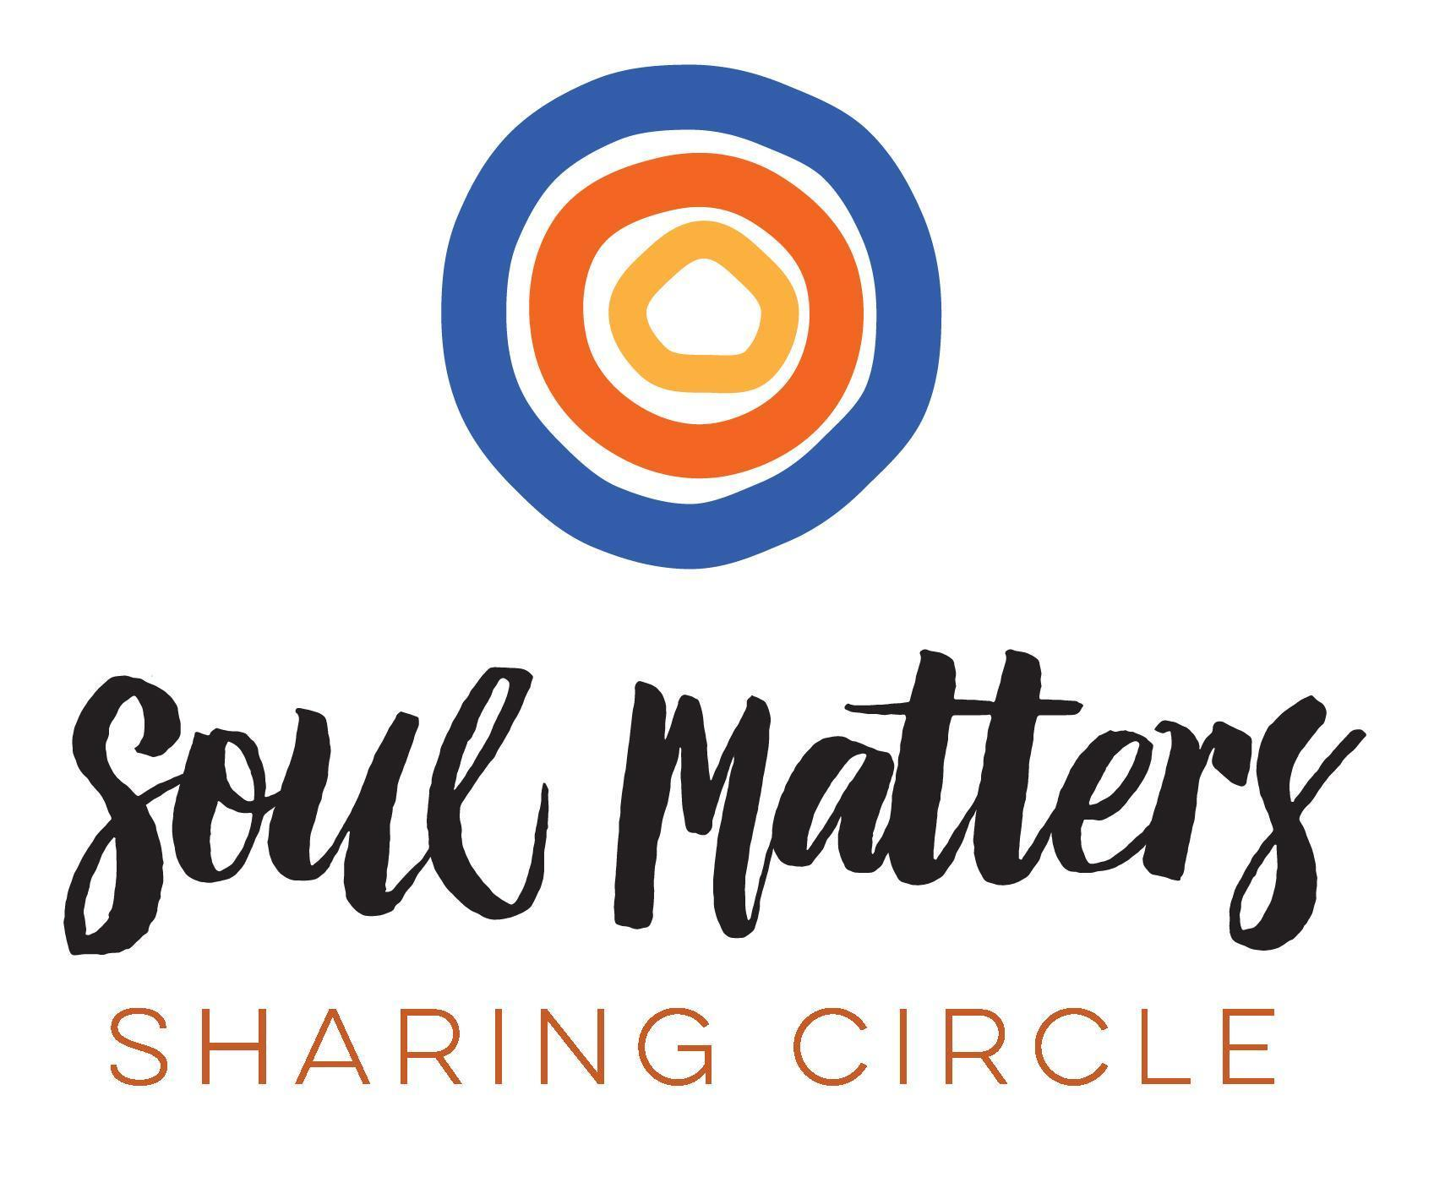
© 2020-21 Soul Matters ALL RIGHTS RESERVED

Packets are for use only by member congregations of the Soul Matters Sharing Circle.
Learn how to join at
https://www.soulmatterssharingcircle.com

