2021 Cotting School Yearbook
Order Form

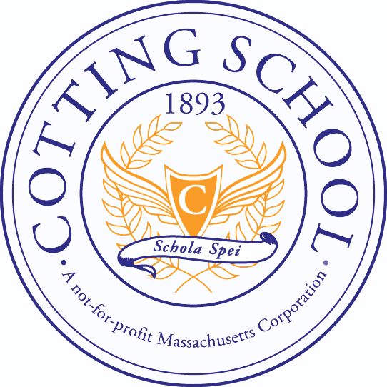

Cost is $25 per book

Yearbooks will be distributed to classrooms in June.

Please make checks payable to Cotting School with “Yearbook 2021” in the memo line and return the completed form and payment to the Development Office, attention Abby Farquharson, by Friday, May 21.

If you have questions, please contact Abby at afarquharson@cotting.org or 781-862-7323 x174.

Student Name: __________________________________________________________

Teacher Name: __________________________________________________________

*I would like to order ____ yearbook(s) at $25 per book.

I’ve enclosed cash ____ or check ____ or paid by Venmo (@Cotting-School) ____.

*Seniors are provided one yearbook free of charge.

