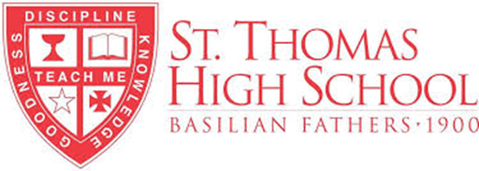

**Academic Skills Camp for Middle School Girls and Boys**

**Pathways to Independent Learning**

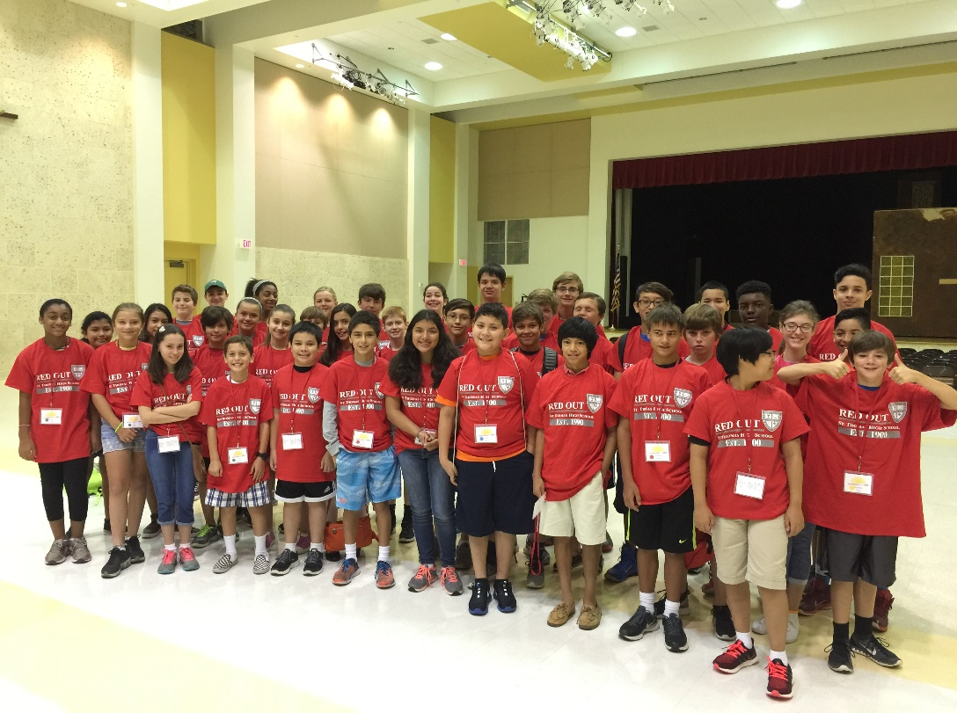

Developing **Skill Sets** for Success:

* Self-Advocacy
* Effective Communication
* Executive Functioning
* Critical Thinking

A **St. Thomas High School** program for **girls and boys** to nurture independent learners who go to school each day with a positive attitude and intellectual curiosity, motivated to succeed.

## In the **Pathways to Independent Learning** course, students are given tools and strategies to take charge of the learning process. They will be able to take full responsibility for choosing effective approaches to long-term learning. Students need the skills and strategies of independent learning to excel in any learning environment or situation. **Research has proven that facility and practice of executive functioning skills and critical thinking is a greater predictor of student success than IQ.** Students who develop the skills of independent learning are better able to adapt and succeed when they encounter obstacles.

The program consists of three major instructional units:

1. Developing Self-Advocacy
2. Developing Communication Skills
3. Developing Critical Thinking Skills

St. Thomas offers this course in two separate sessions. Session 2 repeats the content offered in Session 1. We conduct these classes in person. We will supply all materials, but students should bring notebooks for note taking. Classes are open to girls and boys.

**Session 1 CLOSED**

Saturday, March 22, 2025, 9:00-11:00 AM

Saturday, March 29, 2025, 9:00-11:00 AM

Saturday, April 5, 2025, 9:00-11:00 AM

**Session 2**

Saturday, April 12, 2025, 9:00 AM-12:00 PM

Saturday, April 26, 2025, 9:00 AM-12:00 PM

For questions, contact Rod Takacs at [rodney.takacs@sths.org](mailto:rodney.takacs@sths.org)

To register for the course, click [here](https://takeushigherlearning.com/events/sth-spring2025/)!

Thank you!