Lady Stings Basketball Shirts
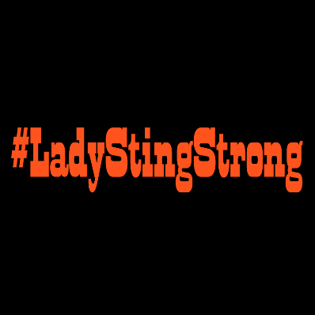
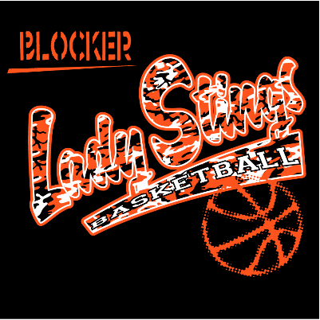
Front of Shirt Back of Shirt

Short sleeve shirts are $14 and long sleeve shirts are $18 for all sizes up to an XL. For any size larger than an XL, there will be an additional $2 added to the price of the shirt.
Name: ___________________________________ Campus __________________________
Phone number/Extension ___________________________________

Short Sleeve (indicate quantity in the space next to the shirt size)
AS ____ AM ____ AL ____ AXL ____ 2XL ____ 3XL ____
Long Sleeve (indicate quantity in the space next to the shirt size)
AS ____ AM ____ AL ____ AXL ____ 2XL ____ 3XL ____

Select Payment Type
Cash _________ Check (made payable to Blocker Girls’ Basketball) ________

ALL ORDERS AND MONEY NEED TO BE RETURNED TO COACH KELEMEN AT BLOCKER BY FRIDAY, NOVEMBER 18TH, 2016.

