Sunday | Monday | Tuesday |  | Wednesday | Thursday |  |  | Friday |  | Saturday
2019 |  |  |  |  |  |  | 1  9:30 Duplicate Bridge  11:30 Boston Symphony  7:30 Movie |  | 2  9:30 Morning Social  11:45 Met Opera  2:00 Movie  7:30 Movie
3  Church  12:30 Seekonk Square/Target  2:00 Movie  7:30 Movie  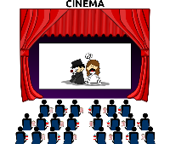 | 4  1:30 Brewery Tour and Beer Tasting  7:30 Bingo | 5  9:00 Hearing Specialist  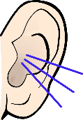  3:00 Tuesday Tea  7:30 Suzanne Scanlan |  | 6  10:00  General Resident Meeting  1:00 Art Collage Class  3:00 Spanish 3:00 Knitwits  7:30 Shakespeare Society  7:30 Pianist, Gideon Rubin | 7  10:00  Activities Committee  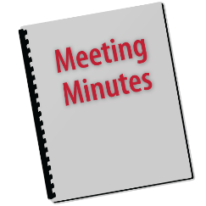  7:30  Bruce Hambro |  |  | 8  9:30 Duplicate Bridge  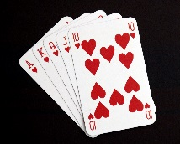  7:30 Movie |  | 9  9:30 Morning Social  2:00  Pianist, Shuann Chai  4:00 Cocktail Party in honor on Ab and Marilyn Ehrenhaus Birthday/  Anniversary 6:45 Providence Singers  7:30 Movie
10  Daylight Savings Time begins  Church  1:30  Bach, Beethoven & Brahms  2:00 Movie  7:30 Movie | 11  11:00 Book Club  3:00 Stephen Collins  7:30 Bingo | 12  10:00 Marketing Committee  2:00 Poetry  Get Together  3:00 Tea with Pianist Frank Castle  7:30 William Monroe |  | 13  12:00 Men’s Lunch  2:00 H&F  3:00 Spanish (final)  3:00 Knitwits  7:30 Movie | 14  Shredding week begins  7:30 Sonata Concert  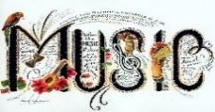 |  |  | 15  9:30 Duplicate Bridge  1:00 Dessert at Pastiche  7:30 Film Movie |  | 16  9:30 Morning Social  12:30 Marshalls  2:00 Film Movie  7:15 RI Philharmonic  7:30 Movie
17  Happy St. Patrick’s Day!  Church  1:15 Gamm Theatre  2:00 Movie  7:30 Movie | 18  10:00 B&G  3:00 Stephen Collins  7:30  Bingo  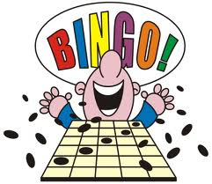 | 19  3:00 Tuesday Tea  7:30 Providence Gay Men’s Chorus |  | 20  10:00 B&F  10:00-3:00  Shoe Sale  2:00 Dining Committee  3:00  Knitwits  4:45 Dinner at Los Andes  7:30 Film Movie | 21  11:30 Pizza Luncheon Sponsored by Sunshine  7:30 Audubon Society of RI  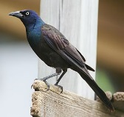 |  |  | 22  9:30 Duplicate Bridge  2:00 Movie Discussion  7:30 Movie  7:30 Let’s Talk with Salley Gibney  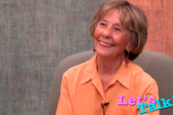 |  | 23  9:30 Morning Social  12:30 Providence Place Mall  2:00 Movie  7:30 Movie
24  Church  2:00 Movie  7:30  Movie  __________  31  2:00 Movie  7:30 Movie | 25  3:00 Stephen Collins  7:30 Bingo |  | 26  9:30 BOD Meeting  3:00 Birthday Tea with Pianist Lois Vaughn  7:30  Tenor Jazz Group | 27  3:00 Knitwits  7:30 Karen Antonowicz |  | 28  6:45 RI Chamber Music Concert  7:30  Movie  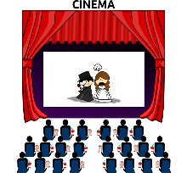 |  | 29  9:30 Duplicate Bridge  2:00 Great Decisions  7:30 Movie |  | 30  9:30 Morning Social  Time: TBD  Out to the Movies  2:00 Movie  7:30 Movie

