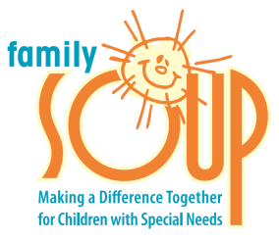

Positive Power for ADHD
Monday, March 26, 2018
6:30pm – 8:30pm
Cooper Avenue Baptist Church
804 Cooper Avenue, Yuba City

Parenting a school age child with ADHD and
Surviving

Presented by
Carla Olmstead- Newman MSW
Family SOUP

Please Join Us!
Free to residents of Yuba, Sutter, and Colusa counties.
Child care available. Call 741-6750 for more information.

