CELEBRATING BLACK HISTORY MONTH

CALVARY PRESBYTERIAN CHURCH
ASHEVILLE, NC

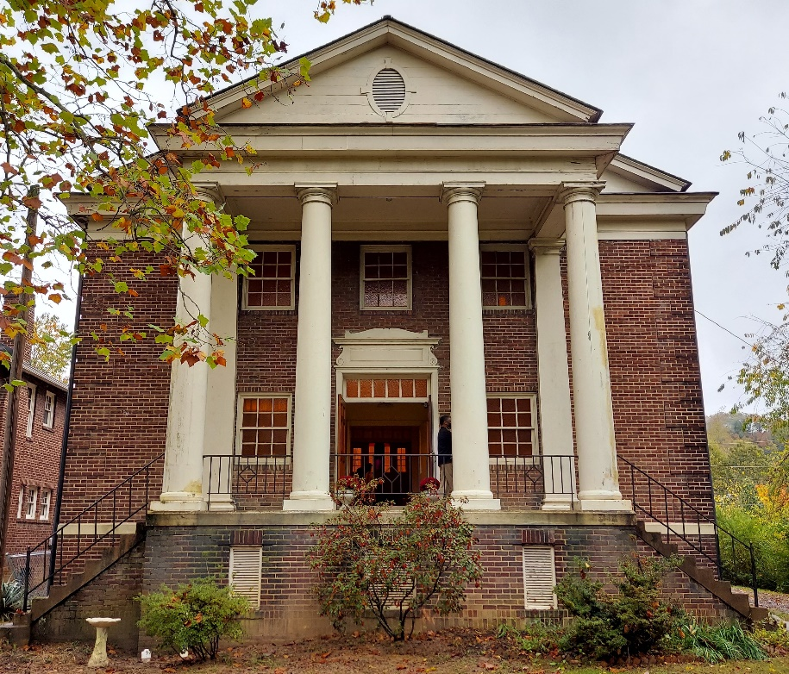

Calvary Presbyterian Church, one of the eight African American Presbyterian Churches in the Presbytery of Western North Carolina, has a wonderful history. The church was founded in 1891 by Dr. Charles Bradford Dusenbury, a great man, pastor and leader in the life and history of Asheville. In addition to serving as the first pastor, he was also an educator and was one of the founders of the Young Men’s Institute (YMI), which was one of the nation’s oldest historic African American institutions which existed for over 120 years. In addition, the Dusenbury School taught African American children and adults for over 30 years. Calvary has a history of serving East End, the oldest African American community in Asheville. Over the years, the Church established the Tiny Tot Nursery; helped to raise funds with five other churches to build Mountainside Apartments, a 100-unit affordable housing complex; and the church shared its space with Hospitality House, an intentional shelter for men and women experiencing homelessness. Under the current leadership of the Rev. Pat Bacon, Calvary continues to serve the community by feeding the homeless with a meal once a month, provide a clothing and food bank, and hosts a group in which women from the church and community gather to share stories of women in the Bible. In October of 2020, Calvary was honored with the installation of a historical marker from the East End/Valley Street Neighborhood Association highlighting the rich history of the church.

Let us give thanks and praise to God for Calvary Presbyterian Church during Black History Month and going forward!

(Excerpts from Calvary Presbyterian Church’s history were used in composing this article)

