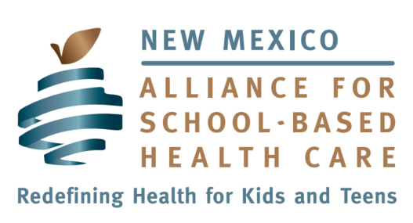

Board of Directors Candidate Application

Thank you for your interest in the Board of Directors of the New Mexico Alliance for School-Based Health Care (NMASBHC). Please complete the following questionnaire so that we can make the best use of your talents and expertise and offer you the most rewarding experience as a member of the Board.
* = Required

First Name * Click here to enter text.

Last Name * Click here to enter text.

Mailing Address * Click here to enter text.

Business Phone * Click here to enter text.

Mobile Phone * Click here to enter text.

Email Address * Click here to enter text.

Short Answer Questions
Please answer the following questions in 6-10 sentences.

Please summarize your educational and professional history. Please highlight your work to support children's health, school-based health care and/or work in school *
Click here to enter text.

Please state why you are interested in being on the NMASBHC Board of Directors. *
Click here to enter text.

Please describe current barriers to access to health care for students in New Mexico. *
Click here to enter text.

How many hours could you contribute to the organization, on average, on a monthly basis? *
Click here to enter text.

On which standing committee(s) are you interested in serving? *
☐ Advocacy
☐ Resource Development
☐ Finance

Are you interested in taking on a leadership role, either now or in the future? *
☐ President-Elect
☐ Treasurer
☐ Secretary
☐ Advocacy Committee Chair
☐ Resource Development Committee Chair

Describe your experience on other boards on which you serve or have served in the past. *
Click here to enter text.

Demographic Information (requested)

According to the NMASBHC by-laws, we must have two Directors who are between 18 and 35 years of age.
Please let us know your category of age:
☐ Under 18 years
☐ Between 18 and 35 years
☐ Over 35 years

Demographic Information (optional)

What is your gender identity? Click here to enter text.
(ex: male, female, gender queer, trans male or female, etc.)

Race
☐ American Indian or Alaskan Native
☐ Asian
☐ Black or African American
☐ Native Hawaiian or Other Pacific Islander
☐ White
☐ Hispanic/Latino/Chicano
☐ Other: Click here to enter text.

Age Click here to enter text.

Skills and Experience Inventory

Special Skills *
Please select any skills which describe you
☐ Administration/management
☐ Finance/accounting
☐ Fundraising
☐ Legal
☐ Lobbying/Advocacy
☐ Marketing/Public Relations
☐ Strategic Planning
☐ Human Resources
☐ Special Events
☐ Education/Training
☐ Investment
☐ Other: Click here to enter text.

Field Based Experience *
Please select any skills which describe you
☐ Public School
☐ School-Based Health Clinic
☐ Physical Health
☐ Dental Health
☐ Mental Health
☐ Higher Education
☐ Related Associations
☐ State/Federal Agency(ies)
☐ Self Employed
☐ Other: Click here to enter text.

Geographic Location *
Please indicate the area of the state in which you currently live
☐ Northwest Quadrant
☐ Northeast Quadrant
☐ Southwest Quadrant
☐ Southeast Quadrant
☐ Central
☐ Other: Click here to enter text.

Please provide this completed application and your resume or curriculum vitae by email to Nancy Rodriguez: nancyrodrigueznmasbhc@gmail.com by February 21, 2018.

