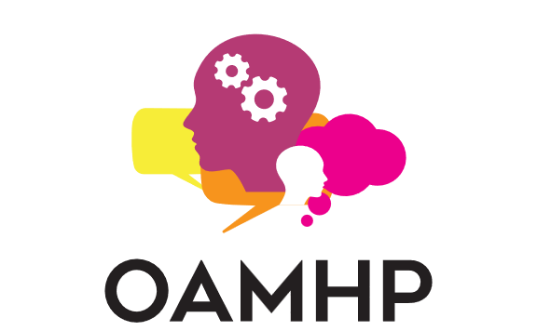
OAMHP Workshop Proposal Form

Organization Information
Contact name:
Phone number:
Email:
OAMHP Member Number (if applicable):
Organization:
Website and social media links (if applicable):
Have you worked with OAMHP in the past:
If yes, please indicate the programmes:
Course/Workshop Information
Course Name
FACILITATOR INFORMATION
Instructor Name
Qualifications (focus on their specialized knowledge of, and expertise in, the area in which they are proposing to present; and their ability and experience in teaching and presenting)
OAMHP Member Number (if applicable)
Social Media Links (optional) | Website:  Twitter:  LinkedIn:  Instagram:  Facebook:  Other:
COURSE CONTENT & LEARNING OBJECTIVES
Session Title
Category | ☐Working with children, youth and families  ☐Working with adults  ☐Education in a specific modality  ☐Safe and effective use of self (self-care for clinicians)  ☐Supervision  ☐Business practices  ☐Ethics and standards of practice  ☐Personal account/experience
Learning Objectives (please provide 3-5 clear key take-aways from this event)
Brief description of scheduled activities
Instructional Methods Used and Time spent on each (ex. Lecture, open discussion, breakout groups, research review, experiential)
Course Deliverables (ex. Acquiring knowledge, skills and techniques, handouts, resources, informing opinion, research review)
DETAILS
Length of Workshop
Level of Training | ☐Introductory  ☐Intermediate  ☐Advanced
Training Prerequisites (if applicable)
Workshop promotes | ☐Psychology  ☐Psychotherapy  ☐Counselling  ☐Psychometry  ☐Consultancy (psychological in nature)  ☐Psychological Assessment  ☐Psychopathology  ☐Psychodiagnostics  ☐Ethics & Conducts of Practice  ☐Foundational areas of psychology (biological, cognitive, social and individual)  ☐Research design, methodology and statistics  ☐Personality and individual differences  ☐Intervention planning, techniques and strategies  ☐Developmental psychology  ☐Psychopharmacology  ☐Safe and Effective Use of Self  ☐Human and Cultural Diversity  ☐Business Administration and/or Management  ☐Other:
Who is this training suitable for? | ☐Registered Psychotherapists  ☐Registered Social Worker  ☐Psychological Associate  ☐Psychometrist  ☐Psychologist  ☐Educator  ☐Counsellors  ☐Other Medical Professional  ☐Child and Youth Workers  ☐Other:
Notes for reviewers (if applicable)
OTHER
Marketing & Media (attach or insert any existing marketing materials for this workshop)
Method of evaluating or collecting feedback for your workshop (including system used and frequency of collection)
Samples of workshop feedback (optional)
COMPENSATION
Are you or anyone involved in your workshop proposal currently under a consent agreement or ethical undertaking with any professional body? |  | ☐Yes  ☐No
Are you or anyone involved in your workshop proposal the subject of a past or present investigation or disciplinary hearing by a regulatory body in any jurisdiction? |  | ☐Yes  ☐No
Expected compensation:

