How do I find videos on ESUMC’s Youtube page?

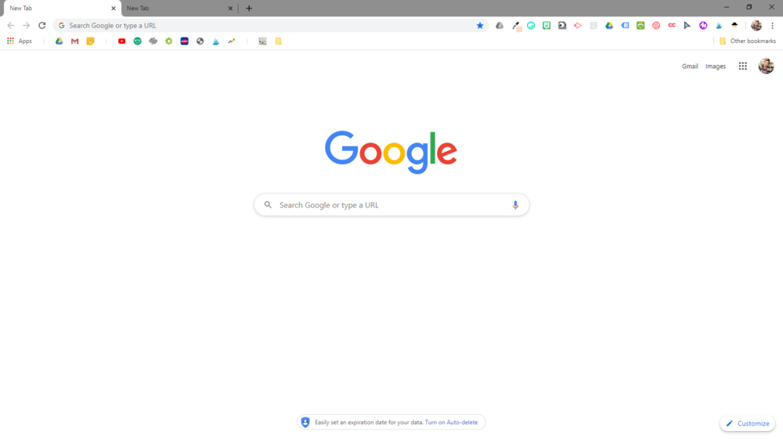
Open your internet browser of choice. A browser is what you use to look for something online. Examples include Chrome, Firefox, Edge, or Safari. It will open to your home page which might look something like this:

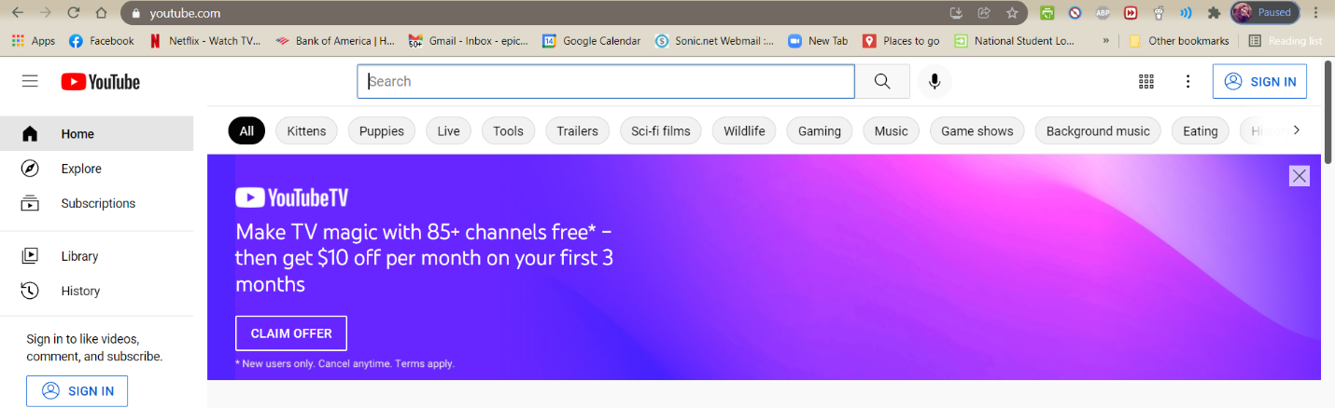
Type into the top search bar: “youtube.com” and press “Enter.” It should load to a page that looks like this:
Where it says “Search” at the top of Youtube, type in “El Sobrante United Methodist Church.” It will look like this:

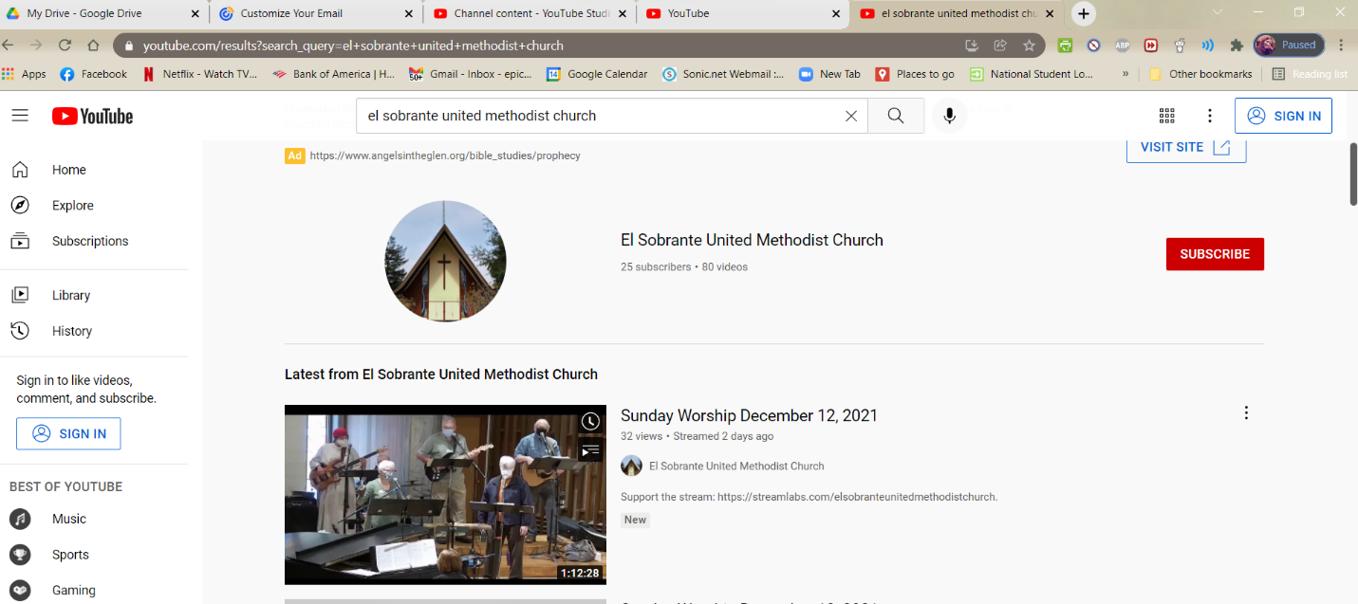
Here, you can click on the latest service from our church (red circle), you can click on our page to find other videos (blue), and you can subscribe to our Youtube page (green) so that you are ALWAYS up to date on all our services. When we get 100 subscribers, we can make our own less complicated link! So please subscribe!

