Ching-Hsiang Hu 胡縉祥
Peppercorns Interactive New Media Art
黑川互動新媒体藝術團隊
Between Mountains and Seas

Since the Dutch invaded Taiwan in 1624, the city of Tainan has experienced 400 years of change and development. For centuries, this historical and cultural ancient capital has been shaped by people from different cultures and backgrounds.

The artwork 'Between Mountains and Seas' symbolizes the interwoven passage of time in the prolonged stream of Tainan history as though the time river carves coastlines and mountain ranges in sandstone. It witnesses the accumulation and alteration of Tainan. The artwork simulates the glittering scenery of mountains and waters, using 81 2-meter-high LED tubes set up in a semicircular installation. With the combination of light art and music, it simulates the scenery of mountains and seas, presenting the harvest time of the land. Visitors are able to immerse themselves in this space to experience diverse environmental textures between the mountains and the sea in Tainan.

The “Between Mountains and Seas” installation presents a chapter in the history of Tainan, in particular the representation of said history via the change in the waterscape of Tainan over time. These changes were initiated by the Dutch who in 1624 colonized the country and made Tainan their trade entrepot in Taiwan.
Also in 1624, the Dutch founded a colony they called New Amsterdam (now New York), so the link between the two islands Manhattan and Taiwan - so distant from each other - was time and a European country at the height of its power.
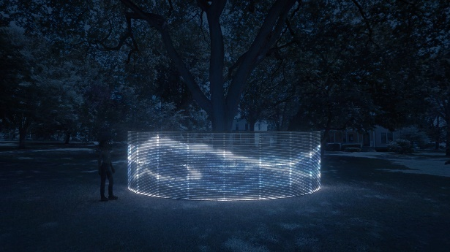

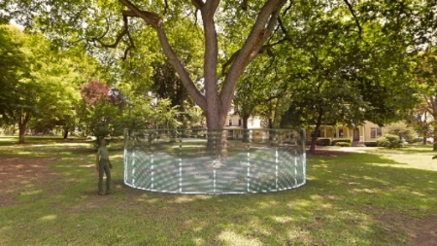

Ching-Hsiang Hu, born in Taiwan, lives and works in Taiwan. He earned an MFA from the Graduate School of Multimedia and Animation Arts of the National University of Arts in Taiwan. He employs artists and programmers who excel at creating art through new media technology. He uses program aesthetics, interactive technology, electronic machinery, the Internet, and lighting as media to explore and reflect on the relationship between people, technology, and the Internet.

Peppercorns Interactive Media Art, founded by Hu, uses new technology and media to create innovative art. They have been acknowledged and exhibited at international art and technology events such as Austria's Ars Electronica Festival, SIGGRAPH Asia, Venice's Laguna Art Prize in Italy, Fukuoka's 404 Arts Festival in Japan, the National Art Exhibition's New Media Art Gold Award, and the Taipei Digital Art Award. Moving forward, the team will continue to innovate, unveiling more immersive digital experiences.

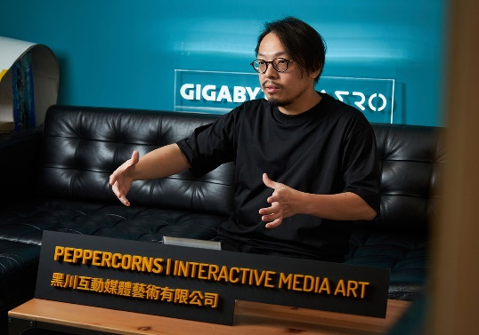
A project of the Taiwanese American Arts Council, house 7B, Nolan Park, Governors Island, New York City, 2024

