Elder Nominees (class of 2027)

Luiz Kemmerle grew up in our church and served on session as a youth. He participated in numerous mission trips, including to visit our partners in Guatemala, and currently is part of the coordinating team for the church’s youth ministries program.

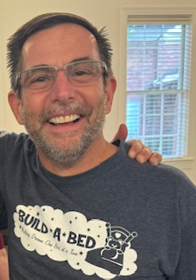
Ben Langley is a Baptist Minister who found a home at CHPC soon after graduating from Southern Seminary in 1993. He and his wife, Shannon, served as mission co-workers for the Presbyterian Church (U.S.A.) in the Dominican Republic from 1997 to 2003. He has since served on session and on the Pastor Nominating Committee. For 15 years he has worked for Jefferson County Public Schools as Director of Community Support Services, which includes working with the Build-A-Bed Project.

Deacon Nominees (class of 2026)

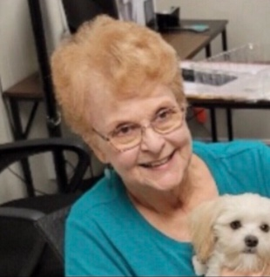
Anita Cary has been a member of CHPC for more than 30 years and has served a term on the session. She also has served on the presbytery’s Commission on Preparation for Ministry. Anita has worked most of her career in social service organizations, including Bellewood Home for Children, Robertson House (for residents with HIV/AIDS), American Printing House for the Blind, and the National Conference of Christians and Jews. She currently certifies records and manages public relations for CareBuilders at Home.

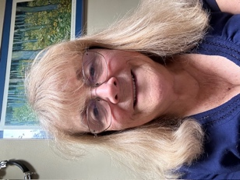
Janine Linder moved from Atlanta to Louisville in 1988 with the rest of the PC(USA)’s Westminster-John Knox Press staff. After visiting CHPC, she says, “I received regular calls from Izzy Jones and/or Lucy Steilberg until I came back.” She and her late husband, Lowell, bought a house on Crescent Avenue across from the church. They both taught in the church’s English Language Learners program and served as deacons and elders. When Lowell died in 2015, “the church was there for me and for our families,” Janine says. “I will never forget it.”

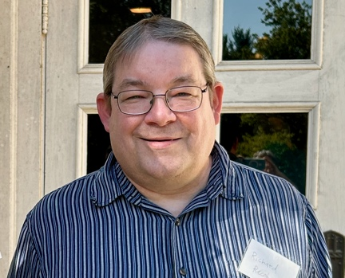
Richard Recob is a student at Louisville Presbyterian Theological Seminary and the husband of CHPC pastor Tami Recob. He joined CHPC this fall by transfer of membership and has been enrolled as an Inquirer by the Commission on Preparation for Ministry of Mid-Kentucky Presbytery, seeking approval to move to Candidacy. In congregations where he has previously been a member, Richard has preached, served on session, and participated in youth ministry, a food pantry, and mission trips.

Phil Lloyd-Sidle has agreed to provide support to the deacons as needed for liturgy and pastoral care. An ordained minister, he will not be elected, ordained, or installed as a deacon.

2025 Nominating Committee At-Large Nominees

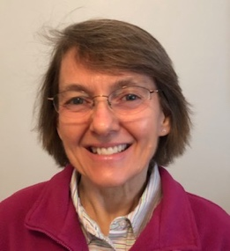
Shannon Langley began attending CHPC in 1993 and officially became a member in 1997. She says CHPC has been a place of healing, learning, and community for her. Over the years, she has been part of the youth group team, English Language Learners program, and women's contemplative group, and has served as a deacon.

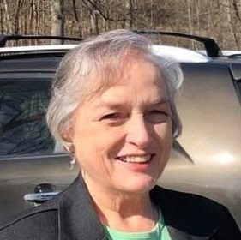
Polly Cushman and her husband came to Louisville in 1988, and she joined CHPC the first time in 1989. She was ordained as a ruling elder by CHPC in 1992 and served on the Session. She and Jim moved away in 1994. After Jim died, Polly moved back to Louisville in 2019 and was delighted to join CHPC again partly because she already had so many friends here. Since 2020 she has served as the Clerk of Session for CHPC. She also sings in the choir and participates in Presbyterian Women.

—2024 Nominating Committee—
Eva Stimson, Beth Yeager, Gail DeMarsh, Ben Langley, Janine Linder

