The Fifth Sunday after Pentecost
Proper 8

28 June 2026
9:00 a.m. Holy Eucharist

The Zabriskie Memorial Church
of Saint John the Evangelist
Newport, Rhode Island
Serving This Week
Clergy Father Kevin D. Beesley
Music Mark Johnson
Altar Guild Amy Garrison and Judy Glenn

Sunday, June 28th, The Fifth Sunday after Pentecost, Proper 8
Ushers………………….Tom Moneymaker and Paul Gilman
Lectors………………… Amy Garrison and Jennifer Johnson

Serving Next Week

Sunday, July 5th, The Sixth Sunday after Pentecost, Proper 9
Ushers…………………. Tom Moneymaker and John Lord
Lectors………………… Ann Boyer and Pelham Boyer

Parish Prayer List
Elizabeth Brooks
Jonah Freese
Phyllis Procaccini
Jim and Shelley Stonehill

…and all prayer requests that remain in our hearts

Birthdays

Mary Jane Rodman

Anniversaries
David and Phyllis Procaccini

Remembrance of the Departed
We pray for all those who have died in the peace of Christ, and for those whose faith is known to God alone.

*If you would like your name(s) added to the Birthday and/or Anniversary lists, please contact the Parish Office.

Copyright Notices: Music graphics reproduced from The Hymnal 1982 are copyright The Church Pension Fund, reproduced by permission of the Rite Song License of the Episcopal Diocese of Rhode Island. All other graphics are proprietary to St. John’s or in the public domain. All rights reserved. Reproduced under One License, License #734228-A. Permission to podcast/stream the music in this service obtained: One License, #734228-A

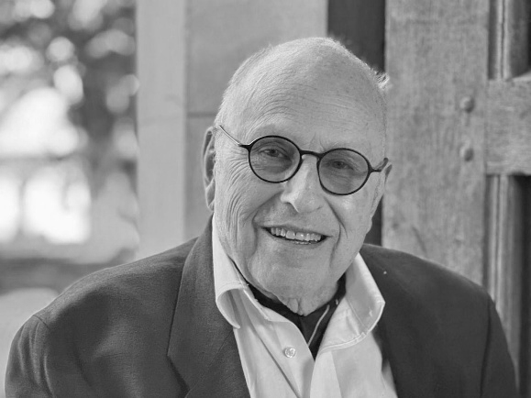

Rest in Peace: The Reverend Norman J. Catir Jr.

With hope in the Resurrection, we share the news that The Reverend Norman J. Catir Jr. passed away peacefully on Sunday, June 21st. Father Catir served faithfully as Priest-in-Charge here at the Church of Saint John the Evangelist, bringing liturgical devotion, scholarly wisdom, and deep pastoral care to our parish community.

Father Catir's life and ministry left an indelible mark on the wider Episcopal Church, championing the beauty of holiness wherever he served.

Deeply tied to Rhode Island, Father Catir was a passionate historian of the church. In 1964, he authored the definitive historical text on Saint Stephen’s Church in Providence, detailing its legacy as a vital center for the Oxford Movement in New England.

For many years, Father Catir served as the Rector of the historic Church of the Transfiguration in New York City. Arriving during a pivotal era of prayer book revision, he served as Chairman of the Liturgical Commission of the Diocese of New York. He spearheaded a rich liturgical renewal centered on the full beauty of the Solemn Mass, public baptisms, and the restoration of the Easter Vigil, keeping serious worship inextricably linked to social justice.

Following his time in New York, Father Catir returned to Rhode Island, stepping in to guide Saint John the Evangelist during a critical period of transition.
“Rest eternal grant unto him, O Lord, and let light perpetual shine upon him. May his soul, and the souls of all the faithful departed, through the mercy of God, rest in peace.”

His requiem will be at 1:00 p.m. on Thursday, July 2, at Saint Stephen's in Providence. In accordance with his wishes, he will buried in violet mass vestments, holding a chalice and paten. All are invited to come to the committal at Swan Point after the requiem, and to a reception in the Great Hall.

The Fifth Sunday after Pentecost: Proper 8

People stand at the sound of the bell for the entrance of the Sacred Ministers into the church.
Prelude

Entrance Hymn Christ is made the sure foundation H-1982, #518

Opening Acclamation

Collect for Purity and Great Commandments
The Celebrant says
Almighty God, unto whom all hearts are open, all desires known, and from whom no secrets are hid: Cleanse the thoughts of our hearts by the inspiration of thy Holy Spirit, that we may perfectly love thee, and worthily magnify thy holy Name; through Christ our Lord. Amen.
Hear what our Lord Jesus Christ saith:
Thou shalt love the Lord thy God with all thy heart, and with all thy soul, and with all thy mind. This is the first and great commandment. And the second is like unto it: Thou shalt love thy neighbor as thyself. On these two commandments hang all the Law and the Prophets.
Matthew 22:37-40

Gloria 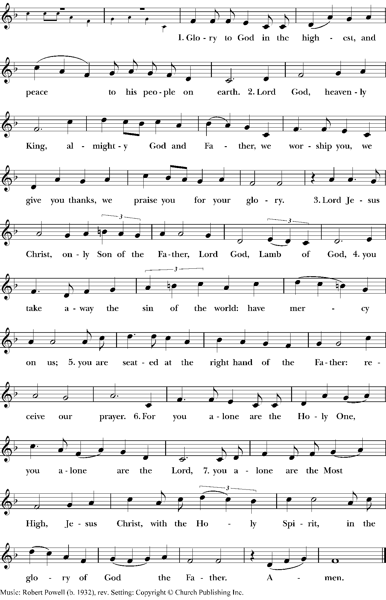
Children’s Sermon
Collect of the Day
Celebrant The Lord be with you.
People And with thy spirit.
Celebrant Let us pray.
O Almighty God, who hast built thy Church upon the foundation of the apostles and prophets, Jesus Christ himself being the chief cornerstone: Grant us so to be joined together in unity of spirit by their doctrine, that we may be made an holy temple acceptable unto thee; through the same Jesus Christ our Lord, who liveth and reigneth with thee and the Holy Spirit, one God, for ever and ever.
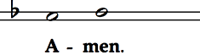
The People are invited to be seated for the readings.
First Reading Jeremiah 28:5-9

A Reading from the book of the prophet Jeremiah.
⁵The prophet Jeremiah spoke to the prophet Hananiah in the presence of the priests and all the people who were standing in the house of the Lord; ⁶and the prophet Jeremiah said, “Amen! May the Lord do so; may the Lord fulfill the words that you have prophesied, and bring back to this place from Babylon the vessels of the house of the Lord, and all the exiles. ⁷But listen now to this word that I speak in your hearing and in the hearing of all the people. ⁸The prophets who preceded you and me from ancient times prophesied war, famine, and pestilence against many countries and great kingdoms. ⁹As for the prophet who prophesies peace, when the word of that prophet comes true, then it will be known that the Lord has truly sent the prophet.”

Lector The Word of the Lord.
People Thanks be to God.

Psalm 100
Sung by all

¹Your love, O Lord, for ever will I /sing; *
from age to age my mouth will proclaim your /faithfulness.
²For I am persuaded that your love is established for/ ever; *
you have set your faithfulness firmly in the /heavens.
³“I have made a covenant with my /chosen one; *
I have sworn an oath to David my /servant:
⁴‘I will establish your line for/ever, *
and preserve your throne for all gene/rations.’ ”
¹⁵Happy are the people who know the festal /shout! *
they walk, O Lord, in the light of your /presence.
¹⁶They rejoice daily in your /Name; *
they are jubilant in your /righteousness.
¹⁷For you are the glory of their strength, *
and by your favor our might is e/xalted.
¹⁸Truly, the Lord is our /ruler; *
the Holy One of Israel is our /King.

Second Reading Roman 6:12-23

A Reading from Paul's Second letter to the Church in Rome.

¹²Do not let sin exercise dominion in your mortal bodies, to make you obey their passions. ¹³No longer present your members to sin as instruments of wickedness, but present yourselves to God as those who have been brought from death to life, and present your members to God as instruments of righteousness. ¹⁴For sin will have no dominion over you, since you are not under law but under grace.
¹⁵What then? Should we sin because we are not under law but under grace? By no means! ¹⁶Do you not know that if you present yourselves to anyone as obedient slaves, you are slaves of the one whom you obey, either of sin, which leads to death, or of obedience, which leads to righteousness? ¹⁷But thanks be to God that you, having once been slaves of sin, have become obedient from the heart to the form of teaching to which you were entrusted, ¹⁸and that you, having been set free from sin, have become slaves of righteousness. ¹⁹I am speaking in human terms because of your natural limitations. For just as you once presented your members as slaves to impurity and to greater and greater iniquity, so now present your members as slaves to righteousness for sanctification.
²⁰When you were slaves of sin, you were free in regard to righteousness. ²¹So what advantage did you then get from the things of which you now are ashamed? The end of those things is death. ²²But now that you have been freed from sin and enslaved to God, the advantage you get is sanctification. The end is eternal life. ²³For the wages of sin is death, but the free gift of God is eternal life in Christ Jesus our Lord.

Lector The Word of the Lord.
People Thanks be to God.

The People are invited to stand as able.

Gospel Hymn Blessed Assurance LEVAS, #184
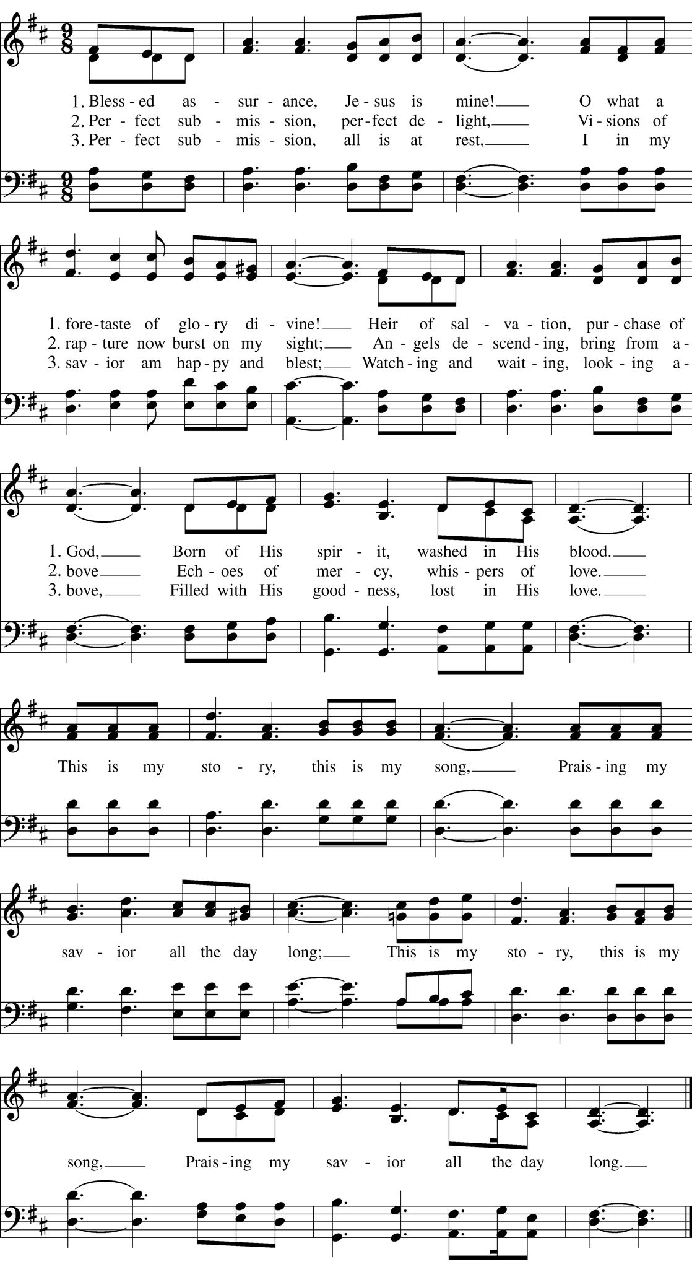
Holy Gospel Matthew 10:40-42

Celebrant The Lord be with you.
People And with thy Spirit.
Celebrant The Holy Gospel of our Lord Jesus Christ according to Saint Matthew.
People Glory be to thee, O Lord.

[Jesus said,] ⁴⁰“Whoever welcomes you welcomes me, and whoever welcomes me welcomes the one who sent me. ⁴¹Whoever welcomes a prophet in the name of a prophet will receive a prophet’s reward; and whoever welcomes a righteous person in the name of a righteous person will receive the reward of the righteous; ⁴²and whoever gives even a cup of cold water to one of these little ones in the name of a disciple—truly I tell you, none of these will lose their reward.”

Celebrant The Gospel of the Lord.
People Praise be to thee O Christ.

The People are invited to be seated for the sermon.
Sermon Father Kevin D. Beesley, Rector

The Creed
All stand.

We believe in one God,
the Father, the Almighty,
maker of heaven and earth,
of all that is, seen and unseen.
We believe in one Lord, Jesus Christ,
the only Son of God,
eternally begotten of the Father,
God from God, Light from Light,
true God from true God,
begotten, not made,
of one Being with the Father.
Through him all things were made.
For us and for our salvation
he came down from heaven:
by the power of the Holy Spirit
he became incarnate from the Virgin Mary,
and was made man.
For our sake he was crucified under Pontius Pilate;
he suffered death and was buried.
On the third day he rose again
in accordance with the Scriptures;
he ascended into heaven
and is seated at the right hand of the Father.
He will come again in glory to judge the living and the dead,
and his kingdom will have no end.
We believe in the Holy Spirit, the Lord, the giver of life,
who proceeds from the Father and the Son.
With the Father and the Son he is worshiped and glorified.
He has spoken through the Prophets.
We believe in one holy catholic and apostolic Church.
We acknowledge one baptism for the forgiveness of sins.
We look for the resurrection of the dead,
and the life of the world to come. Amen.

Prayers of the People
Leader: With all our heart and with all our mind, let us pray to the Lord, saying, "Lord, hear our prayer."
For our Bishop, for our clergy, and for all who minister in Christ. We pray especially for our parish community as we grow, for our efforts to nurture our children in Sunday School, and for those who serve the physical needs of our church, especially our Junior Warden, John, our Sexton, Kevin, and all who volunteer their time and talent to Saint John’s. Let us pray to the Lord.
People: Lord, hear our prayer.
For our President, for the leaders of the nations, and for all in authority. Guide them to paths of justice and peace, that the dignity of every human being may be upheld. Let us pray to the Lord.
People: Lord, hear our prayer.
For this community, for our city, and for our neighbors. Open our hearts to the radical hospitality of the Gospel, that we may welcome the stranger as Christ, and readily offer even a cup of cold water to those in need. We pray especially for our upcoming community meal on July 13 and for all who volunteer. Let us pray to the Lord.
People: Lord, hear our prayer.
For the aged and infirm, for the widowed and orphans, and for the sick and the suffering. We lift up those who have asked for our prayers (particular names may be added here). Bring them comfort, healing, and the assurance of your constant presence. Let us pray to the Lord.
People: Lord, hear our prayer.
For all who suffer in body, mind, or spirit. We remember those who are sick, grieving, or cast aside, especially those we now name silently or aloud (Pause for the people's petitions). Send your disciples into the world today to heal the sick, comfort the brokenhearted, and bind up the wounds of the afflicted. Lord, look upon us with compassion;
People: Lord, hear our prayer.
For all who have died in the hope of the resurrection, and for all the departed (particular names may be added here). Give them eternal rest, O Lord, and let light perpetual shine upon them. Let us pray to the Lord.
People: Lord, hear our prayer.
In the communion of all the saints, let us commend ourselves, and one another, and all our life, to Christ our God.
People: To thee, O Lord our God.
Celebrant: Lord Jesus Christ, you taught us that whoever welcomes your messengers welcomes you: Grant us grace to receive your Word with gladness, to serve our neighbors with humility, and to be your hands and feet in the world; for you live and reign with the Father and the Holy Spirit, one God, now and for ever. Amen.
Confession of Sin
The Celebrant says
Let us humbly confess our sins unto Almighty God.
Minister and People
Most merciful God,
we confess that we have sinned against thee
in thought, word, and deed,
by what we have done,
and by what we have left undone.
We have not loved thee with our whole heart;
we have not loved our neighbors as ourselves.
We are truly sorry and we humbly repent.
For the sake of thy Son Jesus Christ,
have mercy on us and forgive us;
that we may delight in thy will,
and walk in thy ways,
to the glory of thy Name. Amen.

The Priest stands and says
Almighty God, our heavenly Father, who of his great mercy hath promised forgiveness of sins to all those who with hearty repentance and true faith turn unto him, have mercy upon you, pardon and deliver you from all your sins, confirm and strengthen you in all goodness, and bring you to everlasting life; through Jesus Christ our Lord. Amen.
Hear what comfortable words our Savior Christ saith unto all who truly turn to him.
God so loved the world, that he gave his only-begotten Son, to the end that all that believe in him should not perish but have everlasting life. John 3:16

The Peace


The People and Ministers greet one another. Please be seated.

Holy Communion

Offertory Anthem

Little Lamb, who made thee?
Dost thou know who made thee?
Gave thee life and bid thee feed
By the stream and o’er the mead.
Gave thee clothing of delight,
Softest clothing, woolly bright.
Gave thee such a tender voice
Making all the vale’s rejoice.
Little Lamb, who made thee?
Dost thou know who made thee?

Little Lamb, I’ll tell thee.
Little Lamb, I’ll tell thee.
He is called by thy name,
For he calls himself a lamb.
He is meek and He is mild.
He became a little child.

I a child and thou a Lamb.
We are called by his name.
Little Lamb, God bless thee.
Little lamb, God bless thee.

William Blake
E.S. Russell

Presentation Hymn Crown him with many crowns Diademata H-1982, #494

Orate, Fratres et Sororibus

Celebrant Pray, my brothers and sisters, that this, my sacrifice and yours, may be acceptable to God the Father Almighty.
People May the Lord receive this sacrifice at thy hands, to the praise and glory of his Name, both for our benefit and that of all his holy Church.
Celebrant Amen.

Sursum Corda
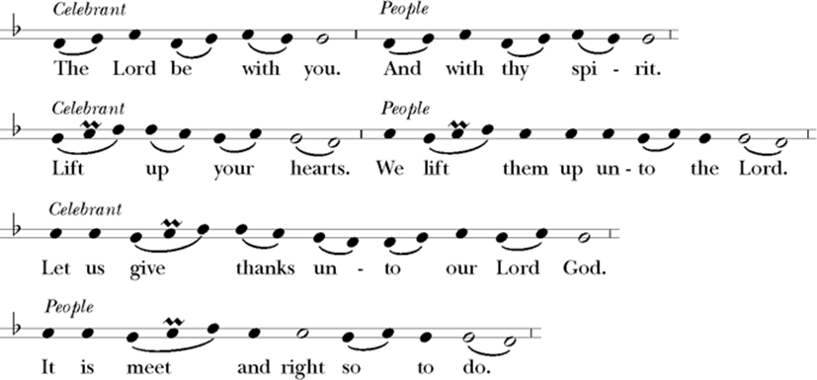

It is very meet, right, and our bounden duty, that we should at all times, and in all places, give thanks unto thee, O Lord, holy Father, almighty, everlasting God.

Who by water and the Holy Spirit hast made us a new people in Jesus Christ our Lord, to show forth thy glory in all the world.

Therefore with Angels and Archangels, and with all the company of heaven, we laud and magnify thy glorious Name; evermore praising thee, and saying,

Sanctus and Benedictus H-1982 #S125
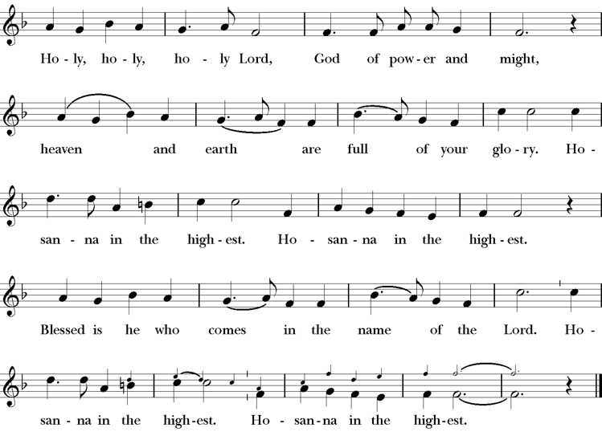
Canon of the Mass
The people kneel. Then the Celebrant continues
Almighty God, our heavenly Father, we give thanks unto thee for the goodness and love which thou hast revealed unto us in creation; in the calling of Israel as thine own people; in thy Word spoken through the prophets; and above all in the Word made flesh, thy Son Jesus Christ. For in the fulness of time thou didst send him to be incarnate from the Virgin Mary, to be the Savior and Redeemer of the world. In him, thou hast delivered us from evil and made us worthy to stand before thee. In him, thou hast brought us out of error into truth, out of sin into righteousness, out of death into life.
On the night before he died for us, our Lord Jesus Christ took bread; and when he had given thanks unto thee, he brake it, and gave it to his disciples, saying,
"Take, eat: This is my Body, which is given for you. Do this for the remembrance of me."

Likewise, after supper he took the cup; and when he had given thanks, he gave it to them saying,

"Drink ye all of this: For this is my Blood of the new Covenant, which is shed for you and for many for the remission of sins.
Do this, as oft as ye shall drink it, for the remembrance of me."

Therefore, according to his command, O Father,

We remember his death,
We proclaim his resurrection,
We await his coming in glory;

The Celebrant continues

And according to his command, O Father, we offer unto thee this sacrifice of praise and thanksgiving, presenting unto thee from thy creation, O Lord of all, this bread and this cup.

We beseech thee, gracious Father, to send thy Holy Spirit upon these gifts that they may be the Sacrament of the Body of Christ and his Blood of the New Covenant. Unite us to thy Son in his sacrifice, that we may be acceptable through him, being cross sanctified by the Holy Spirit. At the last day, put all things in subjection under thy Christ, and bring us to that heavenly country where, with the Blessed Virgin Mary, Mother of God, Blessed Saint John the Evangelist, and all thy saints, we may enter into the everlasting heritage of thy Son, Jesus Christ our Lord, the firstborn of all creation, the head of the Church, and the author of our salvation.

By him, and with him, and in him, in the unity of the Holy Spirit, all honor and glory be unto thee, O Father Almighty, world without end..


The Lord’s Prayer
And now, as our Savior Christ hath taught us, we are bold to say,
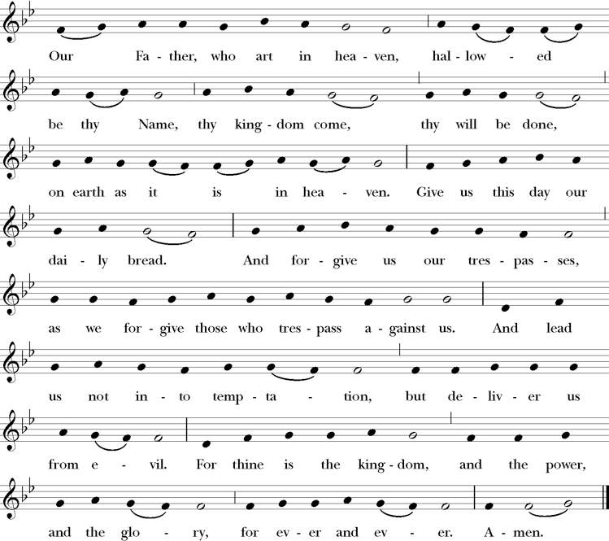

The Embolism

Celebrant Deliver us, we beseech thee, O Lord, from all evils, past, present, and to come: and at the intercession of the ever-blessed and glorious Virgin Mary, the Mother of God, with thy blessed Apostles Peter and Paul, and Andrew, and all Saints, favourably grant peace in our days: that by the help of thine availing mercy we may ever both be free from sin and safe from all disquietude. Amen.

Fraction Anthem H-1982 #S152 The Celebrant breaks the consecrated Bread. A period of silence is kept. Then is sung
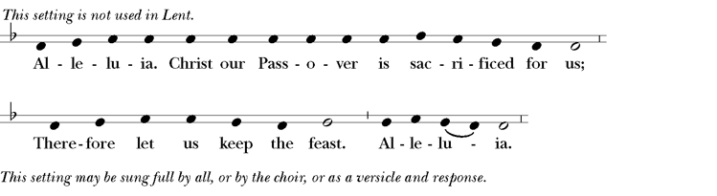

Celebrant May this commixture and consecration of the Body and Blood of our Lord Jesus
Christ avail us who partake thereof unto life eternal.

Prayer of Humble Access

Celebrant We do not presume…
People to come to this thy Table, O merciful Lord, trusting in our own righteousness, but in thy manifold and great mercies. We are not worthy so much as to gather up the crumbs under thy Table. But thou art the same Lord whose property is always to have mercy. Grant us therefore, gracious Lord, so to eat the flesh of thy dear Son Jesus Christ, and to drink his blood, that our sinful bodies may be made clean by his body, and our souls washed through his most precious blood, and that we may evermore dwell in him, and he in us. Amen.

Celebrant Behold the Lamb of God; behold him that taketh away the sins of the world.
People Blessed are we who are called to the supper of the lamb.

Communion Hymn Break thou the bread of life LEVAS #146
Mary A. Lathbury
William F. Sherman

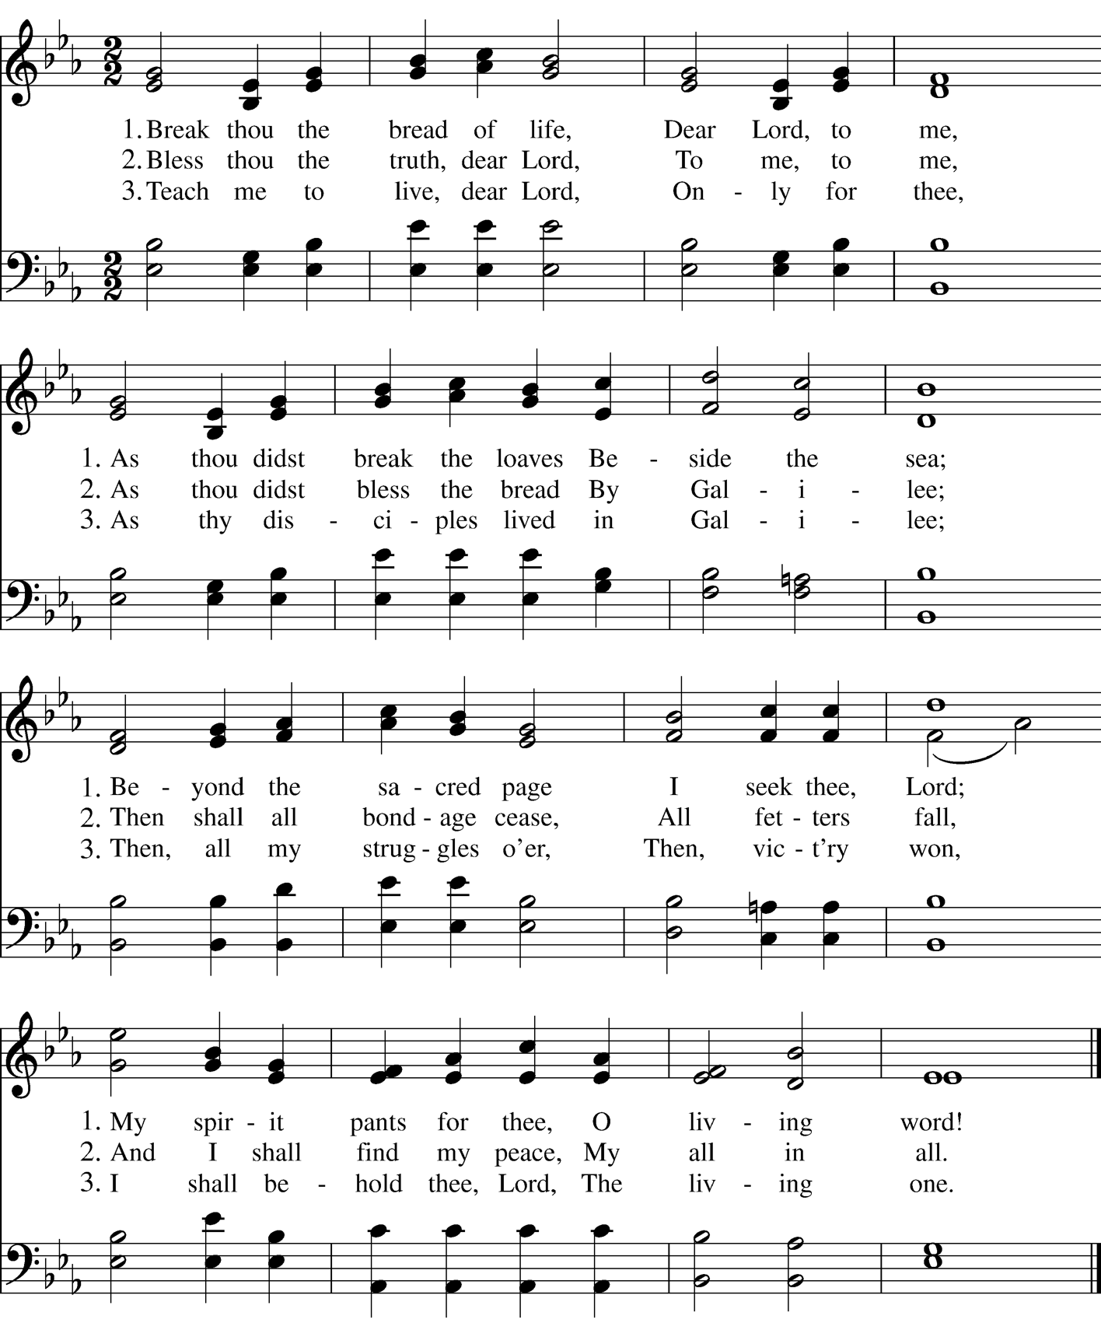

Post-Communion Prayer

Celebrant Let us pray.
Almighty and everliving God…
The People continue
…we most heartily thank thee for that thou dost feed us, in these holy mysteries, with the spiritual food of the most precious Body and Blood of thy Son our Savior Jesus Christ; and dost assure us thereby of thy favor and goodness towards us; and that we are very members incorporate in the mystical body of thy Son, the blessed company of all faithful people; and are also heirs, through hope, of thy everlasting kingdom. And we humbly beseech thee, O heavenly Father, so to assist us with thy grace, that we may continue in that holy fellowship, and do all such good works as thou hast prepared for us to walk in; through Jesus Christ our Lord, to whom, with thee and the Holy Ghost, be all honor and glory, world without end. Amen.

The Blessing
May God, who welcomed Abraham and Sarah, open your hearts to show holy hospitality to the stranger, that you may glimpse the divine in the unexpected guest. Amen.
May Christ, who looks upon the crowds with deep compassion, deliver you from being helpless or harassed, and send you forth as joyful, courageous laborers into his abundant harvest. Amen.
May the Holy Spirit, who binds you to God in an everlasting covenant, fill you with the boldness to proclaim that the kingdom of heaven has come near. Amen.
And the blessing of God Almighty, the Father, the Son, and the Holy Spirit, be upon you and remain with you always. Amen.
The people stand as able.

Dismissal

Celebrant Let us go forth in the name of Christ.
People Thanks be to God.

The Last Gospel

Celebrant The beginning of the Holy Gospel of our Lord Jesus Christ according to Saint John.
People Glory be to thee, O Lord.

In the beginning was the Word, and the Word was with God, and the Word was God. He was in the beginning with God. All things came into being through him, and without him not one thing came into being. What has come into being in him was life, and the life was the light of all people. The light shines in the darkness, and the darkness did not overtake it.

There was a man sent from God whose name was John. He came as a witness to testify to the light, so that all might believe through him. He himself was not the light, but he came to testify to the light. The true light, which enlightens everyone, was coming into the world. He was in the world, and the world came into being through him, yet the world did not know him. He came to what was his own, and his own people did not accept him. But to all who received him, who believed in his name, he gave power to become children of God, who were born, not of blood or of the will of the flesh or of the will of man, but of God.

And the Word became flesh and lived among us, and we have seen his glory, the glory as of a father’s only son, full of grace and truth.

People Thanks be to God.

Closing Hymn Gracious Spirit, give your servants Abbot’s Leigh WLP, #782

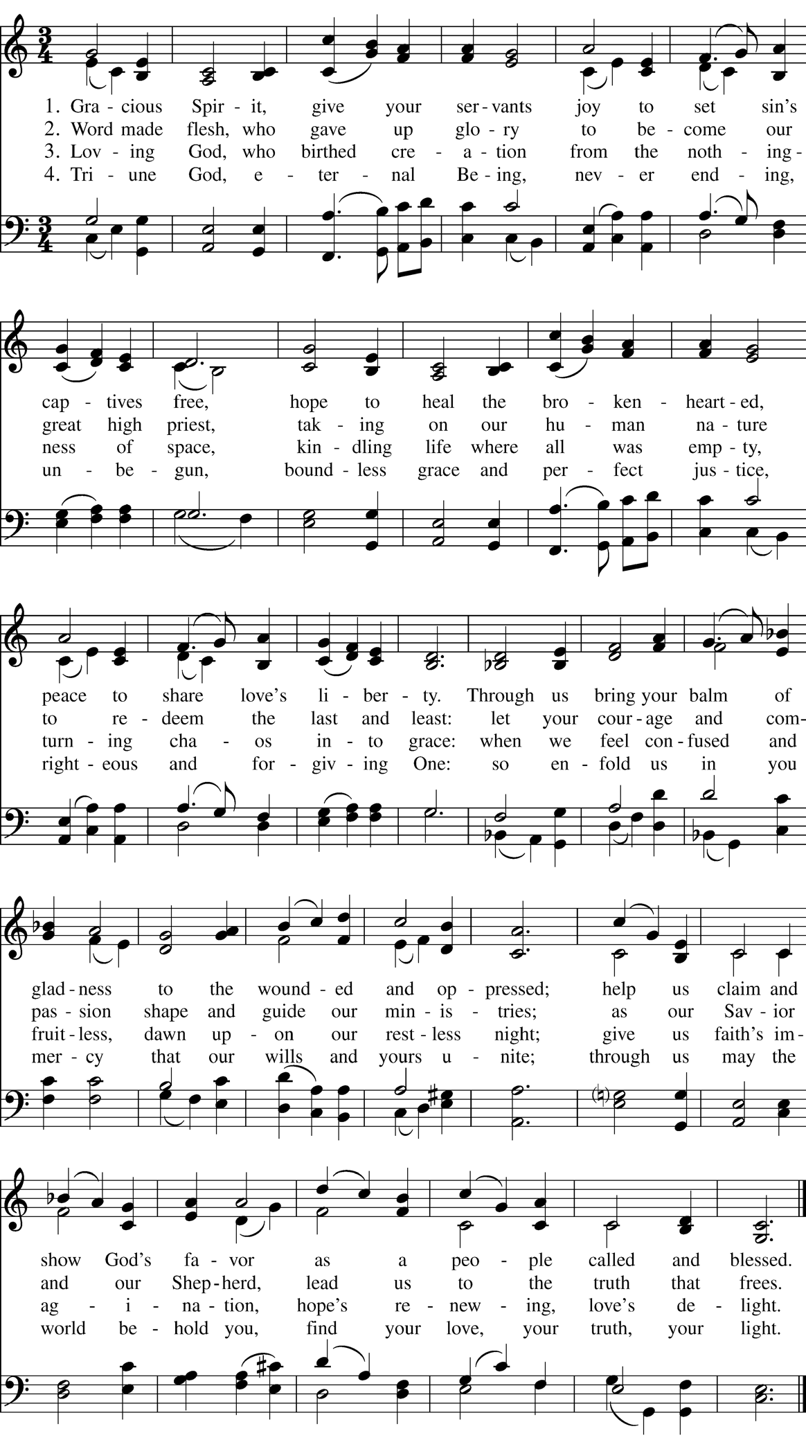

COMING UP AT SAINT JOHN’S

Sunday, June 28th, Coffee Hour

Join us in in the Guild Hall following the 9:00 a.m. Mass for a time of refreshment and fellowship!

Wednesday, July 1st, Midweek Mass
Said Mass……….12:00 p.m.
Chapel of the Blessed Sacrament

Sunday, July 5th, The 6th Sunday after Pentecost

Sung Mass – 9:00 a.m.

Wednesday, July 8th, Midweek Mass
Said Mass……….12:00 p.m.
Chapel of the Blessed Sacrament

Welcome Our New Sexton, Kevin Jerolaman!
We are delighted to announce that Kevin Jerolaman will be joining the staff of Saint John’s as our new Sexton, effective July 1.
In this role, Kevin will assist in caring for our beautiful, historic church buildings and grounds, ensuring our spaces remain welcoming, safe, and well-maintained for worship and community life.
Please join us in giving Kevin a warm Saint John’s welcome when you see him around the parish this summer!
We are incredibly blessed to have him on board.

Volunteers Needed for Community Meal!
We are looking for hands and hearts to help host our next Community Meal on Monday, July 13, from 3:00 PM to 6:00 PM.
Whether you can help with prep, serving, or clean-up, your time and smiling face will make a wonderful difference for our neighbors.
If you are able to pitch in, please see Ginny Gilman after service or reach out to her directly for more information and to sign up. Thank you for your continued generosity and support!

Launching a New Sunday School Program!
We are excited to share that we are working on creating a brand-new Sunday School program here at Saint John’s!
To make this a success, we need the help and input of our wonderful community. We are currently looking for:
- Volunteers interested in helping to teach or assist.
- Parents looking to schedule and enroll their children.
- Supporters who just want to know how they can pitch in.
If you are interested or would like to learn more, please see Fr. Kevin.
Thank you for helping us nurture the next generation of our parish family!

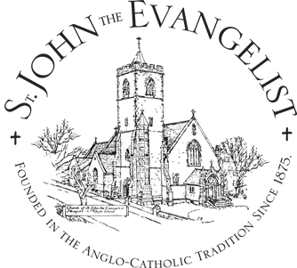

Clergy & Staff
Father Kevin D. Beesley, Rector
Mr. Mark Johnson, Minister of Music
TBD, Administrative Assistant
Mrs. Kathy Mank, Treasurer
Mr. Kevin Jerolaman, Sexton
Mr. John Garnet Lord, Minister of Adult Christian Formation
Mrs. Erin Beesley, Videographer

Vestry
Mrs. Cheryl Abney, Senior Warden
Frank Jenks, Senior Warden Emeritus
Mr. John Garagliano, Junior Warden
Ms. Karen McGee, Clerk
Mr. Edward Carnes, Treasurer Emeritus
Mr. John Garnet Lord
Ms. Linda Nalle
Mr. Paul Gillman
Capt. Tom Moneymaker, USN (Ret.)

Regular Services & Office Hours
Sunday: 9AM
(Coffee hour to follow Mass)
Wednesday: 12 noon
Confessions by appointment.
Office Hours: Tuesday - Friday 9AM-2PM

Fr. Kevin Beesley’s Email: frkevin@saintjohns-newport.org
Fr. Kevin Beesley’s Direct Line: (401) 314-2928
Scan the QR Code to schedule a meeting with Father Kevin:

The Zabriskie Memorial Church of Saint John the Evangelist
Washington & Willow Streets
61 Poplar Street, Newport RI 02840
Phone: (401) 848-2561
Email: parishoffice@saintjohns-newport.org
www.saintjohns-newport.org

