**The Twelfth Sunday after Pentecost**

**Proper 17**

**31 August 2025**

9:00 a.m. Mass

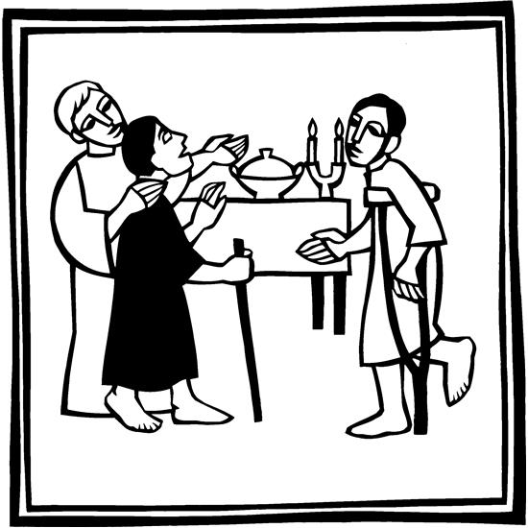

**The Zabriskie Memorial Church   
of Saint John the Evangelist  
Newport, Rhode Island**

**Serving This Week**

**Clergy** Father Kevin D. Beesley

**Music** Mark Johnson

**Altar Guild** Amy Garrison, Bill Therrien

**Sunday, August 31st, The Twelfth Sunday after Pentecost**

Acolytes Bill Therrien and Bill Amado

Ushers John Garagliano and Marvin Abney

Lectors Phyllis Procaccini and Jennifer Johnson

**Sunday, September 7th, The Thirteenth Sunday after Pentecost**

Acolytes Bill Therrien, Mia Abney, Dakota Dunlea-Abney

Ushers Tom Emmett and Walter Chase

Lectors Amy Garrison and Marvin Abney

**Parish Prayer List**  
William Bacchus

Eric Johnson

Nancy Downing

**Birthdays 08.31 - 09.06**

James Walne

Ann Boyer

**Anniversaries 08.31 – 09.06**

Tom Emmett and Amy Garrison

\**If you would like your name(s) added to the Birthday and/or Anniversary lists, please contact the Parish Office.*

**Copyright Notices:** Music graphics reproduced from *The Hymnal 1982* are copyright The Church Pension Fund, reproduced by permission of the Rite Song License of the Episcopal Diocese of Rhode Island. All other graphics are proprietary to St. John’s or in the public domain. All rights reserved. Reproduced under One License, License #734228-A. Permission to podcast/stream the music in this service obtained: One License, #734228-A

**The Twelfth Sunday after Pentecost**

**Prelude**

*The People stand at the sound of the bell for the entrance of the Sacred Ministers into the church.*

**Opening Hymn** Joyful, joyful, we adore thee (Hymn to Joy) *The Hymnal 1982, #376*

*Celebrant:*

Almighty God, unto whom all hearts are open, all desires known, and from whom no secrets are hid: Cleanse the thoughts of our hearts by the inspiration of thy Holy Spirit, that we may perfectly love thee, and worthily magnify thy holy Name; through Christ our Lord. **Amen**.

Hear what our Lord Jesus Christ saith:

Thou shalt love the Lord thy God with all thy heart, and with all thy soul, and with all thy mind. This is the first and great commandment. And the second is like unto it: Thou shalt love thy neighbor as thyself. On these two commandments hang all the Law and the Prophets.

**Gloria in Excelsis**  *The Hymnal 1982, #S280*

*Powell*

**Collect of the Day**

*Celebrant* The Lord be with you.

*People* **And with thy spirit.**

*Celebrant* Let us pray.

*The People are invited to stand.*

Lord of all power and might, who art the author and giver of all good things: Graft in our hearts the love of thy Name, increase in us true religion, nourish us with all goodness, and bring forth in us the fruit of good works; through Jesus Christ our Lord, who liveth and reigneth with thee and the Holy Spirit, one God, for ever and ever.

*People:*

*The People are invited to be seated for the readings.*

**First Reading** *Sirach 10:12-18*

A Reading from Ecclesiasticus, or the Wisdom of Jesus Son of Sirach.

12The beginning of human pride is to forsake the Lord;  
  the heart has withdrawn from its Maker.  
 13For the beginning of pride is sin,  
  and the one who clings to it pours out abominations.  
 Therefore the Lord brings upon them unheard-of calamities,  
  and destroys them completely.  
 14The Lord overthrows the thrones of rulers,  
  and enthrones the lowly in their place.  
 15The Lord plucks up the roots of the nations,  
  and plants the humble in their place.  
 16The Lord lays waste the lands of the nations,  
  and destroys them to the foundations of the earth.  
 17He removes some of them and destroys them,  
  and erases the memory of them from the earth.  
 18Pride was not created for human beings,  
  or violent anger for those born of women.

*Reader* The Word of the Lord.

*People* **Thanks be to God.**

**Psalm 112**

*Sung by all.*

  1Hallelujah!  
 Happy are they who fear the / Lord *  
  and have great delight in his com/mandments!

 2Their descendants will be mighty in the / land; *  
  the generation of the upright will be / blessed.

 3Wealth and riches will be in their / house, *  
  and their righteousness will last for/ ever.

 4Light shines in the darkness for the / upright; *  
  the righteous are merciful and full of com/passion.

 5It is good for them to be generous in / lending *  
  and to manage their affairs with / justice.

 6For they will never be / shaken; *  
  the righteous will be kept in everlasting re/membrance.

 7They will not be afraid of any evil rumors;   
  their heart is / right; *  
  they put their trust in the / Lord.

 8Their heart is established and will not / shrink, *  
  until they see their desire upon their / enemies.

 9They have given freely to the poor,   
  and their righteousness stands fast for/ ever; *  
  they will hold up their head with / honor.

 10The wicked will see it and be angry;  
 they will gnash their teeth and pine a/way; *  
  the desires of the wicked will / perish.

**Second Reading** *Hebrews 13:1-8,15-16*

A Reading from the letter to the Hebrews.

1Let mutual love continue. 2Do not neglect to show hospitality to strangers, for by doing that some have entertained angels without knowing it. 3Remember those who are in prison, as though you were in prison with them; those who are being tortured, as though you yourselves were being tortured. 4Let marriage be held in honor by all, and let the marriage bed be kept undefiled; for God will judge fornicators and adulterers. 5Keep your lives free from the love of money, and be content with what you have; for he has said, “I will never leave you or forsake you.” 6So we can say with confidence,  
 “The Lord is my helper;  
  I will not be afraid.  
 What can anyone do to me?”  
  7Remember your leaders, those who spoke the word of God to you; consider the outcome of their way of life, and imitate their faith. 8Jesus Christ is the same yesterday and today and forever. 15Through him, then, let us continually offer a sacrifice of praise to God, that is, the fruit of lips that confess his name. 16Do not neglect to do good and to share what you have, for such sacrifices are pleasing to God.

*Reader* The Word of the Lord.

*People* **Thanks be to God.**

*The People are invited to stand as able.*

**Gospel Hymn** How firm a foundation, ye saints of the Lord (Lyons)*The Hymnal 1982, #637*

*Celebrant* The Lord be with you.

*People* **And with thy Spirit.**

*Celebrant* The Holy Gospel of our Lord Jesus Christ according to Luke.

*People* **Glory be to thee, O Lord.**

**Holy Gospel** *Luke 14:1,7-14*

1On one occasion when Jesus was going to the house of a leader of the Pharisees to eat a meal on the sabbath, they were watching him closely.  
  7When he noticed how the guests chose the places of honor, he told them a parable. 8“When you are invited by someone to a wedding banquet, do not sit down at the place of honor, in case someone more distinguished than you has been invited by your host; 9and the host who invited both of you may come and say to you, ‘Give this person your place,’ and then in disgrace you would start to take the lowest place. 10But when you are invited, go and sit down at the lowest place, so that when your host comes, he may say to you, ‘Friend, move up higher’; then you will be honored in the presence of all who sit at the table with you. 11For all who exalt themselves will be humbled, and those who humble themselves will be exalted.”  
  12He said also to the one who had invited him, “When you give a luncheon or a dinner, do not invite your friends or your brothers or your relatives or rich neighbors, in case they may invite you in return, and you would be repaid. 13But when you give a banquet, invite the poor, the crippled, the lame, and the blind. 14And you will be blessed, because they cannot repay you, for you will be repaid at the resurrection of the righteous.”

*Celebrant* The Gospel of the Lord.

*People* **Praise be to thee Lord Christ.**

*The People are invited to be seated for the sermon.*

**Sermon** *Father Kevin D. Beesley, Rector*

**The Creed**

*All stand as able.*

**We believe in one God,**

**the Father, the Almighty,**

**maker of heaven and earth,**

**of all that is, seen and unseen.**

**We believe in one Lord, Jesus Christ,**

**the only Son of God,**

**eternally begotten of the Father,**

**God from God, Light from Light,**

**true God from true God,**

**begotten, not made,**

**of one Being with the Father.**

**Through him all things were made.**

**For us and for our salvation**

**he came down from heaven:**

**by the power of the Holy Spirit**

**he became incarnate from the Virgin Mary,**

**and was made man.**

**For our sake he was crucified under Pontius Pilate;**

**he suffered death and was buried.**

**On the third day he rose again**

**in accordance with the Scriptures;**

**he ascended into heaven**

**and is seated at the right hand of the Father.**

**He will come again in glory to judge the living and the dead,**

**and his kingdom will have no end.**

**We believe in the Holy Spirit, the Lord, the giver of life,**

**who proceeds from the Father and the Son.**

**With the Father and the Son he is worshiped and glorified.**

**He has spoken through the Prophets.**

**We believe in one holy catholic and apostolic Church.**

**We acknowledge one baptism for the forgiveness of sins.**

**We look for the** cross **resurrection of the dead,**

**and the life of the world to come. Amen.**

**Prayers of the People**

*All remain standing.*

*Celebrant* Let us pray for the whole state of Christ’s Church and the world.

*After each paragraph of this prayer, the People may make an appropriate response, as directed.*

Almighty and everliving God, who in thy holy Word hast taught us to make prayers, and supplications, and to give thanks for all people: Receive these our prayers which we offer unto thy divine Majesty, beseeching thee to inspire continually the Universal Church with the spirit of truth, unity, and concord; and grant that all those who do confess thy holy Name may agree in the truth of thy holy Word, and live in unity and godly love.

Give grace, O heavenly Father, to all bishops and other ministers especially Sean our Presiding Bishop, Nicholas our Diocesan Bishop, and Kevin and Andrew our Priests, that they may, both by their life and doctrine, set forth thy true and lively Word, and rightly and duly administer thy holy Sacraments.

And to all thy people give thy heavenly grace, and especially to this congregation here present; that, with meek heart and due reverence, they may hear and receive thy holy Word, truly serving thee in holiness and righteousness all the days of their life.

We beseech thee also so to rule the hearts of those who bear the authority of government in this and every land especially Donald our President, Daniel our Governor, and all elected officials, that they may be led to wise decisions and right actions for the welfare and peace of the world.

Open, O Lord, the eyes of all people to behold thy gracious hand in all thy works, that, rejoicing in thy whole creation, they may honor thee with their substance, and be faithful stewards of thy bounty.

And we most humbly beseech thee, of thy goodness, O Lord, to comfort and succor all those who, in this transitory life, are in trouble, sorrow, need, sickness, or any other adversity.

For what else shall we pray?

*All are invited to make their petitions and thanksgivings either silently or aloud*

And we also bless thy holy Name for all thy servants departed this life in thy faith and fear, beseeching thee to grant them continual growth in thy love and service; and to grant us grace so to follow the good examples of the Blessed and Glorious Virgin Mary, Mother of God, Saint John the Evangelist and of all thy saints, that with them we may be partakers of thy heavenly kingdom.

*Celebrant* Grant these our prayers, O Father, for Jesus Christ’s sake, our only Mediator and Advocate.

*People* **Amen**.

**Confession and Absolution**

*All kneel as able.  
The Celebrant says*Let us humbly confess our sins unto Almighty God.

*Silence may be kept.*

*Minister and People*

**Most merciful God,**

**we confess that we have sinned against thee**

**in thought, word, and deed,**

**by what we have done,**

**and by what we have left undone.**

**We have not loved thee with our whole heart;**

**we have not loved our neighbors as ourselves.**

**We are truly sorry and we humbly repent.**

**For the sake of thy Son Jesus Christ,**

**have mercy on us and forgive us;**

**that we may delight in thy will,**

**and walk in thy ways,**

**to the glory of thy Name. Amen.**

*The Celebrant alone stands and says*

The Almighty and merciful Lord grant you cross absolution and remission of all your sins, true repentance, amendment of life, and the grace and consolation of his Holy Spirit. **Amen.**

**The Peace**

Click to get the full file (S 110 The Peace () 1 (Staff).tif):  (Staff)

Click to get the full file (S 110 The Peace () 2 (Staff).tif):  (Staff)

*The People and Ministers greet one another. Please be seated.*

**The Holy Communion**

Walk in love, as Christ loved us and gave himself for us, an offering and sacrifice to God.

*Ephesians 5:2*

**At the Offertory, Anthem** Break Thou the Bread of Life *LEVAS, #146*

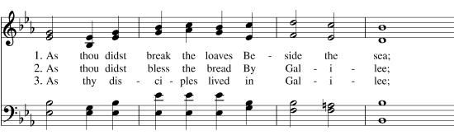

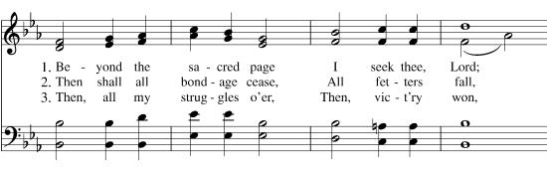

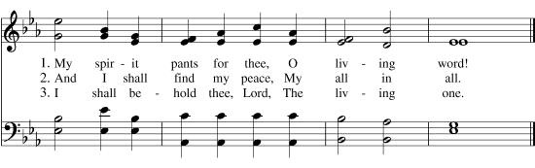

*Text: Mary A. Lathbury (1841-1913)  
Music: William F. Sherwin (1826-1888)*

**Orate, Fratres et Sororibus**

*Celebrant* Pray, my brothers and sisters, that this, my sacrifice and yours, may be acceptable to God the Father Almighty.

*People* **May the Lord receive this sacrifice at thy hands, to the praise and glory of his Name, both for our benefit and that of all his holy Church.**

*Celebrant* Amen.

**Sursum Corda**

Click to get the full file (S 112 Lift up your hearts 1 (Staff).tif):  (Staff)

Click to get the full file (S 112 Lift up your hearts 2 (Staff).tif):  (Staff)

Click to get the full file (S 112 Lift up your hearts 3 (Staff).tif):  (Staff)Click to get the full file (S 112 Lift up your hearts 4 (Staff).tif):  (Staff)

It is very meet, right, and our bounden duty, that we should at all times, and in all places, give thanks unto thee, O Lord, holy Father, almighty, everlasting God.

Who by water and the Holy Spirit hast made us a new people in Jesus Christ our Lord, to show forth thy glory in all the world.

Therefore with Angels and Archangels, and with all the company of heaven, we laud and magnify thy glorious Name; evermore praising thee, and saying,

**Sanctus and Benedictus** *The Hymnal 1982 #S124*

**Canon of the Mass, Rite I, Prayer II**

*The People kneel or stand as able. The Celebrant continues.*

All glory be to thee, O Lord our God, for that thou didst create heaven and earth, and didst make us in thine own image; and, of thy tender mercy, didst give thine only Son Jesus Christ to take our nature upon him, and to suffer death upon the cross for our redemption.

He made there a full and perfect sacrifice for the whole world; and did institute, and in his holy Gospel command us to continue, a perpetual memory of that his precious death and sacrifice, until his coming again.

For in the night in which he was betrayed, he took bread; and when he had given thanks to thee, he broke it, and gave it to his disciples, saying,

*“Take, eat, this is my Body, which is given for you. Do this in remembrance of me.”*

Likewise, after supper, he took the cup; and when he had given thanks, he gave it to them, saying,

*“Drink this, all of you; for this is my Blood of the New Covenant, which is shed for you, and for many, for the remission of sins. Do this, as oft as ye shall drink it, in remembrance of me.”*

Wherefore, O Lord and heavenly Father, we thy people do celebrate and make, with these thy holy gifts which we now offer unto thee, the memorial thy Son hath commanded us to make; having in remembrance his blessed passion and precious death, his mighty resurrection and glorious ascension; and looking for his coming again with power and great glory.

And we most humbly beseech thee, O merciful Father, to hear us, and, with thy Word and Holy Spirit, to bless and sanctify these gifts of bread and wine, that they may be unto us the Body and Blood of thy dearly-beloved Son Jesus Christ.

And we earnestly desire thy fatherly goodness to accept this our sacrifice of praise and thanksgiving, whereby we offer and present unto thee, O Lord, our selves, our souls and bodies. Grant, we beseech thee, that all who partake of this Holy Communion may worthily receive the most precious Body and Blood of thy Son Jesus Christ, and be filled with thy grace and heavenly benediction; and also that we and all thy whole Church may be made one body with him, that he may dwell in us, and we in him; through the same Jesus Christ our Lord;

By whom, and with whom, and in whom, in the unity of the Holy Ghost all honor and glory be unto thee, O Father Almighty, world without end. ***AMEN.***

**The Lord’s Prayer**

And now, as our Savior Christ hath taught us, we are bold to say,

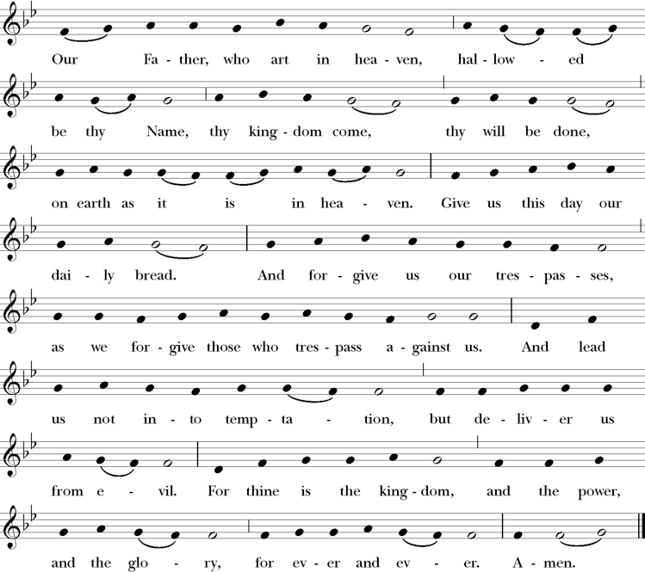

**Fraction Anthem** *The Hymnal 1982 #S152*

*The Celebrant breaks the consecrated Bread. A period of silence is kept. Then is sung*

*Celebrant* May this commixture and consecration of the Body and Blood of our Lord Jesus   
Christ avail us who partake thereof unto life eternal.

**Prayer of Humble Access**

*All kneeling as able, the following prayer may be said by all in a quiet voice, the Celebrant beginning.*

*Celebrant* We do not presume

*People* **to come to this thy Table, O merciful Lord, trusting in our own righteousness, but in thy manifold and great mercies. We are not worthy so much as to gather up the crumbs under thy Table. But thou art the same Lord whose property is always to have mercy. Grant us therefore, gracious Lord, so to eat the flesh of thy dear Son Jesus Christ, and to drink his blood, that our sinful bodies may be made clean by his body, and our souls washed through his most precious blood, and that we may evermore dwell in him, and he in us. Amen*.***

*The Celebrant says*

*Celebrant* Behold the Lamb of God; behold him that taketh away the sins of the world.

*People* **Blessed are we who are called to the supper of the lamb.**

**Communion Hymn**  I am the Bread of Life (Kusik) *WLP #762*

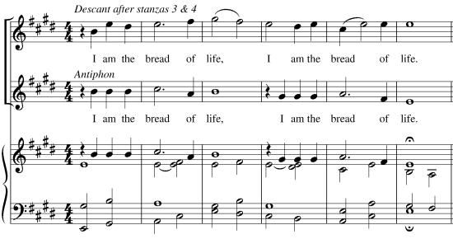  
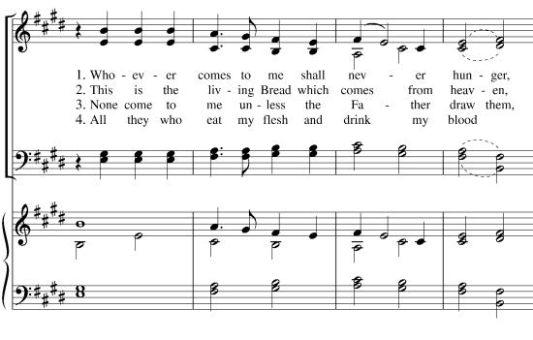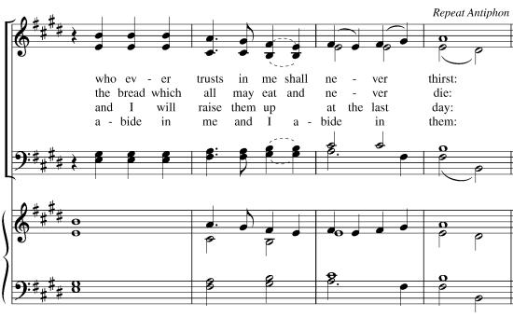

*Text: Jack Warren Burnam (b. 1946), based on John 6, Music: Jack Warren Burnam (b. 1946)*

**Post Communion Collect**

*The People kneel or stand as able. The Celebrant begins*

Let us pray.

Almighty and everliving God,

*The People continue…*

**…we most heartily thank thee for that thou dost vouchsafe to feed us who have duly received these holy mysteries, with the spiritual food of the most precious Body and Blood of thy Son our Savior Jesus Christ; and dost assure us thereby of thy favor and goodness towards us; and that we are very members incorporate in the mystical body of thy Son, which is the blessed company of all faithful people; and are also heirs, through hope, of thine everlasting kingdom by the merits of his most precious death and passion. And we humbly beseech thee, O heavenly Father, so to assist us with thy grace, that we may continue in that holy fellowship, and do all such good works as thou hast prepared for us to walk in; through Jesus Christ our Lord, to whom, with thee and the Holy Ghost, be all honor and glory, world without end. Amen.**

**Blessing**

*The Celebrant blesses the people, saying*

The peace of God, which passeth all understanding, keep your hearts and minds in the knowledge and love of God, and of his Son Jesus Christ our Lord; and the blessing of God Almighty, cross the Father, the Son, and the Holy Spirit, be upon you and remain with you for ever. **Amen.**

**Dismissal**

*Celebrant* Go in peace to love and serve the Lord.

*People* **Thanks be to God.**

### **The Last Gospel**

*Celebrant* The beginning of the Holy Gospel of our Lord Jesus Christ according to Saint John.

*People* **Glory be to thee, O Lord.**

In the beginning was the Word, and the Word was with God, and the Word was God. He was in the beginning with God. All things came into being through him, and without him not one thing came into being. What has come into beingin him was life, and the life was the light of all people. The light shines in the darkness, and the darkness did not overtake it.

There was a man sent from God whose name was John. He came as a witness to testify to the light, so that all might believe through him. He himself was not the light, but he came to testify to the light. The true light, which enlightens everyone, was coming into the world.

He was in the world, and the world came into being through him, yet the world did not know him. He came to what was his own, and his own people did not accept him. But to all who received him, who believed in his name, he gave power to become children of God, who were born, not of blood or of the will of the flesh or of the will of man, but of God.

And the Word became flesh and lived among us, and we have seen his glory, the glory as of a father’s only son, full of grace and truth.

*People* **Thanks be to God.**

**Closing Hymn**

All praise to thee, for thou, O King divine (Engelberg) *The Hymnal 1982, #477*

**THIS WEEK AT SAINT JOHN’S**

**Wednesday, September 3rd**

Midweek Morning Prayer……….12:00 p.m.

**Sunday, September 7th**

The Thirteenth Sunday after Pentecost

Mass……….9:00 a.m.

**ANNOUNCEMENTS**

Please join us after Mass for coffee hour in the Guild Hall.  
Everyone is invited!

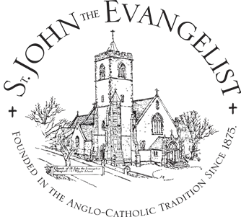

**Clergy & Staff**

Father Kevin D. Beesley, *Rector*Father Andrew Mead*, Associate Priest*Mr. Mark Johnson*, Minister of Music*

Mrs. Michaela Wallace*, Administrative Assistant*

Mrs. Kathy Mank, *Treasurer*

Mr. Bill Therrien, *Sexton*

Mr. John Garnet Lord, *Minister of Adult Christian Formation*

Mrs. Erin Beesley*, Videographer*

**Vestry**

Mrs. Cheryl Abney, *Senior Warden*

Frank Jenks, *Senior Warden Emeritus*

Mr. John Garagliano, *Junior Warden*

Ms. Karen McGee, *Clerk*

Mr. Edward Carnes, *Treasurer Emeritus*Mr. John Garnet Lord

Ms. Linda Nalle  
Mr. Josh Larkum

**Regular Services & Office Hours**

Sunday: 9AM   
(Coffee hour to follow Mass)  
Wednesday: 12 noon

Confessions by appointment.

Office Hours: Tuesday – Friday 9AM-2PM

**Scan the QR Code to schedule a meeting with Father Kevin:**

**The Zabriskie Memorial Church of Saint John the Evangelist**

Washington & Willow Streets

61 Poplar Street, Newport RI 02840  
Phone: (401) 848-2561  
Email: parishoffice@saintjohns-newport.org

www.saintjohns-newport.org