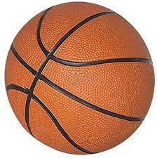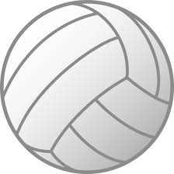
Dear St. Bernadette Parents,
St. Bernadette is a part of the Northern Virginia Junior Catholic Youth Organization (NVJCYO). NVJCYO offers several sports programs for Catholic school and religious education students, including basketball, track and field, cross country, and girl’s volleyball. These programs are immensely popular and rewarding for the children and the parents. None of these programs can happen without volunteers.
The most important volunteer for the parish is the CYO Parish Representative. I have held this position for St. Bernadette for the last seven years. However, our youngest graduates from St. Bernadette this year so this will be my last season serving as Parish Representative.
The parish needs a volunteer to step up and serve as Parish Representative. I can provide training this year, while I am still active. It is a rewarding role that allows you to shape the experiences that your children, and their peers, will have while attending St. Bernadette.
Please contact me via email, yatmung@yahoo.com If would like to volunteer or have questions about the position.
Thanks,
Matt Young
St. Bernadette CYO Parish Representative

