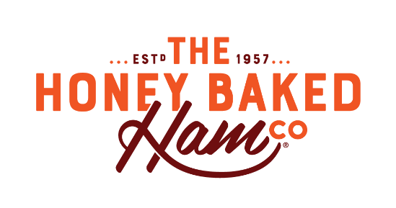
Our kiddos, teachers, and school staff deserve the best!
As your PTO, our goal is to support the expanding needs & desires of our faculty as they look to create that educational environment one can only achieve in a Catholic School community.
We invite you to partner with the 2023-2024 PTO Honey Baked Ham - Home Cooked Goodness & No Fuss campaign which is available from November 10, 2023 – March 31, 2024.
Plan your Thanksgiving gathering, Christmas meal,
Easter dinner or pick up a quick last minute gift by simply purchasing a e-gift card then place your order!
Shop today and St. Bernadette’s receives 20% of all sales.
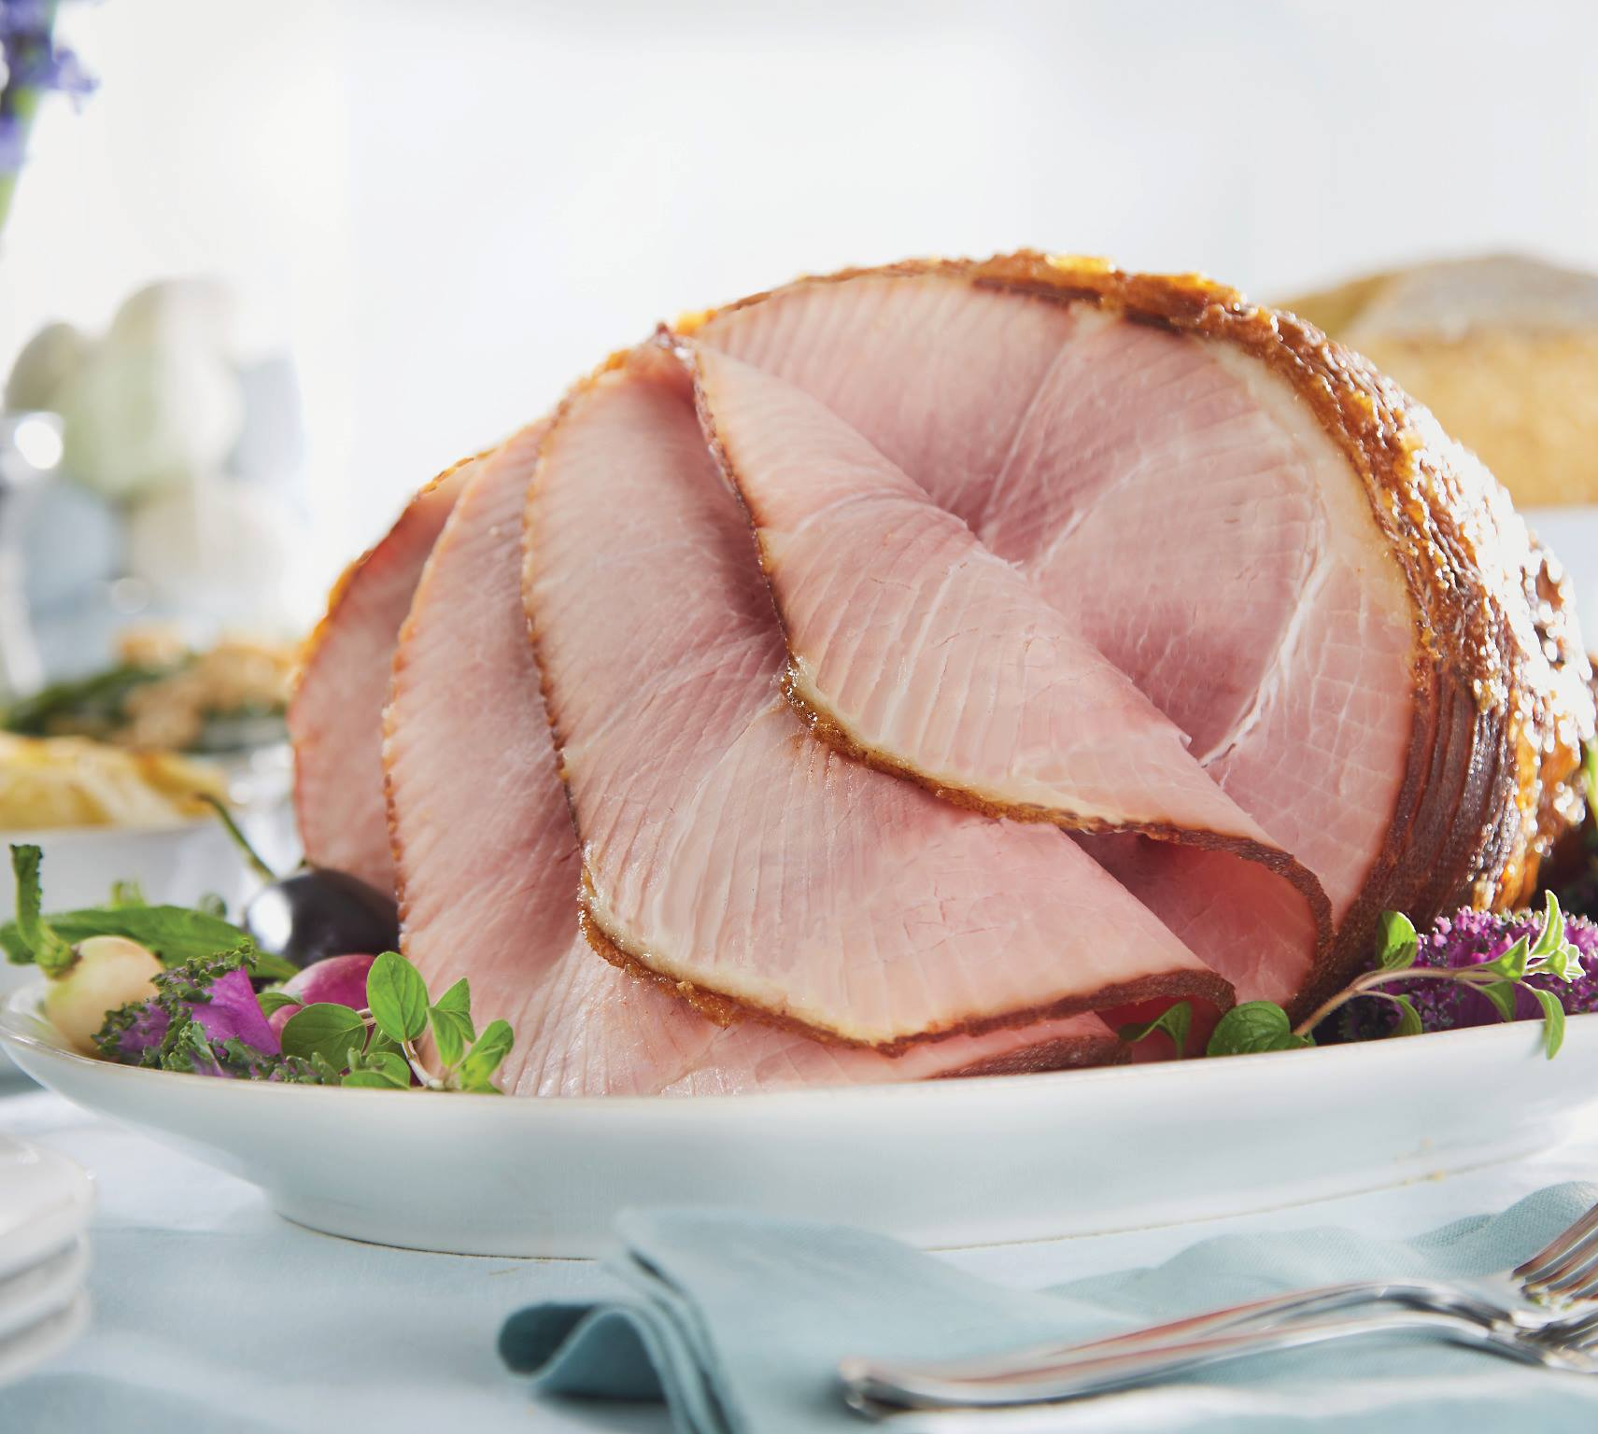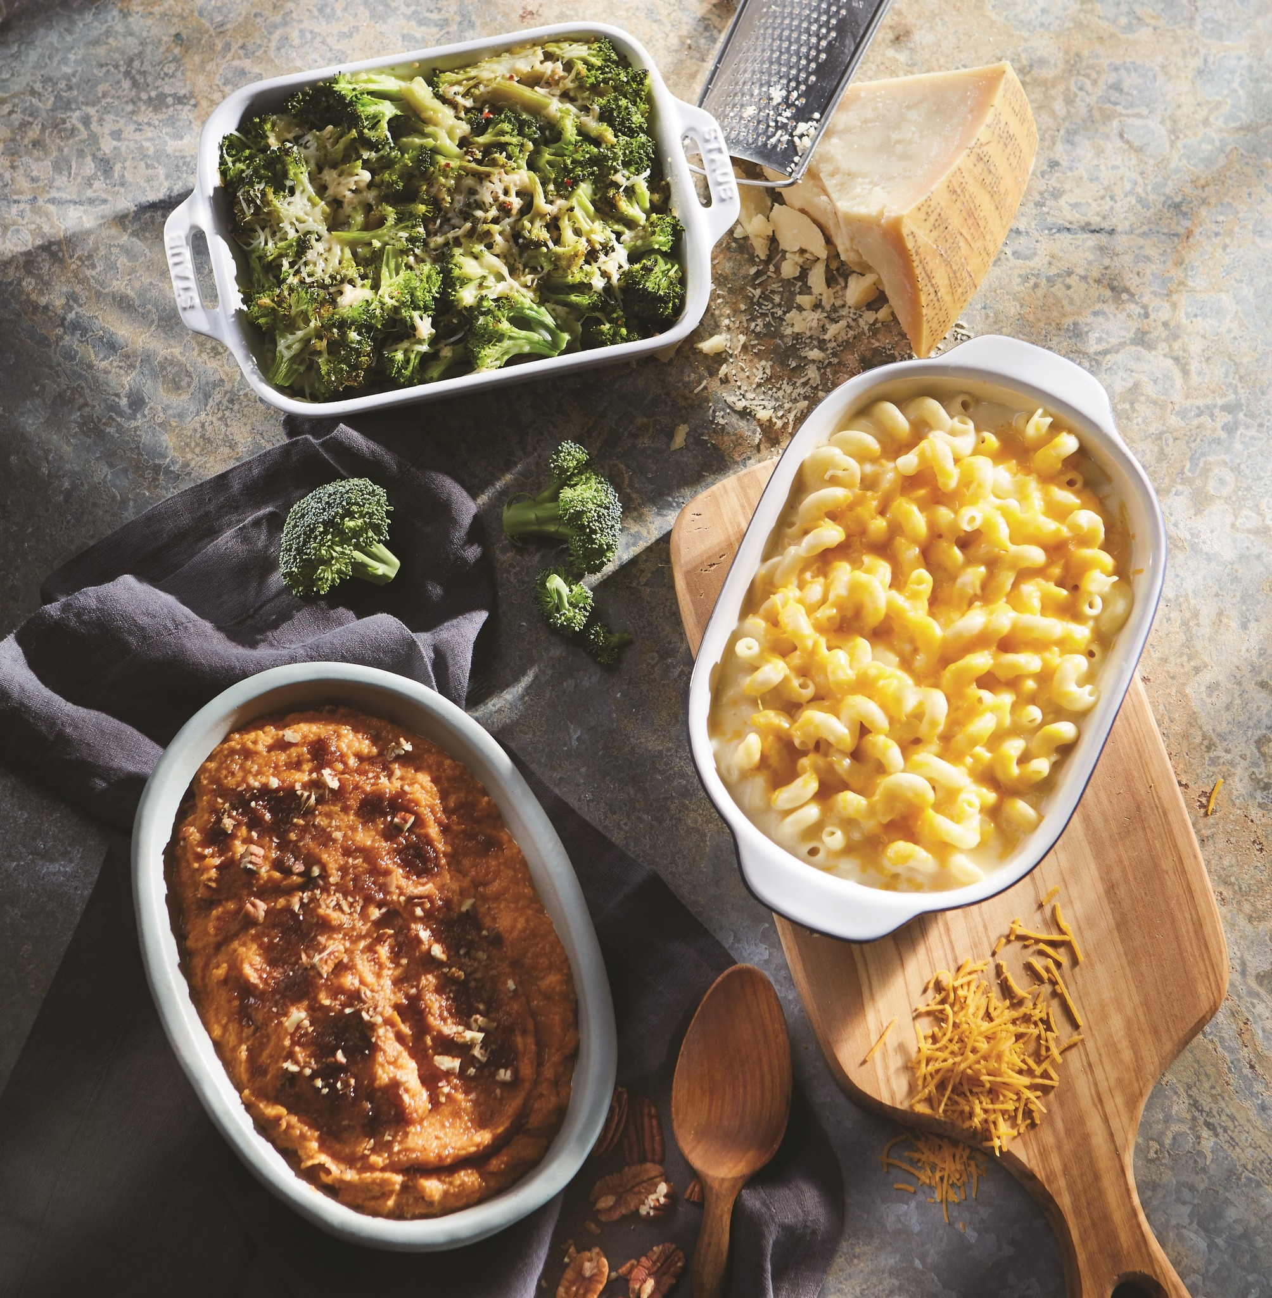
Home Cooked Goodness & No Fuss

